EMC related aspects of Cyber-Physical Systems in cars
1: Introduction
EMC is the abbreviation for ElectroMagnetic Compatibility. Two electronic devices are electromagnetically compatible when the operation of the first device does not have an impact on the operation of the second device and vice versa.
EMI is the abbreviation for ElectroMagnetic Interference. EMI occurs when two electronic devices are operating in each others proximity and when the operation of one device has a (negative) effect on the operation of the other device. Examples of EMI are:
- The use of a mobile phone might disturb the electronic devices in an airplane needed by the pilots. Due to this reason, the use of mobile phones (and other electronic equipment) is forbidden during the takeoff and the landing of an airplane.
- The use of a mobile phone might disturb the operation of several electronic devices in a hospital (needed to save the life of a patient). Due to this reason, it is often forbidden or at least discouraged to use a mobile phone in a hospital.
- The use of a mobile phone or other electronic equipment might disturb the operation of electronic systems controlling the behaviour of the airbag, the central locking system, the audio systems, the ABS system or other devices of a car.
In an airplane, it is realistic to forbid and avoid the use of mobile phones and other electronic devices of the passengers during the takeoff and the landing. Due to the rise of mobile phones and other mobile electronic devices, it becomes harder to avoid the use of mobile electronic devices by patients and visitors in a hospital. Especially in a car or a bus, it is really impossible to avoid the use of mobile electronic devices by the drivers and the passengers. This implies avoiding EMI is very important when designing Cyber-Physical Systems in a car i.e. the electronic devices of the drivers and the passengers are not allowed to disturb the proper working of the electronic devices (also the Cyber-Physical Systems) integrated into the car. Moreover, it is important that the electronic devices (also the Cyber-Physical Systems) integrated in the car by the car manufacturer do not disturb each other. Application of the EMC philosophy is needed to reach these goals.
“You will not disturb and you will not be disturbed” is the main principle inside the engineering discipline EMC. EMC is often defined as (International Electrotechnical Vocabulary):
The ability of a device, equipment or system to function satisfactory in its electromagnetic environment without introducting intolerable electromagnetic disturbance to anything in that environment.
Due to technical evolutions, without precautions it becomes harder to satisfy the EMC philosophy. In a lot of devices/applications, the number of electronic parts has increased steadily and this evolution will continue in the future. For instance a car (also a bus or a truck) contains a large amount of electronic parts (including sensors, Electronic Control Units, actuators,…). Each electronic part (possibly) causes an emission of disturbances and care must be taken in order to prevent failure of other parts.
Due to technical evolutions, people more and more depend on electronic applications to guarantee their safety. This evolution is also visible when designing cars, autonomous cars (driverless cars, self-driving cars), automated guided vehicles,… Especially in such situations, it is important the electronic devices (and the Cyber-Physical Systems) have no EMI related problems.
1.1: Emission and immunity
At one hand, more and more electronic devices intend to emit disturbances. The so-called emission level increases. For instance, the traditional incandescent lamp only accounts for a very limited emission of disturbances. Notice however the rise of power electronics, clocked processors and also mobile devices requiring wireless communication which account for much more electromagnetic emissions.
At the other hand, electronic devices are more and more susceptible to disturbances i.e. their so-called immunity level has decreased. Indeed, the transition from vacuum tubes to semiconductor transistors, the transition from 5V technology to 3V technology (or even lower voltage levels), … imply electronic devices are more and more vulnerable to disturbances.
Figure 1 visualises, for the last century, the natural increase of the emission level. The same Figure 1 also visualises, for the last century, the natural decrease of the immunity level. In case the emission level exceeds the immunity level, one device will disturb the proper operation of another device. EMI related problems arise.
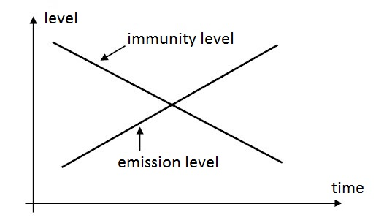
Figure 1: Natural evolution of emission and immunity levels
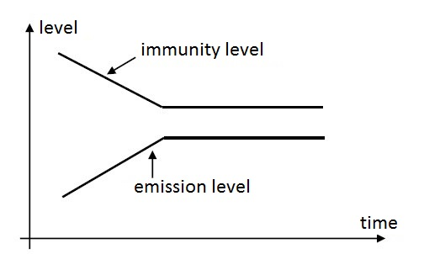
Figure 2: EMC-directives limit emission and immunity levels
The evolution visualised in Figure 1 illustrates that the emission level increases as a function of time and that the immunity level decreases as a function of time. At a certain instant of time, both curves intersect and (undesired) EMI occurs. In the EU, the EMC-Directive intends to avoid an intersection of the curves of Figure 1 by
- keeping the emission level sufficiently low,
- keeping the immunity level sufficiently high.
The EMC-directives intend to realise the situation visualised in Figure 2. The emission level is not allowed to exceed the immunity level and even a gap is needed between both levels. Legislations in other parts of the world (e.g. FCC in the US) tend to achieve the same goal.
Until now, we mainly emphasized that a first device is not allowed to disturb the proper operation of a second device. This is correct, but a device is also not allowed to disturb its own operation i.e. also this so-called ‘intra-system EMC’ is very important.
1.2: Emission
When talking about emission, it is important to make a distinction between conducted emission and radiated emission. An electronic device can emit disturbances using conductors (conducted emission) i.e. undesired currents are flowing in the conductors causing voltage drops. When the device is fed by the electrical power grid, a distinction can be made between
- harmonics (low frequent, multiples of the 50 Hz grid frequency),
- high frequent disturbances having frequencies higher than 9 kHz,
- changes in the voltage level of the power grid and flicker.
When considering a car, the electronic devices are generally fed by a battery providing a DC voltage. Cyber-Physical Systems (electronic devices, electrical loads) can also emit high frequent disturbances using the conductors which feed all loads with the DC voltage of the battery. Due to changes in the power consumption i.e. by changes in the consumed current, the supply voltage level changes. These changes in the voltage level can also have an impact on the operation of other devices.
An electronic device generally also accounts for radiated emission. The conductors and other components behave as antennas (transmitting aerial) causing radiated emission in the environment/atmosphere. Electromagnetic waves are emitted and these electromagnetic waves have an impact on other conductors and components which behave as receiving antennas. Due to the voltages generated by these receiving antennas, the proper operation of electronic devices can be disturbed.
1.3: Immunity
When considering immunity, it is also important to make a distinction between disturbances which propagate using conductors (immunity against conducted disturbances) and disturbances which propagate using the atmosphere (immunity against radiated disturbances).
When considering e.g. the battery power supply for the electronic devices in a car, immunity against changing supply voltage levels is important (e.g. voltage dips can occur). Also immunity against incident electromagnetic waves, magnetic fields and electrostatic fields is important.
Electromagnetic immunity indicates to what extent an electronic device (Cyber-Physical System) is able to withstand the influence of disturbances. In case the proper operation of the device is disturbed, there are a number of possibilities. Possibly, the proper operation is temporarily disturbed and the device behaves normal once the disturbances have disappeared.
The situation can be worse. Possibly, the device will not behave normal once the disturbances have disappeared. The device only behaves normal after resetting or switching off and on the device. The user must interact to restore the normal behaviour.
The worst situation occurs when the disturbances damage the device permanently i.e. a normal reset or switching the device off and on does not solve the problem. In such a situation, the device must be repaired or replaced.
Another criterion is the question to what extent the undesired behaviour of the device harms the safety of people (e.g. consider a medical device in a hospital but also a safety critical device in a car). Does the EMI related problem cause material damage and what are the consequences of this damage?
2: Automotive electronics
The number of electronic devices and components in a car is increasing fast which implies ever new EMC related challenges. A car contains power supply units, Electronic Control Units (ECU), connections to sensors and actuators, data communication networks…
When focusing on the communication needs, a distinction can be made between wired and wireless communication. Communication between different devices in one single car, communication between the car and road side infrastructure and also communication between different cars are needed.
Electronic Control Units are almost everywhere in a modern car. The engine control unit is a classical example but ECUs are also used to control transmissions, airbags, ABS systems, cruise control systems, electric power steering systems, audio systems, mirror adjustment systems, recharging systems for hybrid/electric cars…
The number of applications is ever increasing, we restrict ourselves to a limited number of examples.
- Auto start/stop system: A number of sensors (e.g. speed sensors, steering angle sensors, …) determine whether the engine can be shut down in order to save fuel and to reduce harmful exhaust gases.
- Hill-hold control: A tilt sensor detects the tilt of the car when standing on a slope. The wheels are kept clamped for a number of seconds after the driver has released the brake pedal.
- Rear park assist system: The system is useful while parking the car and engaging the reverse gear. By using ultrasonic sensors on the rear bumper, the driver is warned when other cars or objects are too close to the car.
2.1: Electronic Control Unit and EMC related aspects
Figure 3 visualises a block diagram of an Electronic Control Unit. Notice the power supply which is fed by a DC voltage source (e.g. originating from the battery) which can be highly volatile. This non constant DC voltage is converted into different voltage levels. Changes in the original DC voltage level are not allowed to impact the final voltage levels (i.e. they are constant). To change the voltage level, linear voltage controllers or switched DC/DC converters are possible. Although switched DC/DC converters (SMPS: Switching Mode Power Supply) have a higher efficiency and they also provide the possibility to boost the voltage level, they can be an important source of EMC related problems due to the switching of the semiconductors in the converter.
Common voltage levels needed for the digital circuits are 5V, 3.3V, 2.4V, 1.8V or even lower. When considering analog circuits, other voltage levels are more common. When considering sensors, voltages of 5V or 12V are quite common. When considering actuators, often higher voltage levels are needed (e.g. some fuel injectors need a voltage up to 200 V which is much higher than the original supply voltage).
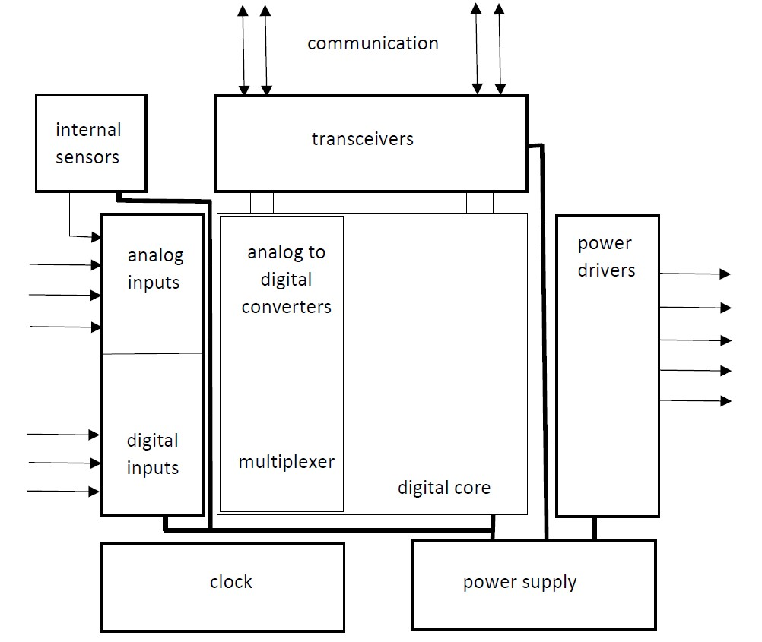
Figure 3: Block diagram of an Electronic Control Unit
Notice the presence of a number of sensor inputs interfacing with digital and analog sensors. When considering a modern car, the range of sensors is very broad: speed sensors, acceleration sensors, tilt sensors, rain sensors, temperature sensors, seat belt sensors, ultrasonic sensors to detect objects,… Multiplexers are needed to select the required sensors. Analog to digital converters (ADCs) are needed to convert signals originating from the analog sensors to digital signals which can be processed.
Power drivers are needed to drive a large range of actuators. Especially when considering the power drivers, care must be taken to drain off the heat losses. The power drivers also need much attention concerning EMC (especially from the point of view of emission requirements). Especially when high currents are switched large disturbances might be generated.
Figure 3 also visualises a number of transceivers which allow the Electronic Control Unit to communicate with other devices. Several communication protocols are possible, but the use of the CAN bus or FlexRay are common choices when dealing with electronic devices in cars (FlexRay is designed to be more reliable and faster than the more traditional CAN bus).
2.2: Clock signals
When considering an Electronic Control Unit as visualised in Figure 3, notice the presence of a clock needed to clock the microcontroller (belonging to the digital core) and other digital components. An ideal clock signal is a rectangular signal which often has a duty cycle of $50\%$. In real life a clock signal merely has as trapezoidal shape as visualised in Figure 4. Notice the rise time $t_{r}$ and the fall time $t_{f}$ (an ideal clock signal has rise and fall times which equal zero).
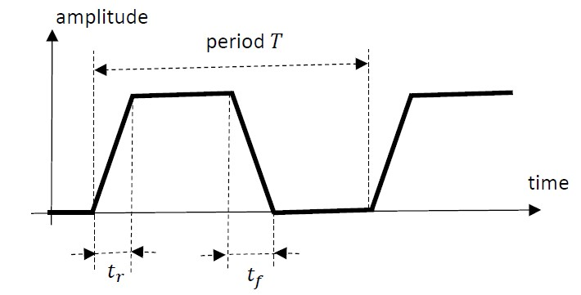
Figure 4: Clock signal
If the timing of the rising edge or the timing of the falling edge of the clock signal is not accurate, jitter occurs. Due to this jitter phenomenon, clocked digital hardware will act too early of too late. Figure 5 visualises a practical example where a processor reads data from a data bus at the positive edge of the clock. In case the ideal clock signal is used, the processors samples valid data from the data bus. In case jitter occurs, the processor samples the data too early i.e. data is sampled before it is valid. Electromagnetic interference can impair jitter which implies a higher risk that digital hardware will act too early of too late.
Additionally, electromagnetic interference can cause voltage spikes in the clock signal. These spikes can be misinterpreted as additional clock signal edges. Sometimes different integrated circuits (processors…) are hit in a different way by spikes implying a distortion of the global operation of the entire system.
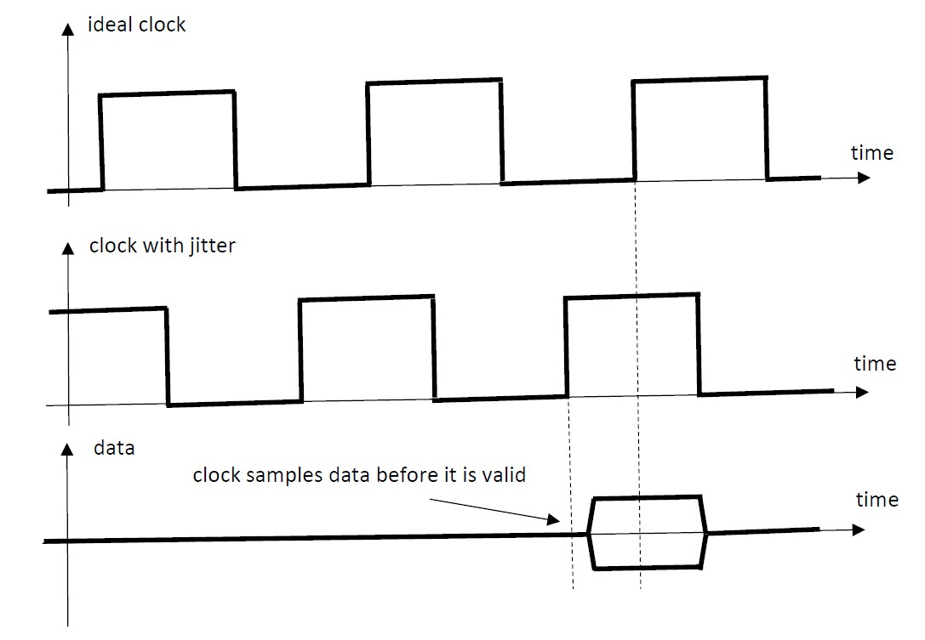
Figure 5: The impact of jitter when reading data
2.3: Analog sensors
The proper working of an Electronic Control Unit, as visualised in Figure 3, depends on information originating from analog and digital sensors. Automotive microcontrollers contain Analog to Digital Converters which convert the analog information originating from analog sensors to digital values. These digital values are stored in registers allowing to process the information. Quite often, the number of analog inputs is larger than the number of Analog to Digital Converters implying the need for analog multiplexers to select the appropriate sensor input.
When considering analog sensors, a distinction can be made between resistive sensors, capacitive sensors and inductive sensors. Especially resistive sensors are frequently used in the automotive industry. Resistive sensors convert a physical value (e.g. temperature, magnetic field strength, light intensity, …) into a resistive value.
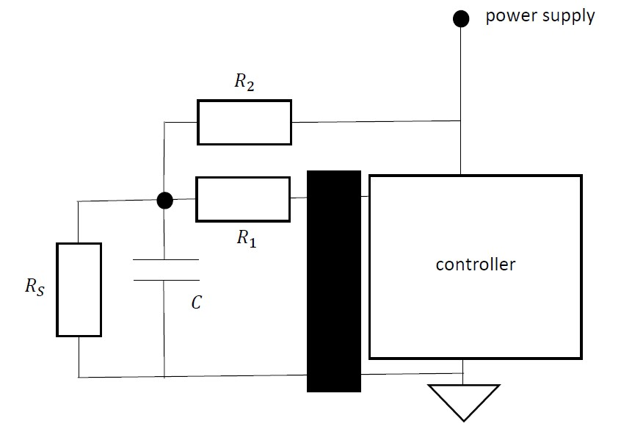
Figure 6: Analog input obtained by a resistive sensor
Notice in Figure 6 the resistive sensor providing a resistance $R_{S}$ which depends on the physical value which needs to be measured. Notice the resistance $R_{2}$ connected with the power supply and the resistive sensor $R_{S}$. A voltage divider obtained by $R_{2}$ and $R_{S}$ implies a voltage across $R_{S}$ which depends on the measured physical value. No real current is flowing in resistor $R_{1}$ since $R_{1}$ only intends to protect against voltages higher than the power supply. Notice also capacitor $C$ which diverts high-frequent disturbances (also burst pulses are diverted). The controller contains an ADC converting the input voltage across $R_{S}$ in a digital value which can be stored. Notice also the presence of additonal protection circuits (indicated by the black rectangle in Figure 6).
Capacitive sensors are less common when considering car electronics. Some engines have oil quality sensors where the oil quality has an impact on the permittivity. By measuring the capacitor value, the permittivity is obtained which gives information about the oil quality. Capacitive humidity sensors are also used implying e.g. the possibility to detect rain. Acceleration sensors can also contain capacitive micro-mechanical sensors (e.g. to be used in an airbag to detect a car crash).
Inductive sensors are, just like capacitive sensors, not that common when considering car electronics. Inductive sensors are used to measure e.g. the motor speed or the wheel speed. Using a permanent magnet and an induction coil, voltage pulses are induced. By counting these voltage pulses, information about the speed is obtained.
2.4: Digital sensors
Digital inputs are actually switches which are open or closed. By replacing the resistive sensor $R_{S}$ in Figure 6 by a switch, a digital input is obtained. Typical examples of digital switches in a car are brake pedal switches or door contact switches. From a broader point of view, bus interfaces are also digital outputs or inputs.
2.5: Power drivers
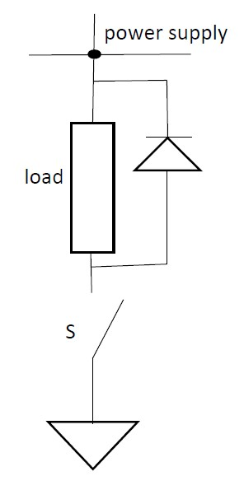
Figure 7: Power driver with actuator
Based on information originating from the input sensors and the communication with other devices, actuators are switched on or off by the Electronic Control Unit using a transistor. Bipolar transistors can be used but MOSFETs (Metal-Oxide-Semiconductor Field-Effect Transistors) are more common. In case of high-voltage applications, mainly IGBTs (Insulated Gate Bipolar Transistors) are used.
In case the transistor conducts (operates in saturation mode i.e. switch $S$ in Figure 7 is closed), the supply voltage is available across the actuator which is an electrical load. In case the transistor does not conduct (operates in cut off mode i.e. switch $S$ is open), no current is flowing in the load.
By opening and closing the switch $S$ with an appropriate duty cycle, a pulse width modulated voltage (PWM voltage) appears across the actuator (the load in Figure 7). By changing the duty cycle, the mean value of the voltage can be controlled.
2.6: Transceivers
It is important Electronic Control Units are able to communicate with other Electronic Control Units using a bus system. In general, data can be sent in both directions implying the need of transceivers (combining a transmitter and a receiver).
When considering a car, the communication buses are operating in a harsh envirmonment i.e. the bus systems face a lot of disturbances. For instance a CAN bus (Controller Area Network) is often used to communicate between automotive ECUs. In the next section, the main properties of the CAN bus will be considered. When considering this CAN bus, attention goes to the reliability of the communication and the robustness against electromagnetic disturbances. Alternatives for the CAN bus are the use of a MOST (Media Oriented Systems Transport) network or FlexRay.
3: The CAN bus
As already mentioned, the CAN bus is often used for data communication in the automotive industry. Attention goes to the reliability of the communication and the robustness against electromagnetic disturbances.
In general, data exchange between e.g. automotive ECUs is not based on analog signals. Analog signals are too sensitive to electromagnetic interference (EMI). Digital signals are used to transmit data. As long as the EMI amplitudes are rather small, the information in the digital signals remain unchanged. As the EMI amplitudes increase the bit error ratio BER increases. The bit error ratio BER is the ratio between the number of corrupted bits and the total number of bits.
In case the EMI amplitudes are rather small, the BER increases slowly as the EMI amplitudes increase. But when the EMI amplitudes exceed a threshold, the BER increases quickly. Finally no communication is possible anymore.
Bits are transmitted in adjacent groups called messages, packets or data frames. As the BER increases an increasing number of frames become erroneous. The majority of the protocols try to detect erroneous frames or even try to correct these erroneous frames. In case an erroneous frame is detected, the frame can be retransmitted or the data in that frame is simply omitted. For instance the CAN bus shuts down communication nodes which provide too many erroneaous frames.
3.1: Reducing EMI: electrostatic coupling
In order to reduce EMI related problems, a lot of serial buses use an UTP cable (Unshielded Twisted Pair), a coaxial cable or a STP cable (Shielded Twisted Pair). In order to understand the use of such types of cables, we consider the origin of electrostatic and magnetic coupling. We also study approaches to make the communication less vulnerable to disturbances.
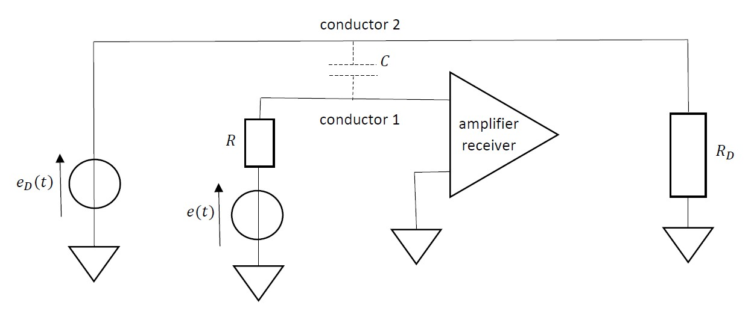
Figure 8: EMI based on electrostatic coupling
Consider the situation visualised in Figure 8. A voltage source $e\left(t\right)$ sends a signal to an amplifier or a receiver using a conductor (conductor 1). Analog and digital signals can be considered. In the proximity of conductor 1, other electric or electronic devices account for disturbances. The origin of these disturbances is modelled by the voltage source $e_{D}\left(t\right)$, the load $R_{D}$ and a conductor (conductor 2). Due to the presence of a parasitic capacitor $C$, the voltage source $e_{D}\left(t\right)$ has an impact on conductor 1. Actually, the input of the amplifier/receiver is obtained by applying the superposition theorem with $e\left(t\right)$ and $e_{D}\left(t\right)$.
In general, the parasitic capacitor $C$ is small. In case $e_{D}\left(t\right)$ contains steep slopes corresponding with high frequent components, the capacitor has for these high frequencies a low impedance implying these high frequent components of $e_{D}\left(t\right)$ are also applied at the input of the amplifier/receiver. When considering low frequent components, the small parasitic capacitor $C$ behaves as an open circuit implying these low frequencies have no impact on the amplifier/receiver.
Figure 9 visualises how the impact of $e_{D}\left(t\right)$ on conductor 1 and on the input of the amplifier/receiver can be reduced drastically. When having a shielding around conductor 1, the parasitic capacitor $C$ is situated between conductor 2 and that shielding. It is important the shielding around conductor 1 has a proper grounding.
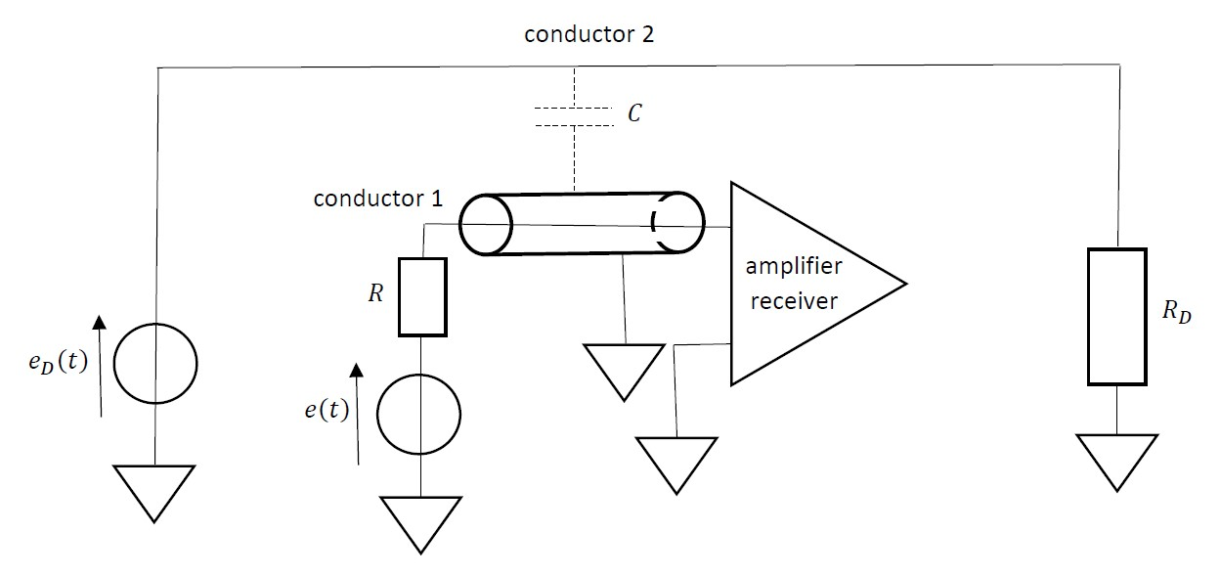
Figure 9: Reducing EMI based on electrostatic coupling
The behaviour of the configuration visualised in Figure 9 is visualised in Figure 10. Notice again the voltage source $e\left(t\right)$ which is connected with the input of the amplifier/receiver by conductor 1. Due to the grounded shielding, the parasitic capacitor $C$ connects $e_{D}\left(t\right)$ with the ground. This implies the impact of the high frequent components of $e_{D}\left(t\right)$ on conductor 1 and the input of the amplifier/receiver is avoided.
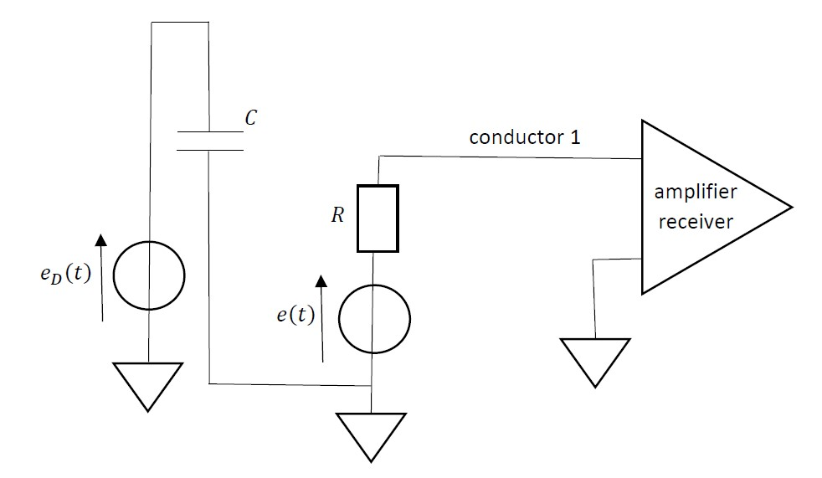
Figure 10: Reducing EMI based on electrostatic coupling
3.2: Reducing EMI: magnetic coupling
Consider the situation visualised in Figure 11. A voltage source $e\left(t\right)$ sends a signal to an amplifier or a receiver using a conductor 1. In the proximity of conductor 1, other electric or electronic devices account for disturbances. The origin of these disturbances is modelled by the voltage source $e_{D}\left(t\right)$, the load $R_{D}$ and conductor 2 where a current $i_{D}\left(t\right)$ is flowing. Due to the presence of a mutual inductance $M$, the current $i_{D}\left(t\right)$ has an impact on conductor 1. Actually, a voltage
$$M \frac{d i_{D}\left(t\right)}{d t}$$
is induced in conductor 1 as visualised in Figure 12.
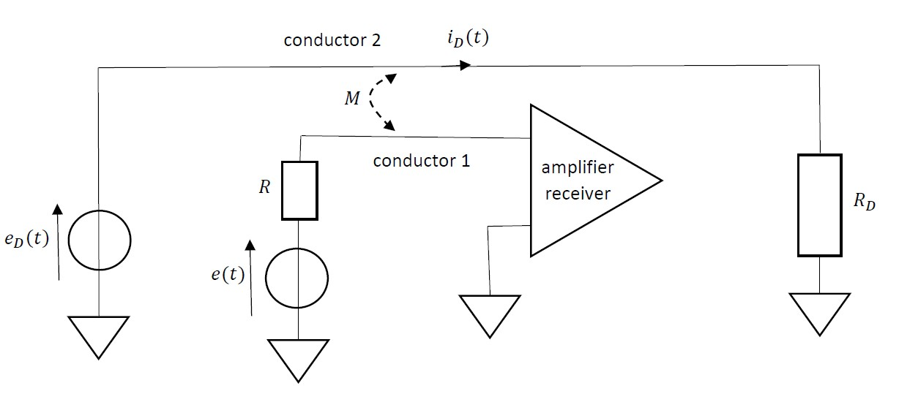
Figure 11: EMI based on magnetic coupling
Notice in Figure 12, the induced voltage is connected in series with the original voltage $e\left(t\right)$ and applied at the input of the amplifier/receiver. Especially the high frequent components in $i_{D}\left(t\right)$ have an impact since in general the mutual inductance $M$ is small.
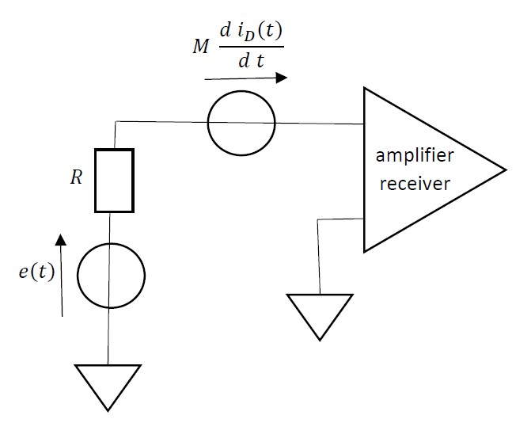
Figure 12: EMI based on magnetic coupling
The mutual inductance $M$ can be reduced by having a larger distance between conductor 1 and conductor 2. The impact of the mutual inductance can also be reduced by using two conductors between voltage source $e\left(t\right)$ and the input of the amplifier/receiver. It is very important to twist these two conductors (giving a twisted pair) as visualised in Figure 13. Notice the voltage
$$M \frac{d i_{D}\left(t\right)}{d t}$$
is induced twice, but taking the polarities into account both voltages cancel each other. Actually the voltages are induced in each loop and in each loop they cancel each other.
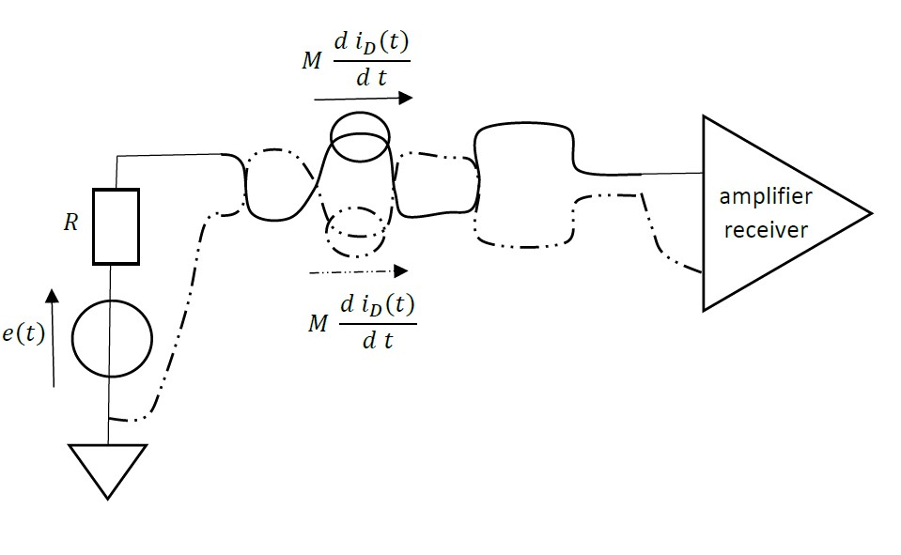
Figure 13: Reducing EMI based on magnetic coupling
Figure 13 visualises the use of an UTP cable (Unshielded Twisted Pair) which is often used in a CAN bus. The voltage $e\left(t\right)$ is a voltage generated by the transmitter and applied on the cable/bus. Notice at the other side of the CAN bus the receiver.
In case EMI based on electrostatic coupling and magnetic coupling needs to be avoided, a STP cable (Shielded Twisted Pair) can be used. Due to the shielding electrostatic coupling will be eliminated and due to the twisting magnetic coupling will be eliminated.
3.3: Physical layer of a CAN bus
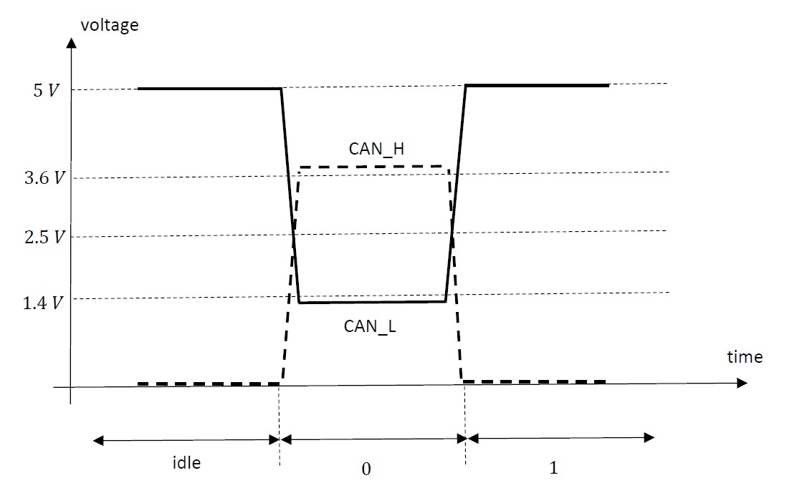
Figure 14: Voltage levels of the low-speed CAN bus
A CAN bus is a serial bus where EMI is reduced by using an UTP cable (Unshielded Twisted Pair) and by using differentially driven lines as visualised in Figure 14 for a low-speed CAN bus and Figure 15 for a high-speed CAN bus. Physically, the bus contains a CAN-high ($CAN_H$) wire and a CAN-low ($CAN_L$) wire.
Figure 14 visualises the physical layer of the low-speed CAN bus. An idle voltage corresponds with $0 V$ on the CAN_H and $5 V$ on the $CAN_L$. In case of a logical $0$, the CAN_H is pulled up to more than $3.6 V$ and the CAN_L is pulled down to less than $1.4 V$ which implies a differential voltage of more than $2.2 V$. In case of a logical $1$, a $0 V$ on the CAN_H and a $5 V$ on the $CAN_L$ is chosen in order to have a differential voltage of $-5 V$. In case of the low-speed CAN bus, the maximum data rate equals $125 kbit/s$.
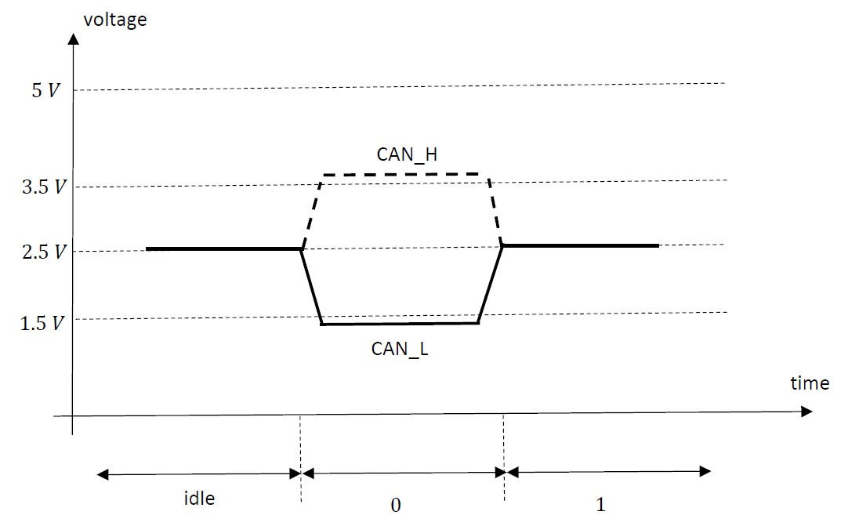
Figure 15: Voltage levels of the high-speed CAN bus
Figure 15 visualises the physical layer of the high-speed CAN bus. An idle voltage corresponds with $2.5 V$ on the CAN_H and $2.5 V$ on the $CAN_L$. In case of a logical $0$, the CAN_H is pulled up to more than $3.5 V$ and the the CAN_L is pulled down to less than $1.5 V$ which implies a differential voltage of more than $2 V$. In case of a logical $1$, a $2.5 V$ on the CAN_H and a $2.5 V$ on the $CAN_L$ is chosen in order to have a differential voltage of $0 V$. In case of the high-speed CAN bus, the maximum data rate equals $1 Mbit/s$ (but $500 kbit/s$ is more typical).
Notice the EMI of the CAN bus is reduced by using an UTP cable which reduces the impact of magnetic coupling. By using differentially driven lines, the impact of electrostatic coupling is reduced (i.e. normally no shielding is needed, no STP cable is needed ). In a few cases with high data rates (used for multimedia applications), a STP cable can be used.
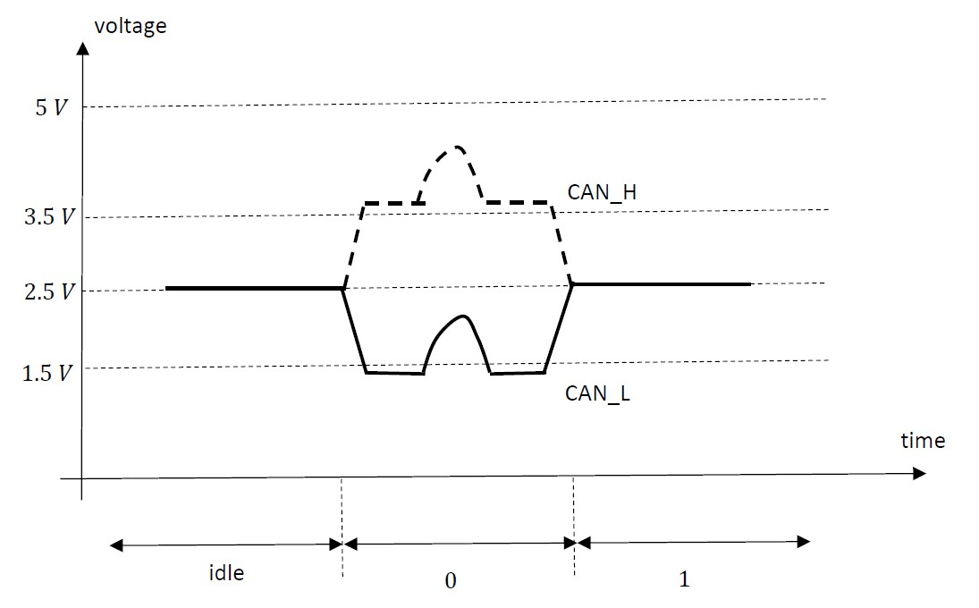
Figure 16: Voltage levels of the high-speed CAN bus in case of electrostatic coupling
Notice that in Figure 14 (low-speed CAN bus) and Figure 15 (high-speed CAN bus), differential voltages are used which are available between the twisted lines of e.g. the UTP cable. Since a differential voltage is used, the impact of electrostatic coupling is eliminated (or reduced considerably). As visualised in Figure 16, twice the same voltage has been induced having no impact on the differential voltage. Figure 16 visualises the situation of a high-speed CAN bus but an identical situation occurs in case of a low-speed CAN bus.
3.4: Transmitter, reciever and termination of a CAN bus
Figure 17 visualises a simplified version of a CAN bus containing a transmitter $Tx$ and a receiver $Rx$. In case the transmitter transmits a zero $0$, both MOSFETs will conduct. The upper MOSFET in Figure 17 is a P-channel enhancement MOSFET. In case a low voltage is applied to the gate G, a conducting P-channel is obtained i.e. the MOSFET will conduct and apply a high voltage to the $CAN_H$ wire. Due to the inverter, a high voltage is applied to the gate G of the lower MOSFET which is a N-channel enhancement MOSFET. The lower MOSFET will conduct and apply a low voltage to the $CAN_L$ wire. As visualised in Figure 15 (high-speed CAN bus), this implies indeed a zero $0$ is applied to the CAN bus.
In case the transmitter transmits a logic $1$, the MOSFETs will not conduct. The high voltage applied to the gate G of the upper MOSFET does not create a conducting channel i.e. the upper MOSFET will not conduct. Due to the inverter, a low voltage will be applied to the gate G of the lower MOSFET which does not create a conducting channel i.e. the lower MOSFET will not conduct. Since both MOSFETs do not conduct, the $CAN_H$ and $CAN_L$ wires both have a voltage level of $2.5 V$ which corresponds with a logic $1$ in Figure 15.
The applied signal propagates through the CAN bus to reach the receiver $Rx$ where the differential voltage is sent to a comparator. When receiving a logic $0$, the voltage level of $CAN_H$ is higher than the voltage level of $CAN_L$ implying a high voltage at the output of the comparator. Due to the inverter after the comparator finally a logic $0$ is obtained at $Rx$.

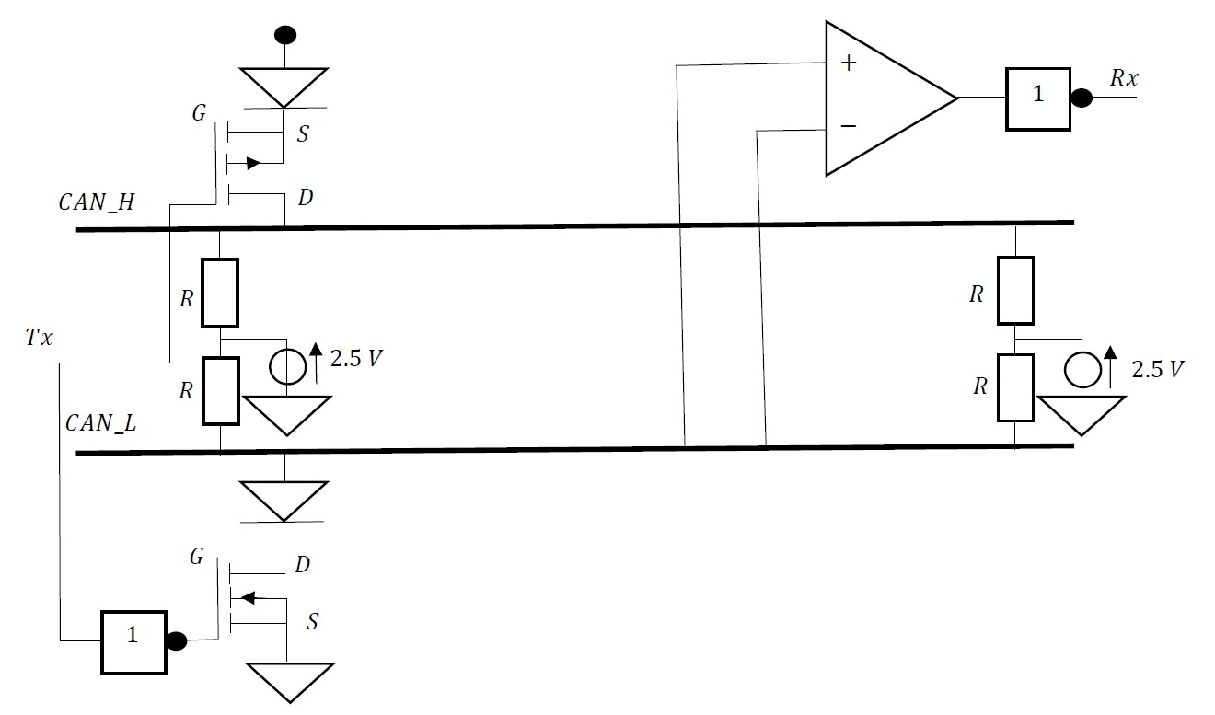
Figure 17: CAN bus with transmitter and receiver
Notice also the presence of termination resistors in order to avoid reflections since the CAN bus behaves as a transmission line. Termination resistors are available at both most distant points of the CAN bus. The characteristic impedance of this transmission line is about $120 Ω$ for a differential mode signal. Termination is obtaind by using two resistors $R=60 Ω$ at both distant points.
3.5: Data frames of a CAN bus
A discussion of the entire working principle of the CAN bus goes beyond the scope of the present text. But it is important to know that a number of bits are combined in a frame. Although there exist four types of CAN-frames, we will restrict ourselves to data frames intended to transmit data from transmitter to receiver.
A frame starts with a single start-of-frame bit which equals a logic $0$. A logic $0$ is dominant over a logic $1$. Indeed, consider the CAN bus of Figure 17 and assume two transmitters try to transmit a bit at the same time. If one of them transmits a logic $0$ and the other one transmits a logic $1$, finally a logic $0$ will be applied to the CAN bus. The transmitter which tried to transmit the logic $1$ is able to detect the dominant $0$ of the other transmitter. This dominance property is also crucial when the identifiers in the frame determine which frame has the highest priority.
A standard frame contains an identifier with a length of 11 bits. A lower identifier implies the frame has a higher priority (based on the dominance principle of the logic $0$). The identifier is followed by a remote transmission request bit. This bit equals $0$ in case of a data frame. The remote transmission request bit is followed by the identifier extension bit which is a logic $0$ in case an identifier of 11 bits has been used. The identifier extension bit is followed by a reserved bit which equals a logic $0$.
The reserved bit is followed by the data length code. The data length code needs 4 bits and mentions the number of data bytes in the data frame (4 bits are needed to have between 0 and 8 bytes). The data field contains finally the data bytes which need to be transmitted. The data field has a length between 0 and 8 bytes as indicated by the data length code.
After the data field, a CRC code (cyclic redundancy check) with a length of 15 bits has been included. This CRC code allows to detect errors in the data due to EMI related problems. A reliable data transmission is not only stimulated by using an UTP cable and using differentially driven lines but also by using this CRC code.
The data frame ends with a CRC delimiter (1 single bit), an ACK slot (1 single bit), an ACK delimiter (1 single bit) and finally an EOF (End-of-frame) having a length of 7 bits.
As already mentioned, immunity against EMI related problems is stimulated by using an UTP cable, by using a differentially driven bus and by using a CRC code. In case still something is going wrong, an ECU can warn other ECUs by using special error detection frames.
4: EMC design hints
When designing electronic devices, Cyber-Physical Systems (and Electronic Control Units in particular) in cars, it is a good attitude to respect a number of EMC design hints in order to reduce the emission levels and to increase the immunity levels.
4.1: A number of hints when designing a Printed Circuit Board and electronic circuits
When designing a PCB (Printed Circuit Board), it is important to have a low ground impedance and a low power impedance. A full plane is preferred above a single trace. A star-shaped power distribution network is preferred above a bus-shaped power distribution network. It is a good practice to have separate analog and digital parts.
It is important to keep loop areas as small as possible. Each conductor behaves as a loop in combination with its return conductor. When designing a PCB, the loop area is minimized by having a return trace which is close to the conductor. Remember an UTP cable, twisting the conductors is also an approach which reduces the loop areas as much as possible. By reducing the loop area, smaller voltages are induced since the time-varying magnetic flux in the loop becomes smaller.
When using capacitors, it is a good practice to keep the capacitor wires as short as possible. The capacitor wires behave as inductors in series (approximately $1 nH/mm$) with the actual capacitor. This implies the behaviour of a series RLC resonant circuit is obtained. When using surface mounted capacitors (SMDs) a smaller inductive behaviour is obtained. In case of a surface mounted capacitor, it is important to avoid stub traces to the capacitor since they also behave as inductors in series.
When using inductors, it is a good practice to avoid long wires in parallel. A parasitic capacitance is obtained between the inductor and the wire which implies a parallel resonant circuit is obtained. Actually, the use of inductors is often avoided. In general, inductors generate a magnetic stray field which couples into the neighbourhood. Only inductors with a closed magnetic loop (toroidal inductors) don’t generate a magnetic stray field. These toroidal inductors are expensive. Moreover, inductors are in general quite expensive and they account for a large volume and weight.
In order to reduce EMI, it is a good practice to keep a sufficiently large distance. By increasing the distance between components and conductors, the parasitic capacitance (as e.g. in Figure 8) decreases. By increasing the distance between components and conductors, the mutual inductance (as e.g. in Figure 11) decreases.
It is a good practice to keep subsystems separated from each other. Subsystems are kept separated from each other by using shieldings, filters and by keeping a distance between the subsystems.
When designing electronic circuits, it is a good practice to have knowledge of the frequencies which occur in the system. Some frequencies are desired but others are undesired. It is important to avoid overlaps in the frequency spectrums. If e.g. a specific frequency is used to realise data communication and there is a disturbance having the same frequency component then EMI will occur if the disturbance is too large. In case the frequency used to realise the data communication differs from the disturbing frequency, normally no EMI will occur.
When considering Figure 8 and Figure 11, the data communication is based on electrical signals. By replacing copper conductors with electrical signals by an optical communication channel, EMI can be avoided. Although optical communication is really robust with respect to electromagnetic disturbances there are also a number of drawbacks: installation problems, lack of standardisation, high cost. Also in case of optical communication, EMC related aspects of the transmitter and receiver must be taken into consideration.
4.2: Reducing the impact of electromagnetic waves in the far field
When considering an Electronic Control Unit in a car, they can have a closed metal case. The metal case helps to conduct heat but it also reflects impinging electromagnetic waves in the far field. Far field shielding is limited due to openings in the metal case. When having an electromagnetic wave with higher frequencies (i.e. having a smaller wavelength) the electromagnetic wave only needs smaller openings to enter. Especially the connectors account for openings in the metal case. Also important is the fact that the metal case generally consists of two halves which are joined together. When these halves do not overlap, a narrow but long slot/opening in the metal case is obtained allowing electromagetic waves to enter the metal case and disturb the behaviour of e.g. the Electronic Control Unit.
A closed metal case can be replaced by a plastic case but a thin metal layer can help to reflect the impinging electromagnetic waves in the far field.
5: Conclusions
When considering Cyber-Physical Systems in a car, a broad range of applications arise. In order to obtain a robust and reliable operation, EMC related aspects must be taken into consideration in order to obtain a sufficiently large immunity against a broad range of electromagnetic disturbances.
References
H. Balzer, P. Fischer, M. Lutz, J. Kappert, EMC: Immuniteitstesten en meetmethoden, De Muiderkring, Weesp, 1993 (in Dutch).
K. Borgeest, EMC and Functional Safety of Automotive Electronics, IET, Herts – United Kingdom, 2018, ISBN 978-1-78561-409-5.
J.J. Goedbloed, Elektromagnetische compatibiliteit, analyse en onderdrukking van stoorproblemen, Kluwer Technische Boeken B.V., Deventer – Antwerpen, 1990 (in Dutch).
H. Johnson, M. Graham, High-Speed Digital Design: A Handbook of Black Magic, Prentice Hall, Upper Saddle River, New Jersey, 1993, ISBN 0-13-395724-1.
A.S. Tanenbaum, Computer Networks, Prentice Hall, Upper Saddle River, New Jersey, 2003.
L. Tihanyi, Electromagnetic Compatibility in Power Electronics, IEEE Press, J.K. Eckert & Company Inc., Butterworth-Heinemann Ltd., Oxford, 1995.
References: websites
Clock signals and jitter: https://ilsiamerica.com/technical-information/mems-oscillator-terms-and-application-notes/clock-jitter-definitions-and-measurement-methods/
The CAN bus: https://en.wikipedia.org/wiki/CAN_bus

