Intelligent transport systems
1: Introduction
When discussing the future of the transport systems, often people focus on the use of hybrid and electric cars. When dealing with aircrafts and ships, people often focus on the use of the so-called more electric aircrafts and more electric ships. In general, the use of electric trains and electric trams is mature technology. And indeed, important changes are expected in the (near) future in an attempt to make the transportation sector greener (e.g. reducing harmful exhaust gasses and reducing CO₂ emissions).
People often forget other evolutions (or revolutions) in the transportation sector like the development of Intelligent Transport Systems ITS. By integrating electronic and ICT technology in cars, trains, trams, aircrafts or ships, a number of goals can be achieved. Especially when focusing on cars and trucks, engineers try to
- make the traffic on the road safer,
- reduce traffic jams,
- reduce the energy consumption while driving,
- combine the use of cars and trucks with the use of trains, trams, ships, aircrafts…
2: Industry 4.0 and Smart Cities
2.1: The industrial revolutions
The present state of the industry is the result of a number of important revolutions which occured in the past. The first industrial revolution started at the end of the 18th century. Due to the rise of steam engines (where mainly coal has been used as the primary energy source), a large scale mechanization of the industry appeared.
The second industrial revolution started at the end of the 19th century with the rise of electrical applications (in combination with the rise of the gas and oil industry). Linked with the second industrial revolution is not only the use of a new energy source like electricity but also the advent of new communication technologies like the telegraph and the telephone.
The third industrial revolution started at the end of the sixties or the beginning of the seventies of the previous century. Due to the rise of electronics (the use of transistors, the use of microcontrollers and microprocessors), due to the increased use of computers and telecommunication technology, new automation applications conquered the industry. Especialy the use of Programmable Logic Controllers (PLC) had a large impact on the industrial automation.
The fourth industrial revolution actually builds upon the third industrial revolution. This fourth industrial revolution and the term ‘industry 4.0’ are often used interchangeably. Others consider the term ‘industry 4.0’ as the subset of the fourth industrial revolution which deals with the industry. Anyhow, it is a technical revolution which is situated in the beginning of the third millenium and it is driven by the availability of the internet.
Due to the availability of the internet, industrial processes and machines are able to communicate and interact with each other in real time. A number of design principles are very important.
- Machines, devices, sensors and also people are able to communicate and interact with each other using the Internet of Things (IoT) or the Internet of People (IoP).
- Large amounts of useful data is available to the operators which allows them to make correct decisions.
- Humans are supported by assistance systems which not only provide but also visualise the (large amount of) data. This allows to make correct decisions in a short period of time i.e. it is possible to react sufficiently fast.
- Machines, devices, cyber physical systems are able to make decentralized decisions on their own. This increased autonomy of the machines implies only a limited number of decisions, problems, conflicts… need to be sent to a higher level.
The use of the new technologies supporting ‘industry 4.0’ applications in the industry are also useful in a much broader range. For instance the use of real time communication possibilities (including the use of mobile devices), the use of (smart) sensors, the use of location technologies, the use of decent human-machine interfaces, the use of cloud computing and cloud storage… also impacts the society outside the traditional industry. Here, the rise of Smart Cities is a good example.
2.2: Smart Cities
It is a worldwide evolution that an increasing number of people are living in the cities. It is a challenge to provide all these people homes, schools, libraries, hospitals, decent transport systems, water supply, electrical energy, decent waste management… Actually a large number of definitions exist for the ‘Smart City’ concept but by using electronic technologies, (smart) sensors, actuators, software, ICT technology, (big) data, internet connections… new applications arise. A large number of devices, buildings, vehicles and people need to communicate with each other (and the government) to provide, collect and use large amounts of data to make intelligent decisions.
Sometimes, six important aspects of a Smart City are considered.
- Smart Economy: Entrepreneurship, innovation and a flexible labour market can be stimulated.
- Smart People: A decent educational system providing people with social networks which participate in the public life.
- Smart Governance: A governance which stimulates the participation of the entire population and which operates in a transparant way is needed. The governance provides the required public and social services.
- Smart Environment: It is important the use of energy, water, food and other natural resources is restricted to a minimum. Decent waste management is needed to reduce environmental problems.
- Smart Living: People need decent homes and the city must be safe. Moreover, the governance must provide decent healthcare, cultural activities and stimulants to social cohesion.
- Smart Traffic and Traffic Infrastructure: By reducing traffic jams, by providing intelligent parking infrastructure, by integrating assistence in case of a (car) accident… smart mobility solutions arise.
Based on the evolutions and the approaches sketched above, the development of decent ‘Intelligent Transport Systems’ is embedded in a broad technical, economical and social context. In the next paragraphs, we will focus on possibilities and the technical aspects of these ‘Intelligent Transport Systems’.
3: Intelligent Transport Systems: global view
When dealing with ‘Intelligent Transport Systems’, two major goals arise. First, dealing with the increasing congestion of the roads which is a major problem in a lot of industrialised countries. Decent road infrastructure, including a sufficient number of roads with a sufficient number of lanes, is needed but will not be able to solve all problems. The congestion of the roads, including traffic jams, accounts for a tremendous loss of time causing a severe economical loss (loss of expensive working hours, loss of fuel, increased risk of accidents,…). Improving the road safety for all road users is a second major goal. To reach these goals a wide range of combined approaches are needed.
3.1: Reducing the congestion of the roads
There exist a number of ways to reduce the congestion of the roads. By supplying correct and real-time traffic information to the (potential) drivers, they are able to choose the most appropriate route to the destination. Alternatively, the potential driver can be informed about alternative choices like using public transport (tram, bus, train,…). The traffic information needs to include correct information concerning the infrastructure works on the roads (including repair and maintenance works).
In order to reduce the congestion of the roads, car-pooling is also an option which can be supported by ICT based tools.
In case the driver looks for a parking lot, real-time information concerning the available nearby parking lots avoids a useless and inefficient search for a parking lot. Inefficient searches for parking lots account for an important loss of time (for the driver and the passengers), account for energy losses (useless fuel consumption) and have a large and disturbing impact on the traffic load. Notice that real-time information concerning the most nearby parking lot requires
- real-time knowledge of the position of the car (GPS system) which needs a parking lot,
- real-time communication between the car and a data center which needs to have real-time information about the free parking lots.
Information concerning available parking lots is not only useful for private cars, it is also useful for trucks. Finding a decent parking lot is mandatory for the truck drivers in order to be able to respect the drive and rest times imposed by law in a lot of countries.
3.2: Improving the road safety
In order to improve the safety of all vehicles on the road, several approaches can be combined. A modern car already has a lot of mechatronic devices which improve the safety of the car.
- Airbag system which contains an accelerometer: In case of a car accident, a large (negative) acceleration will be measured. This measurement data is used to conclude an accident happens and the airbag will be opened to protect the car driver and the passengers.
- Anti-lock breaking system (ABS): The ABS system operates by preventing the wheels of the car from locking up while braking (e.g. during an emergency braking). Achieving a smaller stopping distance (although not always realistic) is a good property but it is especially important to improve the steering control of the car.
- …
By integrating real-time communications between nearby cars (and possibly other road users like cyclists), accidents can be avoided. Suppose a second car is driving after a first car. Suppose the first car performs a sudden braking since the first car driver tries to avoid hitting a pedestrian (it can be a child crossing the road). In case the first car sends a message to the second car behind him, it is possible to warn the driver of the second car as fast as possible. In case the driver of the second car does not respond sufficiently fast, his car can perform an automatic emergency brake.
The presence of nearby but invisible cars (e.g. invisible due to an obstacle) can be detected which avoids collisions. Especially when the visibility is low due to fog, detecting nearby cars is very useful. Real-time communication between the car and traffic infastructure can be useful to prevent the car driver from errors. For instance, when the car reaches a red traffic light and the car does not slow down, it is useful to warn the car driver. Possibly, the car performs an automatic brake due to the red traffic light.
In case still an accident happens (which can e.g. be detected by the activation of the airbag system), the car automatically sends an emergency call to the emergency services. The emergency services have information about the location of the accident and the type of car (or cars) involved in the accident. Possibly a personal communication by the car driver (or passenger) and the emergency services provides extra information. But also without such a personal communication, the emergency services are able to send help (e.g. an ambulance) much faster which can be lifesaving (time reductions up to 50% are considered to be realistic). The implementation of such an automatic communication with the emergency services requires the collaboration of all actors: car manufacturers, telecom providers, emergency services.
In case of an accident, it is not only useful to send information to the emergency services. By sending real-time information to nearby car drivers additional accidents, including chain collisions, can be avoided.
4: Wireless communication
In order to reach the goals sketched in the previous sections, a lot of communication is needed. A distinction can be made between radio-frequent communication and optical communication.
- Radio frequent communication (using electromagnetic waves) can use several frequency bands but in the present appplications a distinction can be made between the VHF band (Very High Frequency band: frequencies from 30 to 300 MHz corresponding with wavelengths of 10 m to 1 m), the UHF band (Ultra High Frequency Band: frequencies from 300 to 3000 MHz corresponding with wavelengths of 1 m to 10 cm) and the SHF band (Super High Frequency Band: frequencies from 3 GHz to 30 GHz corresponding with wavelengts of 10 cm to 1 cm). Wireless communication standards like ZigBee, Bluetooth, Wi-Fi, UWB and CALM are important options.
- Optical communication often uses near-infrared light i.e. infrared light with wavelengths approximaly ranging from 700 nm to 1400 nm (frequenties between 215 THz and 430 THz). The wavelength range of near-infrared light depends on the technical and scientific field of expertise but it is the part of the infrared region which is nearest to the visible light region (wavelengths approximately ranging from 620 nm to 380 nm corresponding with frequencies ranging from 400 THz to 789 THz).
When dealing with wireless communication in the transport sector, a distinction can be made between transactions among vehicles (V2V: vehicle to vehicle communication), transactions between vehicles and infrastructure (V2I: verhicle to infrastructure communication) and transactions between vehicles and hand held devices (V2D: vehicle to hand held device communication). Additionally, also communication is needed between several sensors and components inside one single vehicle i.e. in-vehicle communication.
4.1: Radio frequent wireless communication
In order to introduce intelligence in the transport sector, wireless sensor networks are really needed. The nodes of the wireless sensor networks contain fixed nodes (stationary nodes originating from mainly infrastructure) and mobile nodes (moving nodes attached with vehicles). The wireless sensor network is time-dependent since the nodes attached with the vehicles not only move, they also enter and leave the network.
To realise radio frequent wireless communication, several technologies are available and each technology has a number of properties, advantages and disadvantages. When comparing Zigbee, Bluetooth, Wi-Fi, UWB and CALM a number of conclusions can be made (inspired by the paper of K. Selvarajah et al.).
- Zigbee:
  - Useful to realise in-vehicle, vehicle to vehicle and vehicle to infrastructure communication.
  - A frequency of 2.4 GHz is used (also other communication frequencies exist).
  - A network range up to 100 m is realistic.
  - A bandwidth of 250 kbps is realistic which is small in comparison with the other technologies.
  - In general the power consumption is low and it is also a low cost solution.
  - When comparing with Bluetooth, the Zigbee technology can accomodate a larger number of devices.
- Bluetooth:
  - Useful to realise in-vehicle communication.
  - Similar with Zigbee, a frequency of 2.4 GHz is used.
  - A network range up to 70 m is realistic.
  - A bandwidth of 12 Mbps is realistic which is higher than the bandwidth obtained when using Zigbee.
  - In general, more power is consumed in comparison with Zigbee.
- Wi-Fi:
  - Useful to realise vehicle to vehicle and vehicle to infrastructure communication.
  - Similar with Zigbee and Bluetooth, a frequency of 2.4 GHz is used.
  - A network range up to 100 m is realistic.
  - A bandwidth of 54 Mbps is realistic which is higher than the bandwidths obtained when using Zigbee or Bluetooth.
  - In general, Wi-Fi consumes more power than Bluetooth (which comsumes more power than Zigbee).
- UWB:
  - Ultra Wide Band is useful to realise in-vehicle, vehicle to vehicle and verhicle to infrastructure communication.
  - A frequency of 3.1 GHz is used.
  - A more limited network range of only 20 m is obtained.
  - A large bandwidth of 1000 Mbps is used i.e. it is useful to realise multimedia networking.
- CALM:
  - Useful to realise verhicle to vehicle and vehicle to infrastructure communication.
  - A frequency of 5.8 GHz is used.
  - A larger network range of 1000 m is obtained.
  - A bandwidth of 54 Mbps is realistic (comparable with Wi-Fi).
  - The CALM technology consumes quite a lot of power.
4.2: Radio frequent wireless communication on the road
Research projects, performed by the academic world and the industry, are gathering experience concerning radio frequent wireless communication on the road. The paper of K. Selvarajah et al. (see reference) desribes experiences gathered by the so-called ASTRA project. In the ASTRA project, a number of Crossbow MicaZ modules are used to allow radio communition using Zigbee. Such a module contains several components like an Atmel processor, memories, batteries… The modules are also equipped with an antenna to realize wireless Zigbee communication and an expansion connector to connect with sensor boards (which can contain sensors used to measure light intensity, temperature, barometric pressure, acceleration, …).
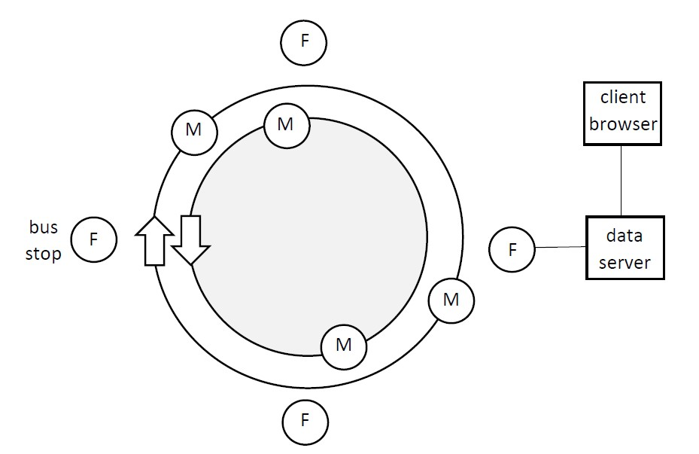
Figure 1: Experimental setup in the ASTRA project
Experiments (see Figure 1) have been performed in Newcastle close to the Central Station i.e. in a real life environment where radio wave reflections occur due to buildings and a broad range of objects. Figure 1 shows a simplified view of the experiment. A number of vehicles are driving along the road (in different directions) and their modules are mobile like the vehicle (indicated by an encircled M in Figure 1). There are also a number of fixed modules (e.g. attached to a bus stop) which are indicated by an encircled F in Figure 1.
The experiment in Newcastle allowed to test vehicle to vehicle communication (communication between a first moving module visualised by an encircled M and a second moving module). The experiment allowed to test vehicle to infrastructure communication (communication between a moving module and a fixed module visualised by an encircled F).
Due to the limited communication range of Zigbee and the larger distances between the fixed modules, it is unlikely the fixed modules are always able to communicate with each other directly. The fixed modules need to communicate indirectly with each other using the moving modules while they are sufficiently close to the desired fixed module. Also communication between the moving modules is possible when they are sufficienly close to each other.
The ability of modules to communicate with each other does not only depend on the distance. Radio reflections and interference can have an important impact on the link quality during the communication. The impact of a number of parameters on the link quality have been investigated.
- When increasing the power level of the transmitter, in general the range increases and the number of lost data packets decreases (but increasing the power level can also stimulate undesired reflections).
- The impact of the weather is limited but an increase of the range is noticed at lower temperatures.
- When using thicker materials to pack, more absorbtion of the radio waves occurs. This implies a lower signal strength and a smaller range.
- Reflections due to buildings and other objects can have a positive or a negative impact on the performance of the radio communication.
- The communication range can increase (and the data packet loss can decrease) by increasing the height of the radio modules.
- The orientation of the antennae has an impact on the recieved signal strengths and on the data packet loss.
4.3: Combining radio frequent wireless communication and near-infrared optical communication
Developing a reliable vehicle to vehicle communication or a reliable vehicle to infrastructure communication is not that easy. By combining radio frequent wireless communication and near-infrared optical communication a much higher reliability can be obtained.
Figure 2 shows a situation where a road sign detection system intends to increase the safety of the car driver and the passengers. In a traditional situation, the driver is expected to see the road sign without any technical assistance. In Figure 2, the road sign is equipped with a radio frequent broadcaster and a near infrared optical emitter. The car is equipped with a radio frequent receiver and a near-infrared optical receiver. This allows to warn the driver of the presence of the road sign. Indeed, the information received by the radio frequent receiver and/or the near infrared optical receiver is processed by an on-board computer which allows to warn the driver (e.g. by visualising the road sign on the dashboard of the car). This warning is useful in case the driver does not see the road sign due to e.g. bad weather conditions, objects blocking the view, distraction of the driver…
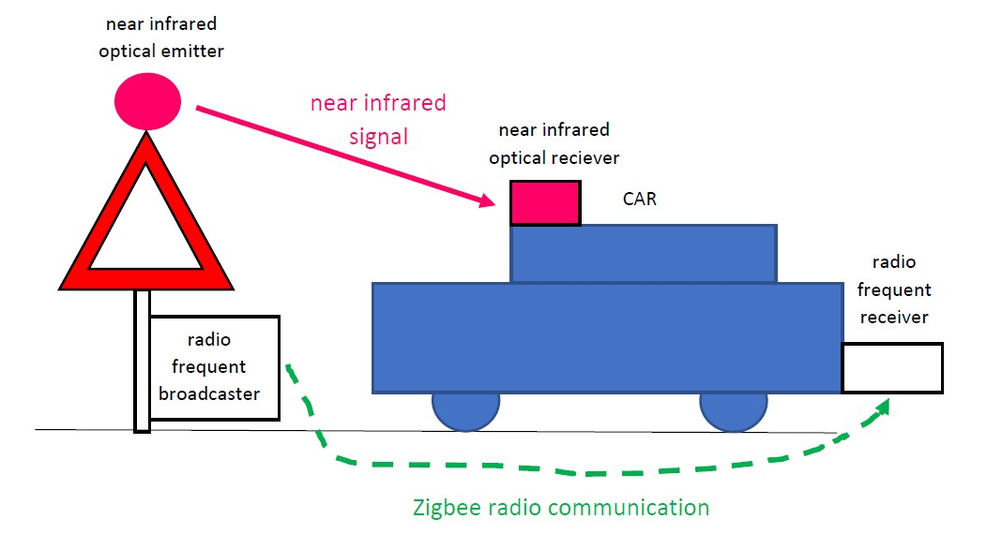
Figure 2: Infrastructure to vehicle communication
Quite often, the near-infrared receiver picks up the signal prior to the radio frequent receiver. In such a situation, the radio frequent signal is a confirmation of the information picked up before by the near-infrared reciever. In some cases (e.g. in case of a bend), the radio frequent signal is received prior to the near-infrared signal. In some other cases (e.g. in case of a visual obstacle), possibly only the radio frequent signal is received.
Possibly, the near-infrared signal has a larger range than the radio frequent signal. But e.g. in case of really sunny weather, the radio frequent signal often has a larger range. It is also interesting to observe that, in general, the near-infrared communication performs better when the car is travelling at a high speed. The radio frequent communication generally performs better when the car is travelling at a low speed. All these observations show that both technologies complement each other.
Related with the complementarity of both technologies, additional aspects appear. In case of radio frequent communication, it is difficult to detect the location and the direction of the detected object. In case of near-infrared communication, it is easier to detect the direction of the detected object (but the communication is susceptible to visual obstacles).
It is also important to avoid false detections of a warning. In case of an optical detection sensor, possibly a false detection occurs due to unappropriate weather conditions. For instance in case of really sunny weather, reflections on the road can erroneously be identified as an object (e.g. a road sign).
In case of radio frequent communication, a false detection can occur due to a car travelling in the opposite direction. In case of radio frequent communication, it is difficult to detect the direction/position of the broadcaster. Several examples of undesired behaviours exist. When a car, driving in the opposite direction, communicates about a braking action no action is needed. But due to the reception of the braking message, possibly a dangerous and unnecessary braking reaction will follow. The combination of different communication technologies helps to avoid false detections.
5: A broad range of applications
When dealing with Intelligent Transport Systems the number of applications is practically unlimited. A number of applications have already been discussed, including some technical background. In the present paragraph, some other applications will be discussed shortly.
5.1: Vehicle to infrastructure communication by emergency vehicles
In case of an emergency, emergency vehicles (ambulances, police cars, fire trucks, …) need to reach their destination as fast as possible. To reach that goal, they are allowed to neglect red traffic lights which is actually quite dangerous. In case an emergency vehicle sends a signal to the nearby traffic lights, the traffic lights give priority to that emergency vehicle by giving a green signal to that emergency vehicle.
5.2: Transportation of dangerous goods
When dealing with safety related aspects of the road traffic, the transport of dangerous goods using trucks needs attention. Trucks are used to transport flammable liquids, gases (compressed, liquefied or dissolved under pressure), corrosive materials,… It can be a good practice to monitor and manage in real time trucks transporting these dangerous goods.
A Transport Integrated Platform (TIP) typically consists of four sub sytems: an on board unit, a transmisson system, a database and a GIS based application.
The on board unit contains, mainly on the trailer of the truck, a number of sensors. These sensors measure important parameters giving information concerning the transported load (e.g. temperature, pressure,…). The measurement data originating from the sensors are collected and processed. The truck also contains a GPS antenna to have information concerning the location of the truck. Information is also available from the odometer but e.g. also the speed and the direction of the truck is known.
The truck has a GPRS transmitter/receiver which allows to transmit real-time data (or information is transmitted e.g. every 5 minutes) to a remote server. Actually, different technologies can be used to transmit the data since signal loss can occur due to GSM uncovering in some areas (e.g. satellite communication is a possibility).
The transmitted data is collected in a database. Efficient and reliable storage of the data is needed. The data must be available for diagnostic activities. A Geographical Information System (GIS) analyses the data and displays them in a graphical way. The graphic interface allows scalability and allows an operator to retrieve the information. For instance, a control room allows a real-time monitoring of the trucks. The control room is able to communicate with the truck drivers during day and night. The control room contains tools for managing alarms and anomalies which are detected during the transport.
References
B. Arief, A. von Arnim, TRACKSS Approach to Improving Road Safety through Sensors Collaboration on Vehicle and in Infrastructure, Proceedings of the 2nd IEEE International Symposium on Wireless Vehicular Communications (WiVeC 2008), Calgary, Canada, September 21-22, 2008.
M. Benza, C. Bersani, M. D’Incà, C. Roncoli, R. Sacile, A. Trotta, D. Pizzorni, S. Briata, R. Ridolfi, Intelligent Transport Systems (ITS) applications on dangerous good transport on road in Italy, 7th International Conference on System of Systems Engineering (SoSE), Genova, Italy, July 16-19, 2012.
E. Felici (author), D. Pieters (red), Intelligent Transport Systems (ITS), Agentschap NL – Ministerie van Economische zaken (retrieved from https://www.rvo.nl/sites/default/files/Intelligent%20Transport%20Systems.pdf)
Intelligent Transport Systems (ITS) for Road, Innovation and Networks Executive Agency (INEAA) of the European Commission (retrieved from https://ec.europa.eu/inea/sites/inea/files/2016_cef_h2020_its_trifold_web.pdf)
K. Selvarajah, B. Arief, A. Tully, P. Blythe, Deploying Wireless Sensor Devices in Intelligent Transportation System Applications, Intelligent Transportation Systems, Dr. Ahmed Abdel-Rahim (Ed.), ISBN: 978-953-51-0347-9, InTech, Available from http://www.intechopen.com/books/intelligent-transportation-systems/deploying-wireless-sensor-devices-in-intelligent-transportation-system-applications
A. Tully, Pervasive tagging, sensors and data collection: a science and technology review for the foresight project on intelligent infrastructure systems, IET Intelligent Transport Systems, vol. 153, pp. 129-146, 2006.
A. von Arnim, M. Perrollaz, A. Bertrand, J. Ehrlich, Vehicle Identification Using Near Infrared Vision and Applications to Cooperative Perception, Proceedings of the 2007 Intelligent Vehicles Symposium, pp. 290-295, Istanbul,Turkey, June 13-15, 2007
References: websites
Crossbow MICAz Wireless system: http://www.openautomation.net/uploadsproductos/micaz_datasheet.pdf
Industry 4.0: https://en.wikipedia.org/wiki/Industry_4.0
Smart Cities: https://en.wikipedia.org/wiki/Smart_city
Smart Cities: https://3bplus.nl/wat-een-smart-city-slimme-stad-een-introductie and https://3bplus.nl/technologie-een-smart-city-sensoren-iot-en-big-data
The four industrial revolutions: https://www.sentryo.net/the-4-industrial-revolutions/

