The impact of electrical vehicles on the power grid
1: Introduction
At present, the use of cars equipped with an internal combustion engine dominates the modern society. But concerns about greenhouse gas emissions (like $CO_{2}$), air pollution in mainly urban areas and also the dependency on the use of fossil fuels pushes the society to look for alternatives.
One of these alternatives is the use of electric cars where the power electronic devices and the traction motors are fed by a battery (or alternatively a fuel cell). The limited energy density when battery energy storage is used, discourages the breakthrough of full electric cars. In order to increase the range of the car, hybrid electric cars/vehicles have been developed.
A hybrid electric car combines the use of an electrical traction motor and an internal combustion engine. Due to the compact energy storage when using e.g. diesel or gasoline a large range is obtained. The battery fed electrical motor can e.g. provide additional torque when accelerating the car. Possibly, the electrical motor drives the car when maken shorter trips or when using the car in an urban area.
In a hybrid vehicle (hybrid electrical vehicle: HEV), the battery can be charged by using the traction motor as a generator which is driven by the combustion engine. In such a situation, the energy stored in the battery originates from the diesel or gasoline tank. A plug-in hybrid electrical vehicle (PHEV) is a hybrid vehicle having a larger battery. By making a connection with the electrical power grid, energy from that power grid is used to load the battery. Full electrical vehicles also need the power grid to charge the battery (battery electrical vehicle: BEV).
In the present text, we use the abbreviation PEV to describe a plug-in electrical vehicle. Two types of PEV can be considered: a PHEV and a BEV.
With a limited amount of PEVs, PHEVs and BEVs, the impact on the electrical power grid is limited. But when the numbers of PEVs, PHEVs and BEVs are increasing, their impact on the electrical power grid is also increasing. This impact will be studied here because the power grid must be prepared to face these challenges. The impact on the electrical power grid contains a number of different aspects:
- When considering the power balance of the grid, it is important the generated and the comsumed power equal each other (here neglecting the heat losses in the grid): more precisely $P_{gen}=P_{cons}$.
- The PEVs are connected with the low voltage distribution grid. In case single phase connections are used to charge the battery of the car, it is important the charging cars are spread amoung the three phases to obtain a more or less symmetric load of the three phase grid.
- The PEVs account for an additional load of the low voltage grid. This implies an impact on the load of the distribution transformer and the feeders of the grid. Due to the higher current levels, more heat losses occur. Moreover, the larger current accounts for voltage drops which affect the resulting voltage levels in the grid.
- In general, the battery charger accounts for non sinusoidal currents which are extracted from the power grid. Indeed, a battery charger is a nonlinear load as it contains a power electronic converter. Due to the grid impedance, these non sinusoidal currents account for non sinusoidal voltage drops and non sinusoidal voltages at the nodes of the grid. Fourier analysis shows these non sinusoidal currents and voltages can be considered as the sum of a $50 Hz$ first order harmonic and higher order harmonics i.e. harmonic pollution of the grid occurs.
In literature, a large amount of information is available. Different researchers also show different, often complementary, approaches to face the technical challenges of the power grid. In the present text, we will mainly consider two papers which are available in literature. When more detailed information is needed, consult the original papers and the references mentioned in these papers.
2: Impact of PEVs on the distribution grid: paper 1
2.1: Initial situation
The paper “Assessment of Plug-in Electric Vehicles Charging Impacts on Residential Low Voltage Distribution Grid in Hungary” by H. Ramadan et al. considers a case study with a low voltage grid which is available in Budapest (Hungary). The structure of the grid is visualised in Figure 1.
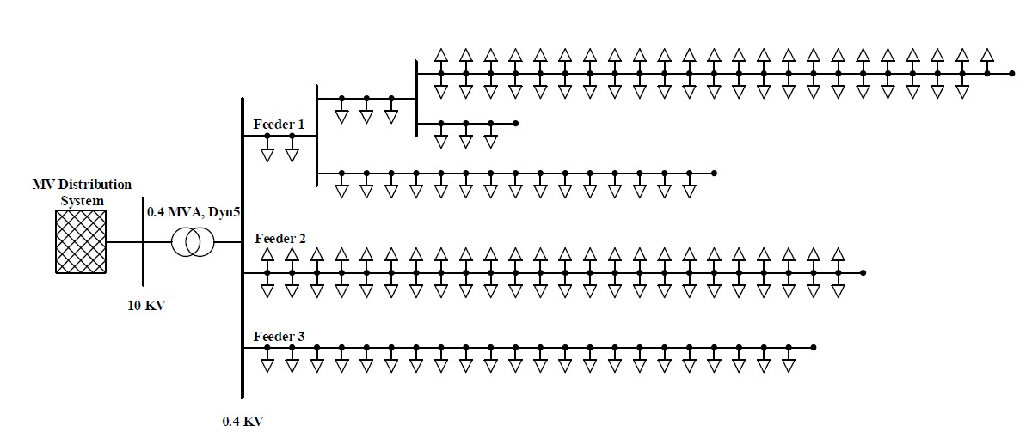
Figure 1: Power grid localized in Budapest (source: Ramadan et al.)
The power grid is a radial three phase distribution grid. Line voltages of $400V$ are available in combination with phase voltages of $231V$ between a phase conductor and the neutral conductor. Without the charging points of the PEVs, a total of 139 residential loads are available. These residential loads are single phase loads and they are evenly distributed to the three phases. The average daily load profile of these loads is visualised in Figure 2.
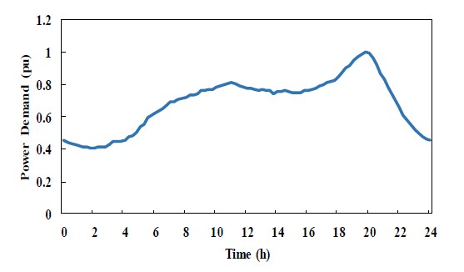
Figure 2: Average daily load profile (source: Ramadan et al.)
Figure 2 visualises the average daily load profile in per unit of the grid visualised in Figure 1. Notice a real peak consumption around 8pm and a smaller peak consumption around 11am. During the night, the power consumption is small in comparison with the consumption during the day.
A load profile as visualised in Figure 2 depends on a number of parameters among which:
- A distinction can be made between load profiles visualising the power distributed by low voltage grids (feeding a large number of small loads) and the total power consumption of e.g. a country. The latter also includes the power consumption of e.g. large industrial factories.
- Load profiles are country dependent.
- Load profiles depend on the climate and the season. When the weather is warm, people use airconditioning to keep the living rooms cool. When the weather is cold, people use electrical heating.
- Load profiles are influenced by the dominant culture and religion (e.g. different religions have different rest days and during a rest day the electrical energy consumption is lower since industrial factories consume less energy).
2.2: Additional power consumption by PEVs
In the paper of H. Ramadan et al., the battery of the PEV is loaded by a $3.3 kW$ single phase charger. The charging is performed with a constant $3.3 kW$ power at home. The energy $E_{C}$ needed to fully charge the battery depends on the initial SOC (State of Charge) of the battery, the total energy storage capacity $C$ and the efficiency $η_{charger}$ of the battery charger. More precisely
$$E_{C}=\left(1-\frac{SOC}{100}\right).\frac{C}{η_{charger}} .$$
The SOC represents the remaining energy in the battery when plugging in the car. This happens when the car driver returns at home after a drive. Due to different driving distances, different SOC values are encountered and this is probabilistic data. A typical probabilistic density function of the battery SOC when the charging starts, is given in Figure 3. Notice in Figure 3 that approximately one third of the cars have an initial SOC of about 50%. Almost no cars have empty batteries or full batteries at the end of the day.
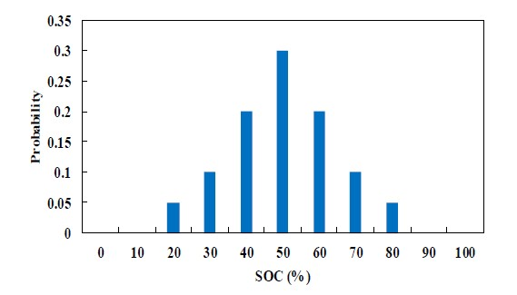
Figure 3: Probability density function of battery SOC (source: Ramadan et al.)
A distinction is made between uncoordinated charging of the batteries and delayed (or coordinated) charging of the batteries. In case of uncoordinated charging, the PEV starts charging when the driver arrives home having finished the last journey of that day. Journey arrival data can be obtained from transportation reports (when considering the USA, the National Household Travel Survey (https://nhts.ornl.gov/) provides a lot of information). Figure 4 visualises PEV’s arrival time according to NHTS-2009. People mainly arrive home in the early evening.
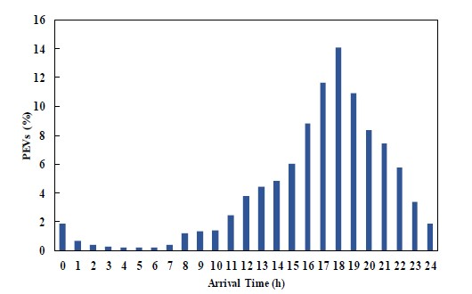
Figure 4: PEV’s arrival time (source: Ramadan et al.)
2.3: Uncoordinated charging
In case of uncoordinated charging, the arrival times of Figure 4 determine when the battery charging starts. Especially between 5pm and 7pm, a lot of cars start charging their batteries which has an impact on the total daily load profile. Such a total daily load profile is visualised in Figure 5.
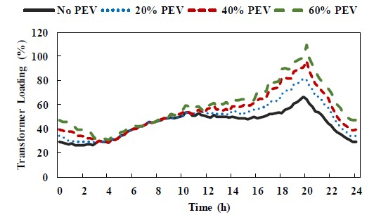
Figure 5: Transformer loading with uncoordinated charging (source: Ramadan et al.)
The total daily load profile gives the evolution of the power provided by the Dyn distribution transformer in Figure 1. The penetration level of the PEVs is important. When no battery charging occurs, the load profile of Figure 2 obtained. Especially when the penetration level is increasing, the impact on the power grid is also increasing. This consideration leads to the study of three penetration levels: 20%, 40% and 60%. In the afternoon and especially during the evening, addtional power consumption occurs. In the late night and the early morning, almost no vehicle charging occurs.
When considering the electrical power generation and the use of all grid components, it is preferable to have a more or less constant load profile i.e. the ratio between the maximum power consumption and the minimum power consumption approaches $1$ as much as possible. When considering the original load profile (without car battery charging) the ratio between the maximum and the minimum power consumption approximately equals $2.5$. Due to the uncoordinated charging of the batteries, the ratio between the maximum and the minimum power consumption increases and approximately a value of $4.5$ is obtained in case of a 60% PEV penetration level. Indeed, during the night when the minimum power consumption occurs only a limited amount of batteries are charged. Around 8pm when the original load profile already reaches a maximum, a lot of car batteries are charged. Using coordinated (delayed) battery charging, a more constant load profile can be obtained.
Notice the transformer maximum loading in Figure 5 equals approximately 110% at 60% PEV penetration level. Due to an overloading of the transformer, the transformer losses increase implying higher temperatures which reduces the life expectancy.
2.4: Coordinated charging
The coordinated battery charging scenario, described in the paper of H. Ramadan et al., mainly loads the batteries during the off-peak period. The battery charging starts at four different instants of time in the off-peak period: 10pm, 11pm, 3am and 4 am. The vehicles having a battery with an initially low SOC get priority and can start earlier with their loading procedure. Approximately around 7am, all batteries have been charged. The vehicles are ready to be used during the day time.
Figure 6 visualises the load profile of the distribution transformer in case of different penetration levels of PEV battery charging. When considering the case of 60% of PEV penetration level, the ratio between the maximum and the minimum power consumption approximately equals $1.5$ (which is even lower/better than the situation without battery charging). The maximum power consumption appears around 7am, the minimum power consumption appears during the day.
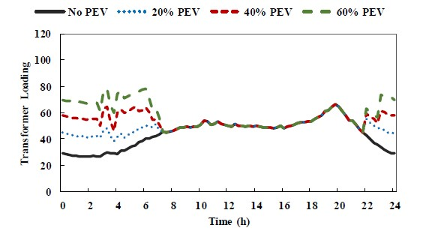
Figure 6: Transformer load profile in case of coordinated charging (source: Ramadan et al.)
Figure 7 visualises the load profile of feeder 1 in Figure 1 (which is the most loaded feeder in the grid) in case of uncoordinated and coordinated battery charging. When comparing with the load profile of the distribution transformer, similar conclusions arise.
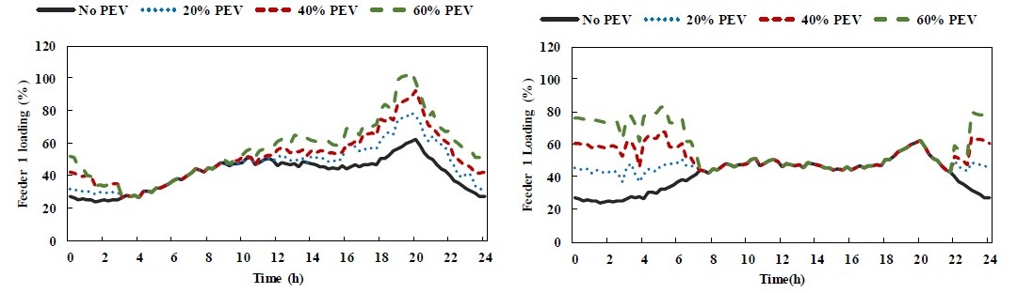
Figure 7: Feeder 1 load profiles in case of uncoordinated (left) and coordinated (right) charging
(source: Ramadan et al.)
2.5: Voltage deviations
In case the power consumption increases, the current level increases accounting for a larger voltage drop across the grid impedance. Figure 8 visualises the voltage deviations in feeder 1. Notice the coordinated battery charging accounts for lower voltage deviations which is an important advantage.
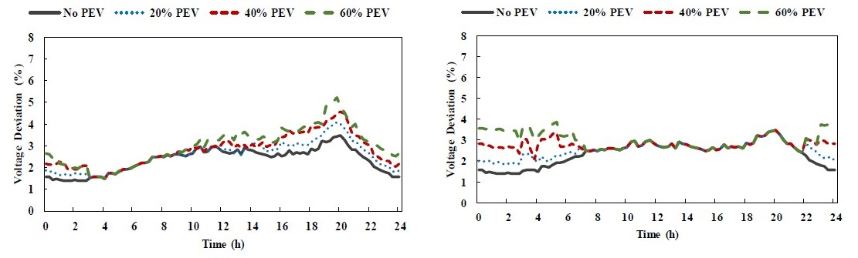
Figure 8: Feeder 1 voltage deviations in case of uncoordinated (left) and coordinated (right) charging
(source: Ramadan et al.)
2.6: Heat losses
In case the power consumption increases, the current level increases accounting for larger heat losses (Joule effect). By charging the batteries additional heat losses occur, especially when the PEV penetration level increases. By applying coordinated instead of uncoordinated charging of the batteries, a reduction of the heat losses is obtained. By reducing the high current values, heat losses reduce since heat losses are proportional with square of the rms value of the current.
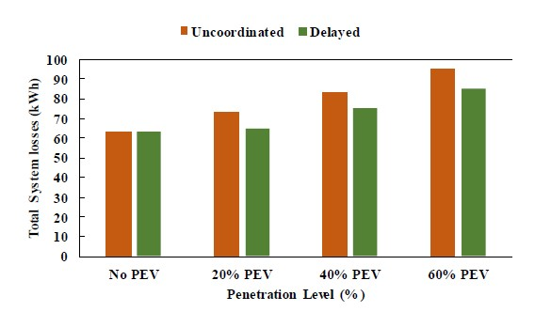
Figure 9: Heat losses in case of uncoordinated and coordinated battery charging
(source: Ramadan et al.)
3: Impact of PEVs on the distribution grid: paper 2
3.1: Main philosophy
The paper “Probabilistic Analysis of Plug-In Electric Vehicles Impact on Electrical Grid Through Homes and Parking Lots” by S. Rezaee et al. considers the impact of plug-in electric vehicles on the grid. When considering these PEVs, the paper makes a distinction between PHEV (plug-in hybrid electric vehicles) and BEV (battery electric vehicles).
These plug-in electric vehicles account for a stochastic behaviour since the instant of time when they are plugged in has a stochastic nature. The batteries of the vehicles are also charged at different locations which are stochastic in nature. This charging not only occurs in the garages of private households but also at parking lots. At these parking lots, a bidirectional power interface allows to charge the batteries and store energy. This stored energy can be used to drive the vehicle (which is the primary goal) but by partially discharging the battery and injecting power into the grid, dispersed generation is obtained. This means not only parking-to-vehicle P2V but also vehicle-to-parking V2P power exchanges occur. At the private households, only charging of the batteries is considered.
In case of a parking lot, parking-to-vehicle and vehicle-to-parking power exchanges are not equal to grid-to-vehicle and vehicle-to-grid power exchanges (the public grid outside the parking lot is considered). Indeed, in a single parking lot a large number of vehicles are connected with the local grid inside the parking lot. In case the battery of a first car is discharging and this power is immediately sent to a second car, then vehicle-to-parking and parking-to-vehicle power exchanges occur. But no vehicle-to-grid nor grid-to-vehicle power exchanges occur.
In the nearby future, merely PHEVs will be used to obtain ranges which are comparable with the ranges of traditional cars having internal combustion engines (fueled by e.g. diesel or gasoline). A real breakthrough of BEVs (without combustion engine) will appear when the technology is sufficiently mature. Efforts to develop and sell BEVs already exist (e.g. with Tesla or Nissan as manufacturers) but their impact is still quite limited.
The future rise of PHEVs and BEVs will have a considerable impact on the electrical power grid. Especially the use of fast charging modes (small recharging times from $0.5$ to $3$ hours) requires quite large powers. Although using uncoordinated/uncontrolled/dumb charging of the batteries is the most likely scenario in the near future, it is non sustainable when the number of PHEVs and BEVs increases considerably. A development of scenarios realising coordinated/optimal/smart charging is necessary. Realising scenarios where a number of vehicles also (partially) discharges their batteries and injects their energy into the grid is an important option.
3.2: Parking lot infrastructure
Figure 10 provides an overview of the parking lot infrastructure. The parking lot is connected with the public three phase AC grid. A DC-AC electronic power interface (EPI) is an interface between the three phase AC grid and a DC bus with a sufficiently high voltage level. The voltage level in the DC bus is higher than the voltage level available at a private household since larger powers are needed and the current level must be limited. Larger powers are needed since a large number of cars will be parked and fast charging must also be possible.
Notice the presence of DC-DC electronic power interfaces providing the appropriate DC voltage level to the vehicles. A number of vehicles are discharging their batteries and deliver power to the parking lot (V2P = Vehicle to Parking lot). Depending on the SOC of the batteries, the upcoming travel length and also the drivers’ willingness a vehicle will or will not provide power to the parking lot. Other vehicles are charging their batteries (P2V = Parking lot to Vehicle).
Possibly, the infrastructure is equipped with stationary energy storage devices (batteries) and local renewable electrical generating units (e.g. PV panels).

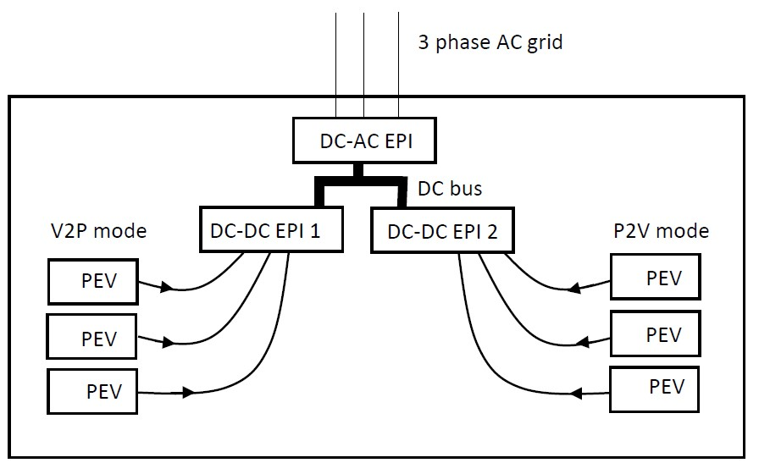
Figure 10: Parking lot infrastructure
3.3: Practical use of a PEV
The behaviour of each individual PEV, used in an urban environment, is different which complicates the situation. It is important to have insight in the global behaviour of the vehicles in order to estimate the impact on the electrical grid. For simplicity, the assumption has been made that PEVs have each 24-hour period the same behaviour. Based on statistics available on http://nhts.ornl.gov, a lot of information is available. The paper of Rezaee et al. assumes a daily PEV travel contains three trips as visualised in Figure 11. During a first trip a distance $l_{1}$ is bridged, during a second trip a distance $l_{2}$ is bridged and during a third trip a distance $l_{3}$ is bridged. At the end of the third trip, the vehicle returns home.
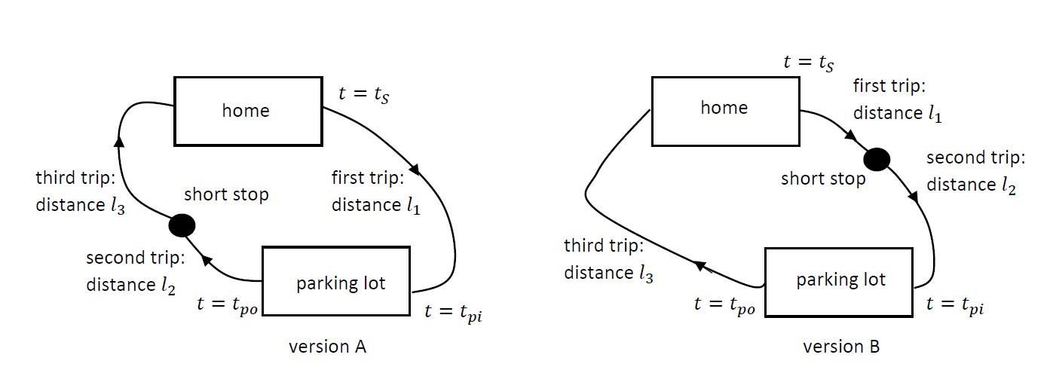
Figure 11: Two versions of a typical PEV daily travel
As visualised in Figure 11, two versions of the travel map exist. In the first version A, the vehicle starts at home at $t=t_{S}$ and has a first stop at a parking lot (at $t=t_{pi}$ the PEV plugs into the electronic power interface). At the parking lot, there is time to recharge the batteries (or partially discharge them). At $t=t_{po}$, the PEV unplugs from the electronic power interface. The second trip starts when leaving the parking lot. Having finished the second trip, there is a short stop (without charging or discharging the battery). Finally, the driver drives home bridging a distance $l_{3}$. Some homes have a battery charger, other homes have no battery charger.
The second version B is very similar but the short stop is situated after the first trip. Only after the second trip, the parking lot is reached where batteries can be recharged or partially discharged.
Based on statistics available on http://nhts.ornl.gov, a number of averaged parameters are obtained.
- On average, a driver makes three trips a day (which corresponds with Figure 11).
- On average, a driver realises a total daily travel distance of 29 miles (approximately 47 km) (with an average speed of 32 miles per hour i.e. approximately 51.5 km per hour).
- On average, the short stop equals 10 minutes.
3.4: Electrical characteristics of PEVs, PHEVs and BEVs
The all-electric range (AER) is an important parameter of a PHEV. The AER gives the distance (expressed in $mile$ or $km$) which can be travelled by only using the energy of an entirely charged battery (i.e. without using the combustion engine). The AER mainly depends on two parameters: the nominal energy storage capacity $C_{N}$ of the battery (expressed in $kWh$) and the average energy consumption $r$ when driving the vehicle (expressed in ${kWh}/{mile}$ or ${kWh}/{km}$). More precisely
$$AER=\frac{C_{N}}{r}.$$
When considering a PHEV, several approaches are possible when combining the electrical traction motor and the internal combustion engine. A possible (in principle easy approach) is using purely electrical traction from the beginning until the battery capacity reaches its lower limit. Then the combustion engine is used garanteeing a total range which is larger than the AER.
When considering a BEV, the $AER=\frac{C_{N}}{r}$.
3.4.1: Battery charger at home
When considering the driving behaviour sketched in Figure 11 and there is a battery charger installed at home, the battery of the PEV can be charged during the night. Normally, there is enough time for charging the battery which implies the daily travel starts at $t=t_{S}$ with a fully charged battery ($SOC=100\%$). With $C_{S}$ the battery charge at the beginning of the daily travel, $C_{S}=C_{N}$.
When reaching the parking lot, from $t=t_{pi}$ till $t=t_{po}$ the battery can be charged (P2V mode) or partially discharged (V2P mode). The choice between P2V or V2P mode depends on the DOD (depth-of-discharge) of the battery when arriving the parking lot and the expected distance which will be travelled between leaving the parking lot and arriving back home.
In case $Δt_{P}$ is the vehicle parking duration, it is clear that $Δt_{P}≥t_{po}-t_{pi}$. In case of P2V mode, sufficient time is needed to charge the battery until it has a sufficiently high SOC i.e. a time interval $Δt_{R}$ is needed.
3.4.2: No battery charger at home
When considering the driving behaviour sketched in Figure 11 and there is a no battery charger installed at home, the battery of the PEV (PHEV or BEV) cannot be charged during the night. This implies the daily travel starts at $t=t_{S}$ without a fully charged battery ($SOC<100\%$). The state of charge at $t=t_{S}$ depends on the driving behaviour the day before. With $C_{S}$ the battery charge at the beginning of the daily travel, $C_{S}<C_{N}$.
In such a situation, especially a BEV absolutely needs a parking lot where the battery can be charged. In this case, P2V mode is needed to charge the battery up to a SOC of 100%.
3.4.3: Four types of PEV travel profiles
S. Rezaee et al. considers four types of PEV travel profiles. Table 1 summarizes the main parameters for these four types of PEV travel profiles.
- PEV profile type 1: daily travel version A in combination with a battery charger at home,
  - Due to the battery charger at home, the battery initial charge $C_{S}=C_{N}$ i.e. one starts with a fully charged battery.
  - $l_{b}$ is the daily length of travel before entering the parking lot and with travel version A: $l_{b}=l_{1}$.
  - $l_{a}$ is the daily length of travel after entering the parking lot and with travel version A: $l_{a}=l_{2}+l_{3}$.
  - Due to the presence of a battery charger at home V2P and P2V modes are both possible at the parking lot in case of a BEV (having a large battery storage capacity in comparison with a PHEV).
- PEV profile type 2: daily travel version B in combination with a battery charger at home,
  - All remarks of PEV profile type 1 are still valid except for $l_{b}$ and $l_{a}$. More precisely, $l_{b}=l_{1}+l_{2}$ and $l_{a}=l_{3}$.
- PEV profile type 3: daily travel version A without a battery charger at home,
  - Due to the absence of a battery charger at home, the battery initial charge $C_{S}<C_{N}$ i.e. one does not start with a fully charged battery. In case of a BEV (having a large battery capacity), a stochastic analysis based on real life data reveals the average $C_{S}$-value equals $C_{S}=0.88 C_{N}$. In case of a PHEV (having a smaller battery capacity), a stochastic analysis based on real life data reveals the average $C_{S}$-value equals $C_{S}=0.36 C_{N}$.
  - $l_{b}$ is the daily length of travel before entering the parking lot and with travel version A: $l_{b}=l_{1}$. $l_{a}$ is the daily length of travel after entering the parking lot and with travel version A: $l_{a}=l_{2}+l_{3}$.
  - Since there is no battery charger at home, no discharging of the battery is allowed at the parking lot (no V2P mode is allowed). Only P2V mode is used, while parked in the parking lot the battery of the vehicle need to be charged during $Δt_{R}$.
- PEV profile type 4: daily travel version B without a battery charger at home.
  - All remarks of PEV profile type 3 are still valid except for $l_{b}$ and $l_{a}$. More precisely, $l_{b}=l_{1}+l_{2}$ and $l_{a}=l_{3}$.
PEV profile type | Battery initial  charge $\frac{C_{S}}{C_{N}}$ (%) |  | $$l_{b}$$ | $$l_{a}$$ | $$Δt_{eff}$$
 | BEV | PHEV |  |  | BEV | PHEV
1 | 100 | 100 | $$l_{1}$$ | $$l_{2}+l_{3}$$ | $Δt_{p}$ for V2P  $Δt_{R}$ for P2V | $$Δt_{p}$$
2 | 100 | 100 | $$l_{1}+l_{2}$$ | $$l_{3}$$ | $Δt_{p}$ for V2P  $Δt_{R}$ for P2V | $$Δt_{p}$$
3 | 88 | 36 | $$l_{1}$$ | $$l_{2}+l_{3}$$ | $$Δt_{R}$$ | $$Δt_{R}$$
4 | 88 | 36 | $$l_{1}+l_{2}$$ | $$l_{3}$$ | $$Δt_{R}$$ | $$Δt_{R}$$

Table 1: Overview of PEV travel profile types
Associated with these travel profiles, there is an evolution in the SOC of the batteries. As already mentioned, the daily travel starts with an initial battery charge $C_{S}$. When connecting with the parking lot (having already travelled over a distance $l_{b}$) at $t=t_{pi}$, the battery charge equals $C_{P}$. During $Δt_{eff}$ power is exchanged between the vehicle and the parking lot using the electronic power interface EPI (charging or discharging the battery). Having disconnecting with the EPI, the driver finishes the daily travel profile and when entering home the battery has a battery charge $C_{L}$.
When a battery charger is available at home, at $t=t_{hi}$ the PEV is plugged in and the charging procedure start. In general, at home, slow charging is used. At $t=t_{ho}$, the PEV is unplugged and the home charging of the battery ends, in general a $SOC=100\%$ is obtained.
3.4.4: Mathematical model of the power transactions
The power transactions can be modelled by mathematical expressions.
The daily travel starts with an initial battery charge $C_{S}$. To reach the parking lot, the vehicle crosses a distance $l_{b}$. With $r$ being the average energy consumption of the car (expressed in ${kWh}/{mile}$ or ${kWh}/{km}$), the remaining battery capacity when entering the parking lot is given by
$$C_{P}= C_{S}-l_{b}.r.$$
When considering the required energy $C_{R}$ available in the battery when leaving the parking lot, a distinction is needed between the situation where a home charger is available and the situation where no home charger is available. First, consider the situation where a home charger is available. The required battery charge $C_{R}$ equals
$$C_{R}=l_{a}.r+0.2.C_{N}.$$
After leaving the parking lot, the vehicle will cross a distance $l_{a}$ requiring an amount of energy which equals $l_{a}.r$. Notice an additional amount of energy $0.2.C_{N}$ will be stored to compensate unforeseen situations (e.g. a larger travelling distance). In case $C_{R}>C_{P}$, charging of the battery is needed i.e. P2V mode is used (during $Δt_{R}$). In case $C_{R}<C_{P}$, discharging of the battery is possible i.e. V2P mode can be used (during $Δt_{p}$).
Consider also the case when no home charger is available. While parked in the parking lot, the battery of the car will always be charged (always P2V mode) and a
$$C_{R}=C_{N}$$
value is preferred. The battery is fully loaded when leaving the parking lot.
By defining $ΔE_{P}$ as the energy exchanged with the parking lot (expressed in $kWh$), a distinction can be made between V2P mode and P2V mode. In case of V2P mode, $C_{R}<C_{P}$ and
$$ΔE_{P}=\left(C_{P}-C_{R}\right).η_{P}>0.$$
With $η_{P}$ being the power conversion efficiency at the parking lot, $ΔE_{P}$ is the net energy injected into the DC bus of the parking lot. Due to losses during the conversion, $ΔE_{P}<C_{P}-C_{R}$. When assuming the battery discharging occurs with a power $P_{P}$ (measured at the parking lot side) the required discharging time
$$\frac{\left|ΔE_{P}\right|}{P_{P}}.$$
In case of P2V mode, $C_{R}>C_{P}$ and
$$ΔE_{P}=\frac{C_{P}-C_{R}}{η_{P}}<0.$$
Due to losses during the conversion, $\left|ΔE_{P}\right|>\left|C_{P}-C_{R}\right|=C_{R}-C_{P}$. When assuming the battery charging occurs with a power $P_{P}$ (measured at the parking lot side) the required loading time
$$Δt_{R}=\frac{\left|ΔE_{P}\right|}{P_{P}}.$$
Since $Δt_{eff}$ equals the actual parking power transaction duration, it is clear $t_{po}=t_{pi}+Δt_{eff}$ (which refers to the parking lot). In case charging at home is possible, mathematical expressions allow to model the energy transactions at home. More precisely,
$$ΔE_{H}=-\frac{0.8.C_{N}}{η_{H}}<0$$
represents the energy exchanged at home (measured at the grid side of the home) while charging the battery. Indeed, after leaving the parking lot the battery charge $C_{R}=l_{a}.r+0.2.C_{N}$. By traveling home, an amount of energy $l_{a}.r$ is consumed leaving a battery charge which equals $0.2.C_{N}$. To obtain a fully charged battery the next day, an additional battery charge which equals $0.8.C_{N}$ is needed.
Losses of the home charger are taken into consideration by using the power conversion efficiency $η_{H}$. Similar with the convention used at the parking lot, $ΔE_{H}$ is negative since power/energy is extracted from the grid to load the battery.
Since $P_{H}$ is the power charging rate for the battery charger at home, a charging time ${\left|ΔE_{H}\right|}/{P_{H}}$ is needed. This implies
$$t_{ho}=t_{hi}+\frac{\left|ΔE_{H}\right|}{P_{H}}.$$
Notice $t_{hi}$ is the time when the PEV plugs into the battery charger and $t_{ho}$ is the time when the PEV plugs out of the battery charger. In order to have a fully charged battery, $t_{ho}$ must be an earlier time stamp than $t=t_{S}$.
Notice that $ΔE_{P}$ and $ΔE_{H}$ are both related to the energy exchange (and power exchange) with the electrical grid. Indeed, the study of the behaviour of PEV, BEV and PHEV is performed in order to estimate the impact on the electrical power grid.
3.5: Stochastic modelling
When considering the two versions of the travel maps visualised in Figure 11, stochastic modelling is required.
- The daily travel starting time is different for different vehicles. In an urban context, a Rayleigh probability density function (pdf) describes the probability of a particular $t_{S}$ (we use the notation $P_{S}\left(t_{S}\right)$). To give an idea, especially between 6am and 7am, a lot of cars are leaving their garage.
- When considering the total daily travel path $l=l_{1}+l_{2}+l_{3}$, Figure 12 visualises (using a bar graph) the percentage of vehicles driving such a distance leading to a probability density function $P_{T}\left(l\right)$. It is also possible to consider the distances $l_{1}$, $l_{2}$ and $l_{3}$ separately. Figure 13 visualises the probability density functions of $l_{1}$ and $l_{2}$.
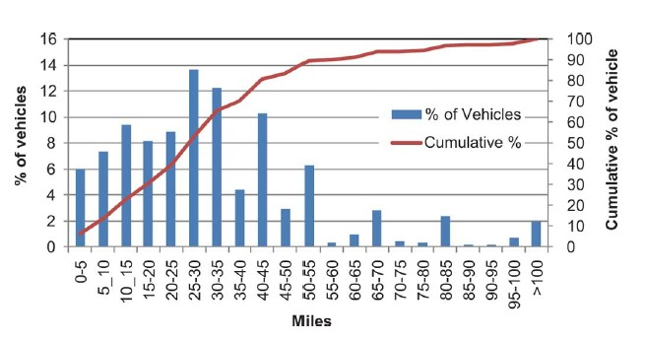
Figure 12: Percentage of vehicles driving a number of miles per day (source: Darabi et al.)
The horizonal axis of Figure 13 on the left actually visualises ${l_{1}}/l$ . This first length trip $l_{1}$ ranges from $0\%$ to $100\%$ of $l$ giving a normal distribution $P_{T1}\left(l_{1}\right)$. The horizontal axis of Figure 13 on the right visualises ${l_{2}}/{\left(l-l_{1}\right)}$ which also ranges from $0\%$ to $100\%$. The probability density function $P_{T2}\left(l_{2}\right)$ is obtained. Once $l$, $l_{1}$, $l_{2}$ are determined, also $l_{3}=l-l_{1}-l_{2}$ is determined.
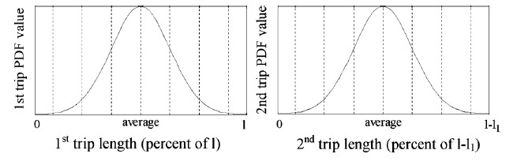
Figure 13: Probability density functions of daily travel parts (source: Rezaee et al.)
When considering the two versions of the travel maps visualised in Figure 11, stochastic modelling is required. We already considered $t_{S}$, $l$, $l_{1}$, $l_{2}$ and $l_{3}$. Also the parking stop duration $Δt_{P}$ is important since sufficient time is needed to load the battery. In the paper ‘Profile of Charging Load on the Grid Due to Plug-in Vehicles’ by S. Shahidinejad et al., a distinction is made between “short” parking periods (less than about half an hour), “medium” parking periods (less than about three hours) and “long” parking periods (longer than about three hours). Based on this consideration, a probability density function $P_{P}\left(Δt_{P}\right)$ can be obtained.
In total, seven parameters are needed to describe a PEV daily travel profile:
- the initial charge of the battery of the PEV: $C_{S}$,
- the travel version A versus the travel version B (see Figure 11),
- the parking stop duration: $Δt_{P}$,
- the time of the beginning of the daily travel: $t_{S}$,
- the total length of the daily travel: $l$,
- the length of the first trip: $l_{1}$,
- the length of the second trip: $l_{2}$.
For $Δt_{P}$, $t_{S}$, $l$, $l_{1}$ and $l_{2}$ the probability density functions have been described. This allows to obtain the probability $P\left(i\right)$ for a specific stochastic case (abbreviated as SC) with number $i$. More precisely
$$P\left(i\right)=0.5\left(P_{S}\left(t_{S}\right).P_{P}\left(Δt_{P}\right).P_{T}\left(l\right).P_{T1}\left(l_{1}\right).P_{T2}\left(l_{2}\right)\right).$$
In order to be able to take the product of the probabilities, the correlation between the random variables must be sufficiently small allowing to assume there is no correlation at all. The coefficient $0.5$ indicates the distinction between a travel version A and a travel version B (assuming half of the vehicles realise travel version A and the other half realises travel version B).
In case $N$ stochastic cases are considered implying $i$ ranging from $1$ to $N$,
$$\sum_{i=1}^{N}{P\left(i\right)=1}.$$
3.6: Power transfer function
The power transfer function PTF describes the daily power transaction of a PEV during 24 hours. A typical PTF is visualised in Figure 14.
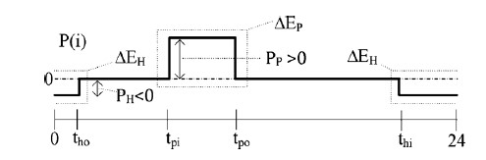
Figure 14: Power transfer function of stochastic case SCi (source: Rezaee et al.)
Actually the power transfers with the electrical grid are considered. Between $t_{hi}$ and $t_{ho}$, the battery is charged at home. The charging power is fixed and equals $P_{H}$ which is always negative (power is extracted from the grid to load the battery). Notice also the total energy transfer $ΔE_{H}$. Between $t_{pi}$ and $t_{po}$, power exchange occurs at the parking lot. In case of Figure 14, $P_{P}$ is positive i.e. discharging of the battery occurs (but also a negatieve $P_{P}$ is possible in case of charging the battery). Notice also the total energy transfer $ΔE_{P}$. Outside these two time intervals, no battery charging or discharging occurs.
The power transfer function $PTF\left(i\right)$ corresponds with stochastic case SCi and has probability $P\left(i\right)$. By adding the impact of all $PTF\left(i\right)$, taking the probabilities into consideration, the so-called average daily power transaction variation (ADPTV) is obtained. More precisely,
$$ADPTV=\sum_{i=1}^{N}{P\left(i\right).PTF\left(i\right)}.$$
In case the parking lot has no distributed generation units (e.g. photovoltaic panels) and there are also no separate energy storage devices at the parking lot, then the power evolution obtained as ADPTV needs to be added to the existing average daily load profile. Actually, the number of PEVs $N_{V}$ must be taken into consideration. The additional power evolution equals $ADPTV.N_{V}$.
3.7: Calculation of the ADPTV for four basic cases
When considering the ADPTVs, four basic cases can be considered
- case 1: a BEV is used with a battery charger at home,
- case 2: a PHEV is used with a battery charger at home,
- case 3: a BEV is used without a battery charger at home,
- case 4: a PHEV is used without a battery charger at home.
In the paper of Rezaee et al. computer code has been used to generate $480 {10}^{3}$ stochastic cases (SC) for BEVs and PHEVs separately. At home, slow charging occurs (starting from a SOC of 20%, e.g. 4 hours are needed to fully charge the battery). At the parking lot, fast charging or discharging occurs (e.g. 1 hour is needed to fully charge the battery). By adding all ADPTVs, an estimation of the impact on the grid is obtained. A distinction has been made between the power profile exchanged at the parking lot (Figure 15) and the power profile exchanged at home (Figure 16).
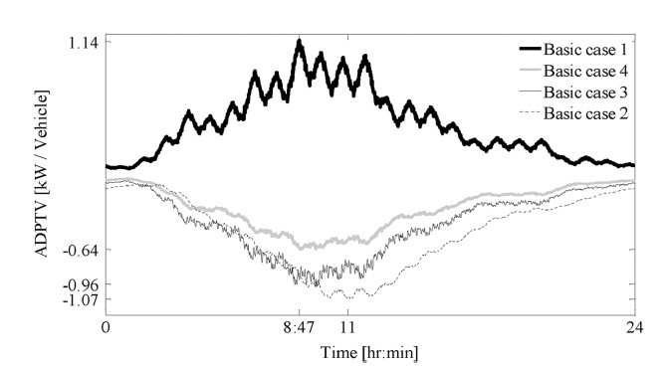
Figure 15: ADPTV of a PEV at a parking lot (source: Rezaee et al.)
Figure 15 makes a distinction between the four basic cases. When having a BEV with a battery charger at home (case 1), the vehicle starts at home with a fully charged battery. The capacity of the battery is rather large which implies the battery can be partially discharged at the parking lot (giving a positieve ADPTV). During the night (at home), energy is extracted from the grid (when the general power consumption is low) and stored in the battery. During the day (at the parking lot), this stored energy is partially extracted from the battery which is useful to charge other batteries (or the energy can be injected into the grid when the general power consumption is high).
When considering cases 3 and 4, no battery charging occurs during the night at home. This implies the batteries must be charged at the parking lot during the day. This implies negative ADPTVs. Since the battery of a BEV is larger than the battery of a PHEV, the values of the ADPTV are more negative for case 3.
Figure 16 only considers basic case 1 and basic case 2 since only these two cases consider a battery charger at home. Since the battery of a BEV is larger than the battery of a PHEV, the values of the ADPTV are more negative for case 1 which considers a BEV.
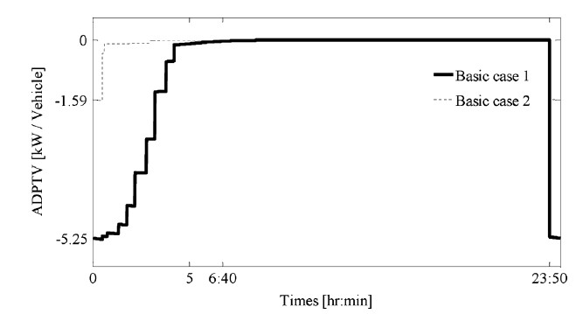
Figure 16: ADPTV of a PEV at home (source: Rezaee et al.)
3.9: Impact on the grid
Finally the impact on the electrical grid will be considered. In the paper of Rezaee et al., the electrical grid visualised in Figure 17 has been considered (see also http://sites.ieee.org/pes-dsacom/ and http://sites.ieee.org/pes-testfeeders/resources/). The grid has a voltage level of 24.9 kV and contains 34 buses. Three parking lots are considered and they are connected with the grid at nodes 5, 15 and 28 (which is a choice).
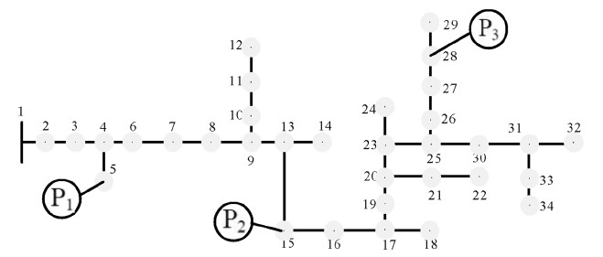
Figure 17: Electrical test grid (source: Rezaee et al.)
The base load of the grid (without the impact of the PEVs) is given in Figure 18. Notice the limited power consumption during the night. A peak consumption occurs around 11am and the largest peak consumption occurs in the evening between 8pm and 9pm. Somewhat less power is consumed during the afternoon.
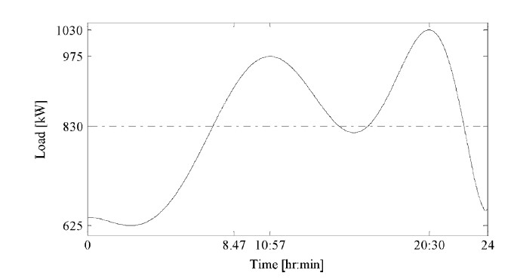
Figure 18: Base load of the grid without the impact of the PEVs (source: Rezaee et al.)
The impact of the PEVs must be added to the base load of Figure 18. It is not only necessary to have knowledge about the shape of the additonal load, it is also important to know the penetration rate of the PEVs. A realistic estimate of the penetration rate can be obtained by studying the behaviour of the citizens.
In the paper of Rezaee et al., the situation in the United States is considered with an average electrical power demand of $1.5 kW/year$ for a private household (which corresponds with approximately 13.1 MWh/year). On average, a household in the United States has 1.87 vehicles (situation of 2009).
When considering Figure 18, with an average power consumption of $830 kW$, actually 553 households are considered. This implies the use of 1034 verhicles. In case a household possesses a maximum of one PEV, this corresponds with a penetration rate of PEV of almost 50%. The impact on the electrical grid will be studied in case of different penetration rates i.e. 0% (no PEV are used), 8%, 22% and finally 50%.
A distinction can be made between four scenarios. For instance in scenario 1, 25% of the vehicles are a BEV and the owner has a battery charger at home (basic case 1), 25% of the vehicles are a PHEV and the owner has a battery charger at home (basic case 2), 25% of the vehicles are a BEV but the owner has no battery charger at home (basic case 3), 25% of the vehicles are PHEV but the owner has no battery charger at home (basic case 4). In a similar way, the other scenarios are considered in Table 2.
Distribution scenario | Basic case 1 | Basic case 2 | Basic case 3 | Basic case 4
Scenario 1 | 25% | 25% | 25% | 25%
Scenario 2 | 0% | 0% | 50% | 50%
Scenario 3 | 11% | 22% | 22% | 44%
Scenario 4 | 22% | 44% | 11% | 22%

Table 2: PEV penetration rate distribution scenarios
3.9.1: Voltage drops
Depending on the scenario, different power profiles are needed giving other current levels in the grid and implying other voltage drops. Figure 19 visualises the voltage profile (at bus 29) in case of scenario 1. In case of 0% penetration, only the base load of Figure 18 accounts for voltage drops. Notice the two power peaks account for higher voltage drops implying a lower remaining voltage level. As the penetration rate increases (more BEV and PHEV are used needing power from the grid), more additional power is required from the grid. Higher current levels account for larger voltage drops implying a lower remaining voltage level.
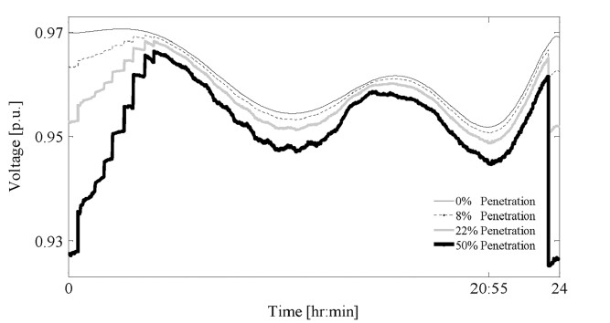
Figure 19: Voltage profile at bus 29 in case of scenario 1 (source: Rezaee et al.)
When considering scenario 1, mainly during the night voltage drops occur. About 50% of the vehicles are charged during the night implying additional power consumption. During the day, the voltage drops are lower since part of the cars are being discharged (V2P mode) while parked in the parking lot. This implies the power needed to charge the batteries in the parking lots (partially) comes from other discharging batteries. The additional load for the grid is limited.
Figure 20 visualises the voltage profile at the same bus 29 in case of scenario 2. There are differences when comparing the results of Figure 19 and Figure 20. No basic case 1 nor basic case 2 are used which implies no home charging occurs during the night (there is no home charging at all). The cars are all charged at parking lots (quite often during the day) which implies higher voltage drops during the day. The resulting bus voltage is lower.
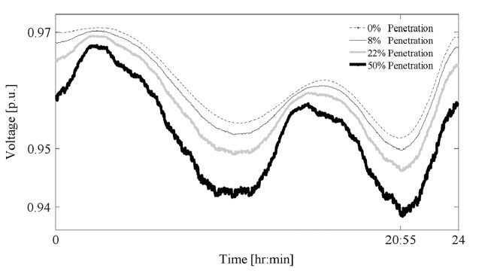
Figure 20: Voltage profile at bus 29 in case of scenario 2 (source: Rezaee et al.)
Figure 21 visualises the voltage profile at the same bus 29 in case of scenario 3. The results of scenario 3 are somewhat similar with the results of scenario 2. Indeed, when considering scenario 3, about 66% of the vehicles have no battery charging opportunities at home (a lot of charging occurs in parking lots, mainly during the day). Notice however also during the night charging of batteries occurs implying voltage drops during the night.
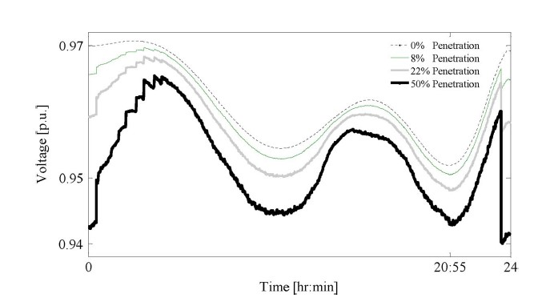
Figure 21: Voltage profile at bus 29 in case of scenario 3 (source: Rezaee et al.)
Figure 22 visualises the voltage profile at the same bus 29 in case of scenario 4. The results of scenario 4 are somewhat similar with the results of scenario 1. Indeed, when considering scenario 4, about 66% of the vehicles have battery charging opportunities at home. Quite a lot of battery charging occurs during the night at home implying a quite large voltage drop. During the day, when parked at a parking lot, a lot of vehicles operate in the V2P mode which provides local power to charge other vehicles without having to much impact on the public electrical grid.
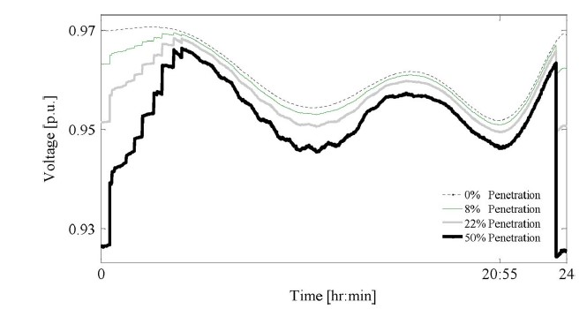
Figure 22: Voltage profile at bus 29 in case of scenario 4 (source: Rezaee et al.)
3.9.2: Grid power losses
The grid currents are determined by the power base load and the additional load due to the PEVs. These grid currents do not only account for voltage drops, they also account for power losses. Indeed, Joule losses arise since the currents are flowing in the resistive parts of the grid impedances. Table 4 gives an overview of the grid power losses (rated in per unit or %) where
- a distinction has been made between the four scenarios,
- a distinction has been made depending on the penetration level.
Penetration  level | Scenario 1 | Scenario 2 | Scenario 3 | Scenario 4
0% | 2.458 | 2.458 | 2.458 | 2.458
8% | 2.637 | 2.651 | 2.639 | 2.641
22% | 2.972 | 2.998 | 2.957 | 2.986
50% | 3.876 | 3.821 | 3.764 | 3.874

As the penetration rate of the PEVs increases, the losses increase in all scenarios. Actually the differences between the considered scenarios are rather limited.
4: Conclusions
Although a lot of papers study the (possible) impact of PEVs, BEVs, PHEVs on the electrical grid, the two papers discussed above give a decent idea of the challenges faced by the grid operators. The introduction of a large amount of PEV, BEV and HPEV generally increase the consumed electrical power implying:
- an increased load for all grid components (e.g. transformers and feeders),
- an increased voltage drop across the grid impedances,
- increased Joule losses in e.g. the feeders of the grid.
The impact of this increased number of electrical loads (car batteries) can be reduced and/or handled by introducing serveral ways of intelligence. Coordinated loading of the batteries can simply include a planned delay of the loading process i.e. loading batteries during the night when the base load of the grid is rather small. Introducing electronic power interfaces which are able to charge and discharge the batteries is also useful. During the night the base load of the grid is rather small and a number of batteries are charged which are partially discharged (in a smart way) during the day when the base load of the grid is larger. By discharging a number of batteries during the day, it is possible to charge other batteries which really need the charging process (and are not able to postpone the charging process) without causing an overload of the electrical grid.
References
Z. Darabi, M. Ferdowski, Aggregated Impact of Plug-in Hybrid Electric Vehicles on Electricity Demand Profile, IEEE Transactions on Sustainable Energy, vol. 2, no. 4, October 2011, pp. 501-508.
H. Ramadan, A. Ali, C. Farkas, Assessment of Plug-in Electric Vehicles Charging Impacts on Residential Low Voltage Distribution Grid in Hungary, 6th International Istanbul Smart Grids and Cities Congress and Fair (ICSG), 2018, pp. 105-109.
S. Rezaee, E. Farjah, B. Khorramdel, Probabilistic Analysis of Plug-In Electric Vehicles Impact on Electrical Grid Through Homes and Parking Lots, IEEE Transactions on Sustainable Energy, vol. 4, no. 4, October 2013, pp. 1024-1033.
S. Shahidinejad, S. Filizadeh, E. Bibeau, Profile of Charging Load on the Grid Due to Plug-in Vehicles, IEEE Transactions on Smart Grid, vol. 3, no. 1, March 2012, pp. 135-141.

