**Hybrid vehicles**

1: Introduction

Hybrid vehicles are intended to combine the advantages of vehicles having a conventional internal combustion engine and the advantages of electric vehicles. Vehicles having a conventional internal combustion engine have a large range since petroleum fuels have a high energy density. Electric vehicles have the advantage to account for no/less pollution while driving. Electric vehicles also have a higher energy efficiency than vehicles having an internal combustion engine.

Hybrid vehicles have more than one energy source. They have an internal combustion engine allowing the use of gasoline or diesel. Diesel or gasoline (or another fossil based fuel) is considered to be the primary energy source guaranteeing the large range of the vehicle. In the future, perhaps it will be possible to replace the diesel or gasoline by hydrogen. The primary energy source is mainly the steady state power source.

Hybrid vehicles also have an electrical motor which is generally battery fed. The battery is considered to be the secondary energy source. The secondary energy source is the dynamic power source (e.g. used while accelerating the vehicle). Batteries also allow to recuperate the brake energy. A battery is indeed a bidirectional energy source since a battery can be discharged and charged (while charging the battery, the electrial traction motor/machine operates as a generator).

A distinction can be made between series hybrid configurations, parallel hybrid configurations, series-parallel configurations and complex hybrid configurations. In the present text, we will mainly focus on the series and the parallel hybrid configurations.

2: Series Hybrid Electric Vehicle

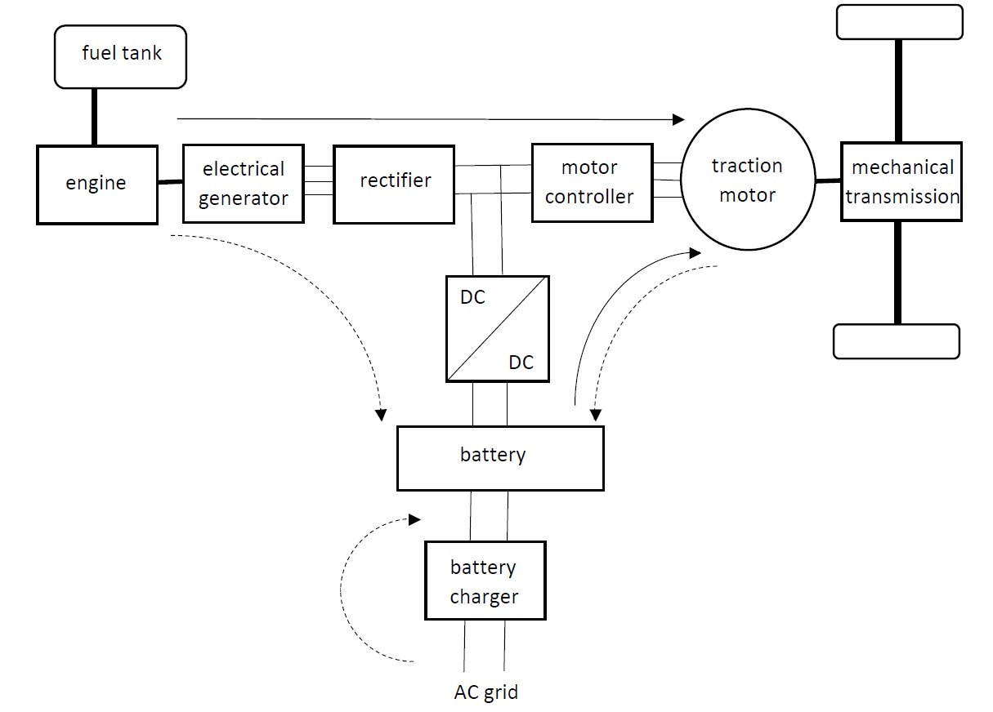

Figure 1: Configuration of a series hybrid electric vehicle

Figure 1 visualises the configuration of a series hybrid electric vehicle. Notice first of all the internal combustion engine connected with a fuel tank containing gasoline or diesel (primary energy source). The combustion engine operates at an optimal working point providing a maximum efficiency. Combustion engines are known to have a low efficiency but the efficiency depends on the speed and the provided power. By choosing the optimal speed and the optimal power, a maximum efficiency is obtained. Due to the series configuration, the speed and the power of the combustion engine are not proportional with the speed and the needed power of the vehicle.

The combustion engine is driving an electrical generator which generates a three phase AC voltage which will be rectified in order to obtain a DC voltage. The DC voltage feeds a motor controller which controls the behaviour of the electrical traction motor (by adjusting the RMS value and the frequency of the three phase voltage feeding the motor). The traction motor is driving the vehicle using the mechanical transmission system.

In case the combustion engine and the generator provide a power which is larger than the power needed by the traction motor, the excess of power is sent to the battery using the DC to DC converter (dotted arrow in Figure 1). When the vehicle needs more power than provided by the combustion engine, the additional power is supplied by the battery (secondary power source).

The traction motor/machine can also function as a generator while braking the vehicle. The brake energy will be converted into electrical energy by the traction generator. The brake energy will be stored in the battery i.e. regenerative braking is obtained. This regenerative braking avoids the kinetic energy needs to be converted into heat by using the friction of traditional brakes.

The configuration of Figure 1 is actually a Plug-in Hybrid Electric Vehicle i.e. there is an additional battery charger which allows to charge the battery using power from the public AC grid. Not all hybrid vehicles are equipped with such an additional battery charger.

2.1: Operation modes of the drivetrain

When considering the drivetrain visualised in Figure 1, a number of operation modes arise.

* Pure electric mode: The combustion engine is turned off and all the driving energy comes from the battery. This mode can e.g. be useful in a densely populated area where exhaust gases need to be avoided and where also noise pollution is undesired.
* Pure engine mode: All the driving energy is coming from the combustion engine i.e. the batteries are not charged nor discharged. For instance, in case the battery is empty and still a long trip is needed, based on fossil fuels and the combustion engine the desired range is possible.
* Hybrid mode: The driving energy is coming from the combustion engine and from the batteries. This allows to provide a large power to the traction motor which can be useful during acceleration of the vehicle.
* Engine traction and battery charging: The engine-generator drives the vehicle and the excess of power is used to charge the batteries. This approach allows the combustion engine to operate at its optimal working point (providing a maximum efficiency) when the mechanical power required by the vehicle is lower than the power of the combustion engine.
* Regenerative braking mode: The traction motor/machine is operating as a generator and the brake energy is stored in the batteries (the combustion engine is not used).
* Battery charging mode: The car is not driven (no power is sent to the traction motor) but the engine-generator charges the batteries.
* Hybrid battery charging mode: The traction motor/machine operates as a generator, together with the engine-generator they charge the batteries.

2.2: Advantages and disadvantages of the series hybrid configuration

The series configuration has a number of advantages. As already mentioned, the combustion engine is able to operate at its optimal working point providing a maximum efficiency. The speed of the combustion engine and the speed of the traction motor (and the vehicle) are not linked with each other. Due to that property, the combustion engine can be designed to behave optimal in a narrow speed and torque region (implying a higher efficiency and lower emissions). This is different from the situation in a traditional car where the combustion engine must operate in a broad range of speeds and torques. The combustion engine can’t behave optimal in such a large region.

The mechanical transmission is entirely driven by the electrical traction motor. Due to the motor controller, the electrical traction motor can operate in a very broad speed range. This implies no multigear transmission is needed between the electrical motor and the driven wheels.

In case two electrical traction motors are used, each driving a wheel, no differential is needed to deal with the different speeds of the wheels. In case the vehicle contains a four-wheel-drive system, it can be an option to use four electrical traction motors.

The series configuration also has a number of disadvantages. The energy originating from the combustion engine is converted twice (a first time by the generator and a second time by the traction motor) which accounts twice for losses. Actually, also losses occur in the rectifier and the motor controller. Moreover, the traction motor must be sized for the full/maximum power. This implies the generator and the traction motor can be heavy and spacious.

3: Parallel Hybrid Electric Vehicle: part 1

3.1: Basic principle

When considering the parallel hybrid electric vehicle configuration of Figure 2, a number of operation modes arise. Possibly the combustion engine alone is driving the mechanical transmission. Possibly the electrical motor alone is driving the mechanical transmission. Possibly the combustion engine and the electrical motor drive together the mechanical transmission. For shorter distances, mainly full electric mode can be used. Due to the combustion engine, a larger range is obtained i.e. larger distances are possible.

Additional options (can) exist. Via the mechanical coupling, the combustion engine drives the electrical machine which operates as a generator. The batteries can be charged. When braking, kinetic energy is used to drive the electrical machine as a generator. Kinetic energy is stored into the battery i.e. regenerative braking is obtained. Indeed, the kinetic energy is not converted into heat by using the friction in traditional brakes.

When considering the mechanical coupling in Figure 2, a distinction can be made between torque coupling and speed coupling.

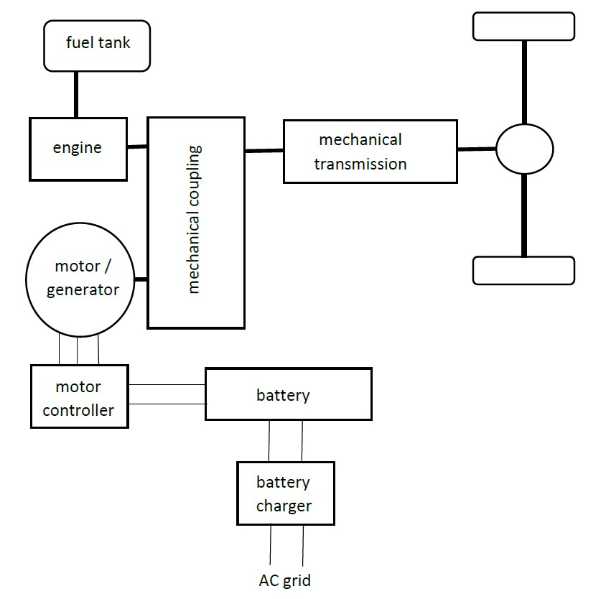

Figure 2: Configuration of a parallel hybrid electric vehicle

3.2: Torque coupling and speed coupling

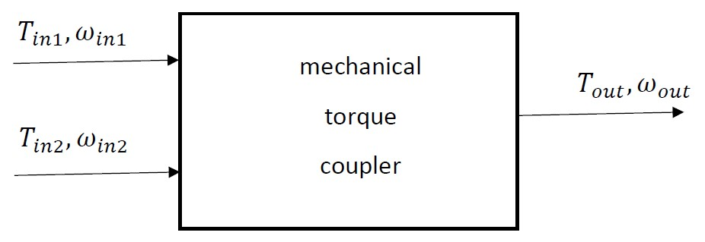

Figure 3: Mechanical torque coupler

The torque coupler of Figure 3 has two inputs and one single output. The first input has a driving torque $T_{in,1}$ and a pulsation (speed) $ω_{in,1}$. The second input has a driving torque $T_{in,2}$ and a pulsation (speed) $ω_{in,2}$. The output provides a torque $T_{out}$ at a pulsation $ω_{out}$. Depending on the torque coupling device, there exist constants $k_{1}$ and $k_{2}$ such that

$$T_{out}=k_{1}T_{in,1}+k_{2}T_{in,2}$$

and

$$ω_{out}=\frac{ω_{in,1}}{k_{1}}=\frac{ω_{in,2}}{k_{2}}.$$

Notice the two input torques $T_{in,1}$ and $T_{in,2}$ are not related with each other. In case both torques are postive (e.g. $T_{in,1}$ originating from the combustion engine and $T_{in,2}$ originating from the electrical motor), a large output torque can be obtained. Such a large output torque can be useful to accelerate the vehicle or to climb a mountain. Notice the speeds $ω_{in,1}$, $ω_{in,2}$ and $ω_{out}$ are proportional with each other. In case one of these speeds has been chosen, all other speeds are fixed.

The speed coupler of Figure 4 has two inputs and one single output. The first input has a driving torque $T_{in,1}$ and a pulsation (speed) . The second input has a driving torque and a pulsation (speed) . The output provides a torque at a pulsation . Depending on the speed coupling device, there exist constants and such that

and

Notice the two input speeds and are not related with each other. Suppose is the speed of the combustion engine and is the speed of the electrical motor. The speed of the combustion engine cannot be too small, but by combining it with a negative speed , a really low output speed can be obtained. In order to limit the fuel consumption of the combustion engine, is also not allowed to be too high. By combining a positive with a positive , a really high can be obtained.Notice the torques $T_{in,1}$, $T_{in,2}$ and $T_{out}$ are proportional with each other. In case one of these torques has been chosen, all other torques are fixed.

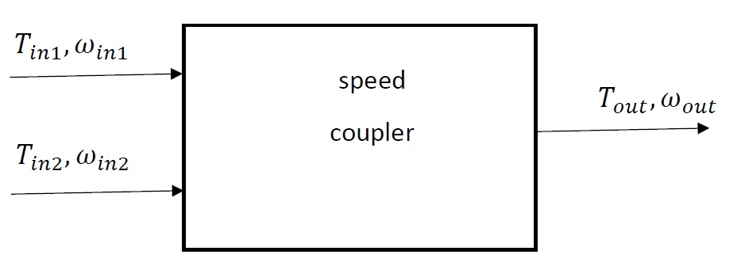

Figure 4: Mechanical speed coupler

3.3: Torque coupling: exercises

There exists a broad range of torque couplers and discussing them all is beyond the scope of the present text. A limited number of torque couplers will be shown with the corresponding $k_{1}$ and $k_{2}$ values. It is left as an exercise to the students to show the given $k_{1}$ and $k_{2}$ values are correct.

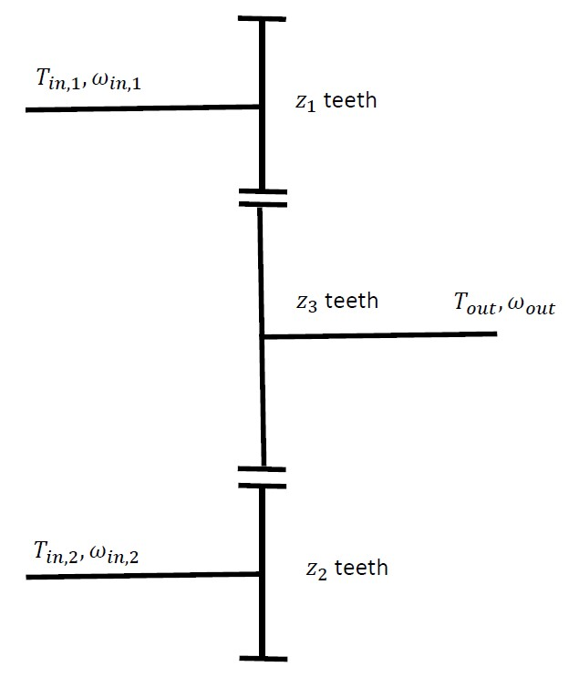

Figure 5: Torque coupler: example 1

Exercise 1:

The torque coupler of Figure 5 contains three gear wheels. The first one has $z_{1}$ teeth (first input), the second one has $z_{2}$ teeth (second input) and the third one (the output) has $z_{3}$ teeth. The sizes of the teeth of all gear wheels are the same which implies the number of teeth of a gear wheel is proportional with its radius. The peripheral speeds of all gear wheels are the same.

When neclecting all losses, the total input power equals the output power i.e.

$$ω_{in,1}T_{in,1}+ω_{in,2}T_{in,2}=ω_{out}T_{out}.$$

Prove that

$$k_{1}=\frac{z_{3}}{z_{1}}, k_{2}=\frac{z_{3}}{z_{2}}$$

implying that

$$T_{out}=\frac{z_{3}}{z_{1}}T_{in,1}+ \frac{z_{3}}{z_{2}}T_{in,2}$$

and

$$ω_{out}=\frac{z_{1}}{z_{3}}ω_{in,1}=\frac{z_{2}}{z_{3}}ω_{in,2}.$$

Exercise 2:

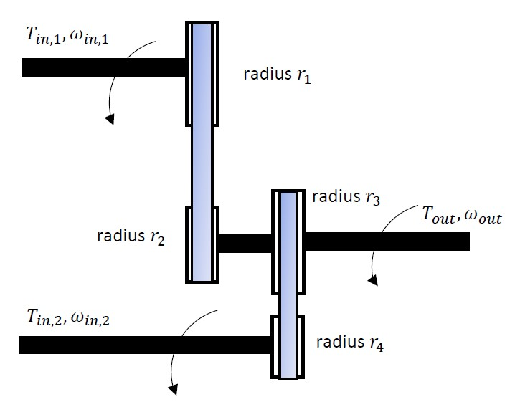

Figure 6: Torque coupler: example 2

The torque coupler of Figure 6 contains pulleys having radii $r_{1}$, $r_{2}$, $r_{3}$ and $r_{4}$. Due to the belts, the pulleys 1 and 2 have the same peripheral speeds and the pulleys 3 and 4 have the same peripheral speeds. The pulleys 2 and 3 share the same axis and have the same number of revolutions per minute. The arrows in Figure 6 indicate the rotational directions. When neclecting all losses, the total input power equals the output power. Prove that

$$k_{1}=\frac{r_{2}}{r_{1}}, k_{2}=\frac{r_{3}}{r_{4}}$$

implying that

$$T_{out}=\frac{r_{2}}{r_{1}}T_{in,1}+ \frac{r_{3}}{r_{4}}T_{in,2}$$

and

$$ω_{out}=\frac{r_{1}}{r_{2}}ω_{in,1}=\frac{r_{4}}{r_{3}}ω_{in,2}.$$

Exercise 3:



Figure 7: Torque coupler: example 3

The torque coupler of Figure 7 has one single axis of rotation. This implies $ω_{in,1}=ω_{in,2}=ω_{out}$ i.e. $k_{1}=k_{2}=1$. The output torque $T_{out}=T_{in,1}+T_{in,2}$. The arrows in Figure 7 do not indicate the rotational directions but the direction of the torques. Notice in the visualisation of Figure 7, the input torques $T_{in,1}$ and $T_{in,2}$ are driving torques whereas the output torque $T_{out}$ is a counteracting torque.

3.4: Torque speed characteristics in case of two transmissions

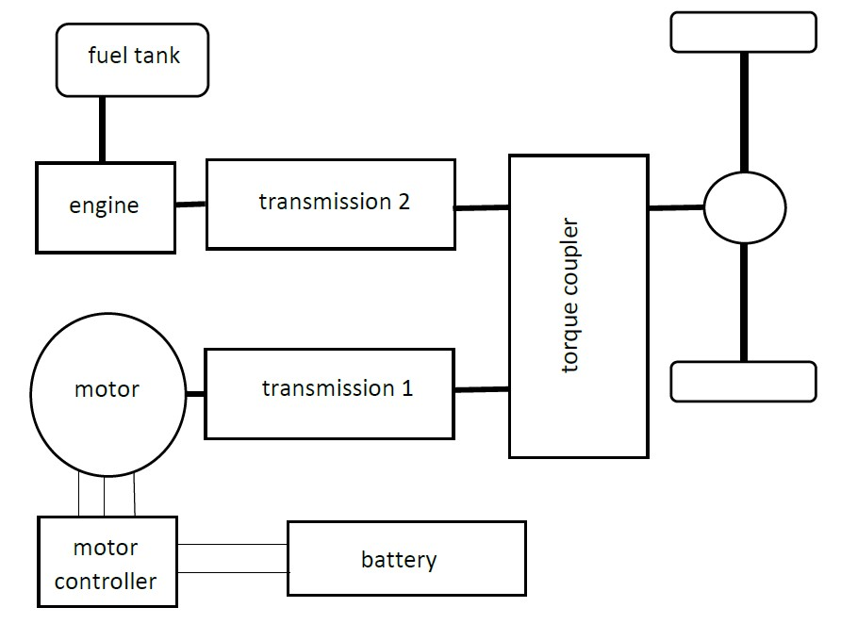

Figure 8: Parallel hybrid configuration with two transmissions

The configuration of Figure 2 is not the only parallel hybrid configuration. Figure 8 visualises an alternative parallel hybrid configuration. Notice in a very similar way the use of the internal combustion engine and the electrical motor. Notice the presence of a torque coupler but notice also the presence of two transmissions (one for the combustion engine and one for the electrical motor). Single-gear transmissions (with only one single speed ratio) or multi-gear transmissions (with several speed ratios) can be used.

In case both transmissions are multi-gear transmissions, a maximum flexibility is obtained but a complicated drivetrain is obtained. In case both transmissions are multi-gear transmissions, the engine and the motor are both able to operate near their optimal working points (e.g. with optimal efficiency).

The maximum flexibility is demonstrated by the torque speed characteristics. The resulting torque speed characteristic is a combination of the torque speed characteristic of the electrical motor and of the torque speed characteristic of the combustion engine. On the left, Figure 9 shows a typical torque speed characteristic of an electrical motor in case it is fed by a motor controller. Up to the nominal speed, the nominal torque can be obtained. Above the nominal speed, only lower torques are obtained. Notice however the speed range is really large. On the right, Figure 9 shows a typical torque speed characteristic of a combustion engine. The speed range of a combustion engine is more limited. The shape of the characteristic can be peak shaped or more flat. In the present text, we consider a rather flat torque speed characteristic.

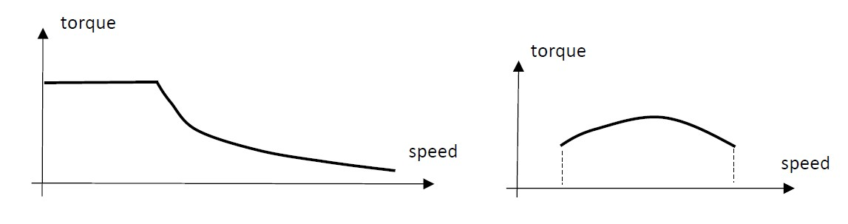

Figure 9: Typical torque speed characteristics

The resulting torque speed characteristic is a combination of the torque speed characteristic of the electrical motor and of the torque speed characteristic of the combustion engine. The speed ratios of the transmissions determine the shape of the resulting torque speed characteristic. A typical result is visualised in Figure 10.

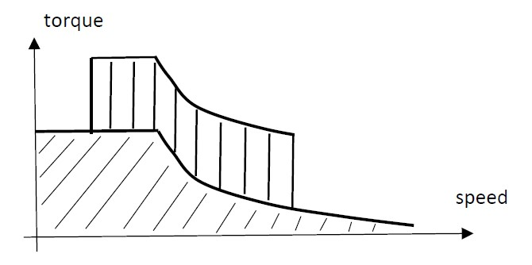

Figure 10: Resulting torque speed characteristic

A transmission typically reduces the speed since the speed of the motor/engine is higher than the finally needed rotational speed. By reducing the speed, the torque is increased with a same factor (when neglecting the losses, the input power and the output power are the same).

When choosing the first gear of transmission 1, the electrical motor gives a high starting torque to the torque coupler and finally to the wheels of vehicle. But that high torque is only available for really low speeds. When choosing a higher gear, the starting torque becomes lower but the torque is available up to higher speeds (compare it with a traditional car, starting occurs in the first gear and as a higher car speed is desired, a higher gear is chosen).

When choosing the first gear of transmission 2, the combustion engine gives a higher additional torque in a more narrow speed range. When choosing a higher gear, the additional torque is lower but available in a broader speed range (the additional torque starts at a somewhat higher speed but it is available up to a really higher speed).

3.5: Single-shaft configurations

Alternatively to the configuration of Figure 8, also a single-shaft configuration can be used. Figure 11 visualises such a single-shaft configuration. Notice the combustion engine providing a torque speed characteristic as visualised in Figure 9 (on the right). Notice the electrical motor providing a torque speed characteristic as visualised in Figure 9 (on the left). The rotor of the electrical motor functions as a torque coupler as visualised in Figure 7. Between the motor and the transmission a total torque $T_{in,1}+T_{in,2}$ is obtained (where $T_{in,1}$ is the torque provided by the combustion engine and $T_{in,2}$ is the torque provided by the electrical motor). The speeds of the combustion engine and the electrical motor are the same i.e. $ω=ω_{in,1}=ω_{in,2}$. In case the transmission accounts for a speed reduction with a factor $k$,

$$T_{out}=k\left(T_{in,1}+T_{in,2}\right)$$

and

$$ω_{out}=\frac{ω_{in,1}}{k}=\frac{ω_{in,2}}{k} .$$

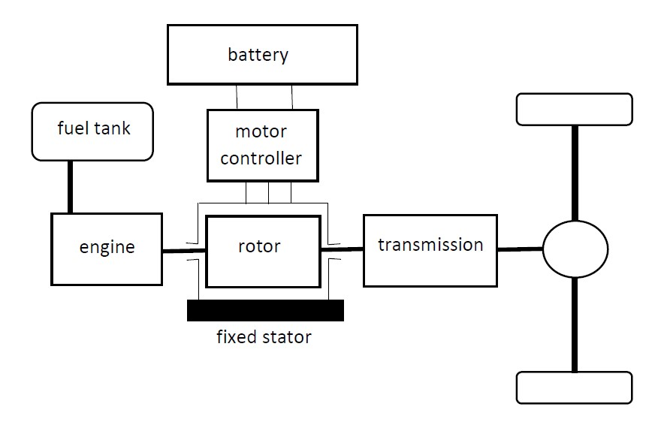

Figure 11: Single-axis configuration with pre-transmission

In the configuration of Figure 11, the torques of the combustion engine and the electrical motor are modified in the same way by the transmission. The speeds of the combustion engine and the electrical motor are modified in the same way by the transmission. This implies the engine and the motor must have the same speed range. By placing a transmission between the combustion engine and the motor (see Figure 12), only the torque and the speed of the combustion engine are modified. The torque of the electrical motor is directly driven to the wheels (drive shaft). The speed range of a combustion engine is more limited than the speed range of an electrical motor. A multi-gear transmission allows to use the engine over a broad speed range of the vehicle.

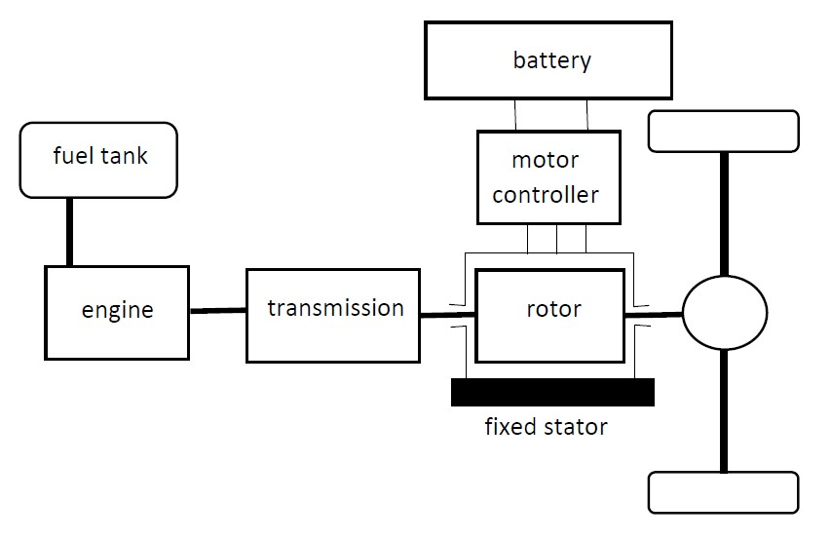

Figure 12: Single-axis configuration with post-transmission

When the engine is driving the electrical machine as a generator, it is possible to charge the batteries. In case of a standstill of the vehicle, the electrical machine does not rotate and it is not possible to charge the batteries.

3.6: The use of separate drivetrains

Figure 13 visualises a hybrid configuration where the combustion engine drives a first drive shaft and the electrical motor drives a second drive shaft.

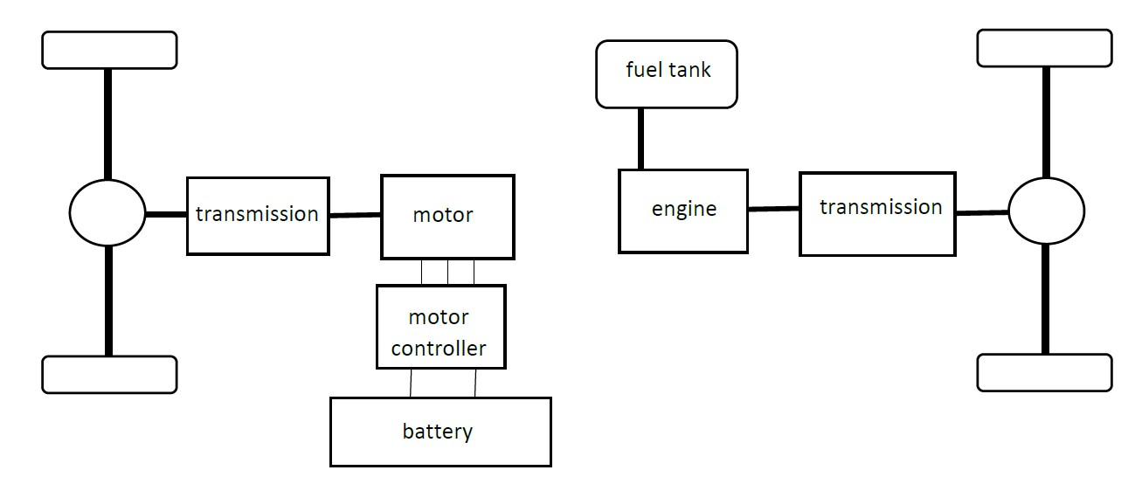

Figure 13: Hybrid configuation with separate driving of the shafts

4: Parallel Hybrid Electric Vehicle: part 2

4.1: The use of a speed coupler

The previous paragraphs mainly considered the use of a torque coupler in a hybrid vehicle configuration. Figure 4 already mentioned the use of a speed coupler. The speed coupler of Figure 4 has two inputs and one single output. The first input has a driving torque $T_{in,1}$ and a pulsation (speed) . The second input has a driving torque and a pulsation (speed) . The output provides a torque at a pulsation . Depending on the speed coupling device, there exist constants and such that

and

Notice the two input speeds and are not related with each other. Suppose is the speed of the combustion engine and is the speed of the electrical motor. The speed of the combustion engine cannot be too small, but by combining it with a negative speed , a really low output speed can be obtained. In order to limit the fuel consumption of the combustion engine, is also not allowed to be too high. By combining a positive with a positive , a really high can be obtained.Notice the torques $T_{in,1}$, $T_{in,2}$ and $T_{out}$ are proportional with each other. In case one of these torques has been chosen, all other torques are fixed.

4.2: The use of a planetary gear

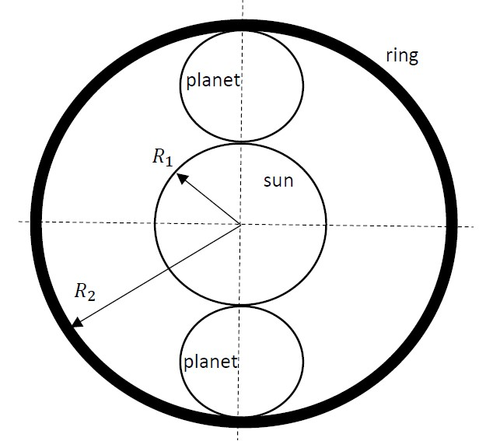

Figure 14: Planetary gear

Figure 14 visualises a planetary gear which functions as a speed coupler. Notice the sun gear having a radius $R_{1}$. The sun gear can be connected with the combustion engine. There is a driving torque $T_{in,1}$ and consider a counterclockwise rotation with pulsation $ω_{in,1}$. Notice also the ring gear having a radius $R_{2}$. The ring gear can be connected with the electrical motor. There is a driving torque $T_{in,2}$ and consider a counterclockwise rotation with pulsation $ω_{in,2}$.

A planetary gear unit not only has a sun and a ring. Notice also the planets which are circulating around the sun. The planets are also circulating around their own center. In Figure 14, there are two planets but the number of planets is a design parameter. The radius of a planet equals

$$\frac{R_{2}-R_{1}}{2}$$

and the center of a planet has a distance

$$R_{3}=\frac{R_{1}+R_{2}}{2}$$

to the center of the sun. The centers of the planets are connected with each other using a carrier (not shown in Figure 14). The carrier rotates with the same center as the sun and the ring. The carrier is actually the output of the planetary gear which will drive the actual load (the vehicle). Suppose the carrier is rotating in a counterclockwise direction with a pulsation $ω_{out,3}$. The load will imply a counteracting torque $T_{out,3}$ which is a clockwise oriented torque.

4.3: Torque and speed behaviour of a planetary gear

Based on Figure 14, first the relationships between the input speeds $ω_{in,1}$ and $ω_{in,2}$ (assume both are in a counterclockwise direction) and the output speed $ω_{out,3}$ (will also be in a counterclockwise direction) will be determined.

Consider the upper planet in Figure 14 and assume it is rotating in a clockwise direction around its own center with a pulsation $ω_{P}$. The peripheral speeds of the sun and the planet must be the same. More precisely

$$ω_{in,1}R_{1}=ω_{P}\left(\frac{R_{2}-R_{1}}{2}\right)+ω_{out,3}R_{3}.$$

The peripheral speeds of the ring and the planet must also be the same. More precisely,

$$ω_{in,2}R_{2}=-ω_{P}\left(\frac{R_{2}-R_{1}}{2}\right)+ω_{out,3}R_{3}.$$

By combining these two expressions, $ω_{P}$ can be eliminated which leads to the expressions

$$ω_{out,3}=\frac{R_{1}}{2 R_{3}}ω_{in,1}+\frac{R_{2}}{2 R_{3}}ω_{in,2}=k_{1}ω_{in,1}+k_{2}ω_{in,2}$$

implying the appropriate $k_{1}$ and $k_{2}$. When neglecting the friction, it is also possible to determine the relationship between the input torques $T_{in,1}$ and $T_{in,2}$ and the output torque $T_{out,3}$. Two relationships are needed i.e.

* the resulting torque applied to the carrier must be zero (with respect to the center of the sun, ring and carrier),
* the resulting torque applied to a planet must be zero (with respect to the center of the planet).

The first relationship implies that

$$T_{out,3}=T_{in,1}+T_{in,2}.$$

The second relationship considers torques applied by the sun and the ring on a planet. In case there are $n$ planets, the torque of the sun implies a peripheral force

$$\frac{T_{in,1}}{ n R_{1}}$$

and the torque of the ring implies a peripheral force

$$\frac{T_{in,2}}{ n R_{2}} .$$

The first force implies a clockwise torque to a planet and the second force implies a counterclockwise torque to a planet (both with respect to the center of the considered planet). In order to maintain a constant speed of rotation of the considered planet, both torques must be the same i.e.

$$\frac{R_{2}-R_{1}}{2} \frac{T_{in,1}}{n R_{1}}= \frac{R_{2}-R_{1}}{2} \frac{T_{in,2}}{n R_{2}}$$

implying that

$$\frac{T_{in,1}}{R_{1}}=\frac{T_{in,2}}{R_{2}} .$$

In combination with the relationship $T_{out,3}=T_{in,1}+T_{in,2}$, one obtains that

$$T_{out,3}=\frac{2 R_{3}}{R_{1}} T_{in,1}=\frac{2 R_{3}}{R_{2}} T_{in,2}=\frac{T_{in,1}}{k_{1}}=\frac{T_{in,2}}{k_{2}}$$

with the already known values for $k_{1}$ and $k_{2}$. This shows indeed a speed coupler is obtained.

4.4: Applying a planetary gear in a hybrid vehicle

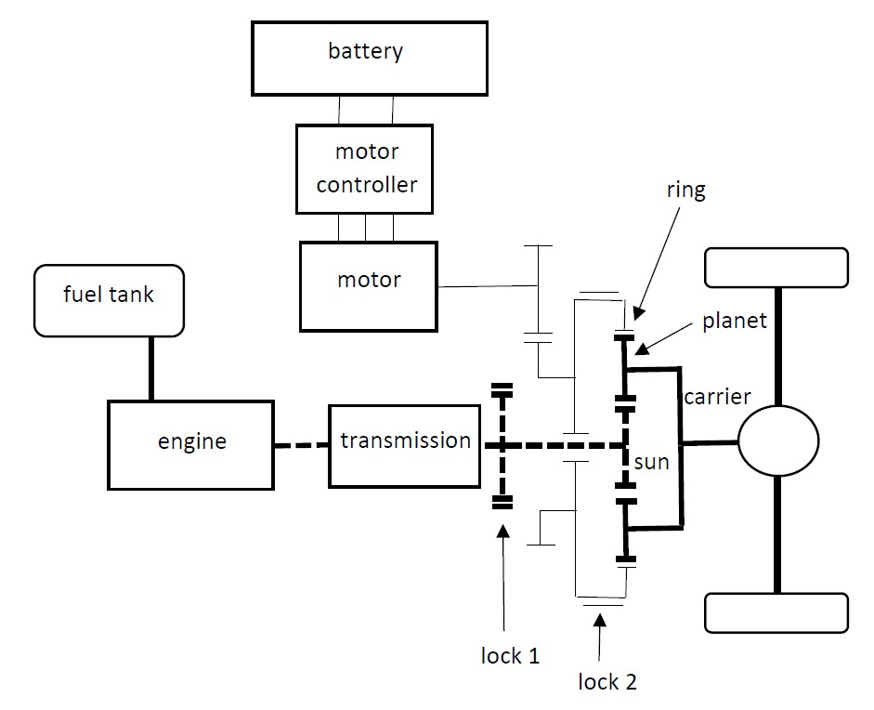

Figure 15: Vehicle equipped with a planetary gear

Notice in Figure 15 a hybrid vehicle equipped with a combustion engine and an electrical motor. Notice the planetary gear containing a sun gear, a ring gear, planets and a carrier. The combustion engine provides its power to the sun gear. The electrical motor provides its power to the ring gear. Notice also two locks. The first lock allows to lock the sun gear. The second lock allows to lock the ring gear.

When lock 1 and lock 2 are both released (sun gear and ring gear are both able to rotate), the combustion engine and the electrical motor both provide power to the wheels. Hybrid traction is obtained.

When only lock 2 is locked (ring gear is locked and sun gear is able to rotate), only the combustion engine provide power to the wheels. Engine alone traction is obtained. When only lock 1 is locked (sun gear is locked and ring gear is able to rotate), only the electrical motor provides power to the wheels. Motor alone traction is obtained.

The configuration of Figure 15 also allows regenerative breaking. When lock 1 is locked (sun gear is locked and ring gear is able to rotate), the combustion engine must be shut off or the clutch (not shown in Figure 15) must be disengaged. The electrical machine functions as a generator. The wheels are driving the carrier, the ring gear and the generator. Kinetic and potential energy is converted into electrical energy which is stored in the batteries. Regenerative breaking is obtained.

The vehicle configuration also allows the combustion engine to drive the electrical machine which functions as a generator. Mechanical energy is converted into electrical energy which is stored in the batteries. Battery charging is obtained with energy originating from the combustion engine.

5: Parallel Hybrid Electric Vehicle: part 3

Not only a planetary gear can be used to realise a speed coupler, it is also possible to use a transmotor i.e. an electrical motor with a floating stator. Figure 17 visualises such a transmotor which is actually a Permanent Magnet Synchronous Motor (PMSM).

5.1: Permanent Magnet Synchronous Motor

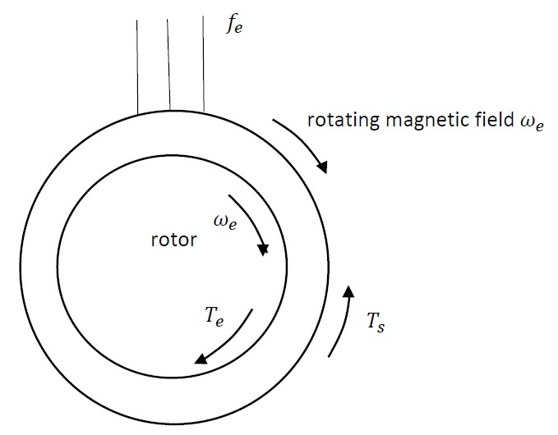

Figure 16: Permanet Magnet Synchronous Motor

A “classical” Permanent Magnet Synchronous Motor has a fixed stator which is fed by a three phase sinusoidal voltage with a frequency $f_{e}$ as visualised in Figure 16. Suppose the three phase stator windings, with a three phase current, generate a rotating magnetic field having $p$ pole pairs. The pulsation of that rotating magnetic field equals

$$ω_{e}=\frac{2π f_{e}}{p} .$$

The rotor contains permanent magnets implying a rotating rotor generates a rotating magnetic field with the same speed as the mechanical speed of rotation. Since the PMSM is a synchronous motor, the rotor will rotate with the same pulsation ${ω_{r}=ω}_{e}$. The motor converts electrical energy into mechanical energy i.e. a torque $T_{e}$ is applied to the rotor providing a mechanical power $ω_{e}T_{e}$. Based on the law of action and reaction, a torque $T_{s}=T_{e}$ is applied to the stator as shown in Figure 16.

5.2: Working principle of a transmotor

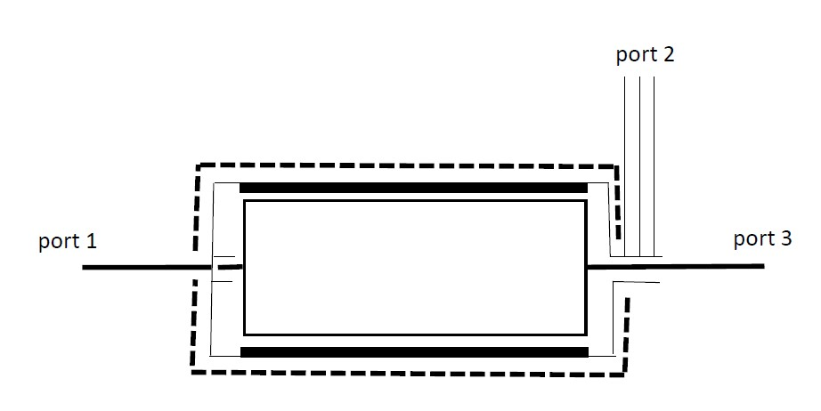

Figure 17: Transmotor

Figure 17 visualises a transmotor which has one single stator and two rotors. The stator (dotted lines in Figure 17) does not really have an ‘electrical’ goal but a fixed mechanical enclosure is needed. The transmotor contains an inner rotor and an outer rotor. The inner rotor is driving the mechanical load (port 3). The inner rotor contains permanent magnets (similar with the rotor in a classical PMSM). The outer rotor (also called the “floating stator”) functions like the stator in a classical PMSM. The outer rotor contains a three phase winding and the outer rotor is fed by an inverter providing an AC voltage with a controllable frequency $f_{e}$ (port 2). Slip rings and carbon brushes are needed to connect the inverter and allow this inverter to provide electrical power to the transmotor (to the outer rotor). The outer rotor is also driven by the combustion engine (port 1) which provides mechanical power to the transmotor.

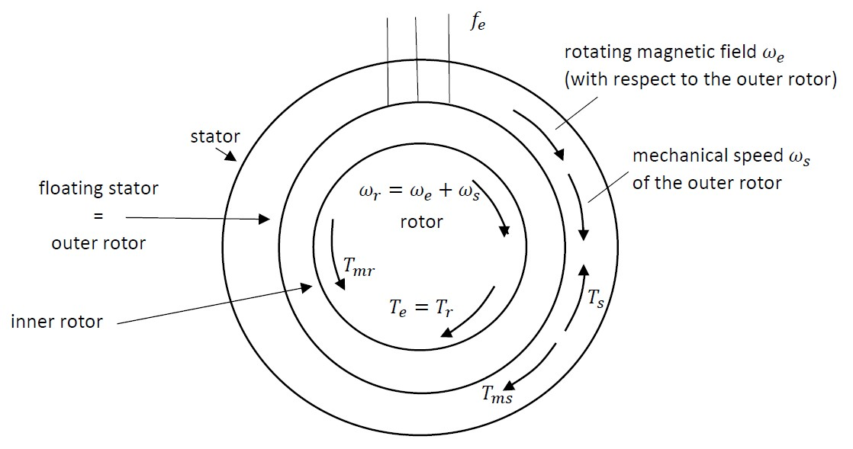

Figure 18: Working principle of a transmotor

Consider the outer rotor in Figure 18. The outer rotor is driven by the combustion engine providing a driving torque $T_{ms}$ and a mechanical speed $ω_{s}$ (the combustion engine provides a mechanical power $ω_{s}T_{ms}$ to this outer rotor). The outer rotor is fed by the inverter injecting a three phase current with frequency $f_{e}$ implying a rotating magnetic field with speed $ω_{e}$ with respect to this outer rotor. This means a rotating magnetic field with an absolute speed $ω_{s}+ω_{e}$ is obtained. The inverter provides an electrical power $ω_{e}T_{e}$ to the rotor.

A steady state torque is applied to the inner rotor when the inner rotor rotates at a mechanical speed $ω_{r}=ω_{s}+ω_{e}$. A driving torque $T_{r}=T_{e}$ implies a mechanical power $ω_{r}T_{r}=\left(ω_{s}+ω_{e}\right)T_{e}$ is provided to the mechanical load (port 3 in Figure 17). The mechanical power at the output is the sum of the mechanical power of the combustion engine $ω_{s}T_{ms}$ and the electrical power provided by the inverter $ω_{e}T_{e}$ (losses in the transmotor are neglected).

Notice the speed of the internal rotor is constant since the driving torque $T_{r}=T_{e}$ equals the mechanical counteracting torque $T_{mr}$ of the mechanical load. Since the outer rotor applies a driving torque $T_{r}=T_{e}=T_{mr}$ to the inner rotor, the law of action and reaction implies the inner rotor applies a torque $T_{s}=T_{e}=T_{mr}$ to the outer rotor. To keep the mechanical speed of the outer rotor constant, the combustion engine needs to apply a driving torque $T_{ms}=T_{s}=T_{e}=T_{mr}$.

5.3: Transmotor in a hybrid electrical vehicle

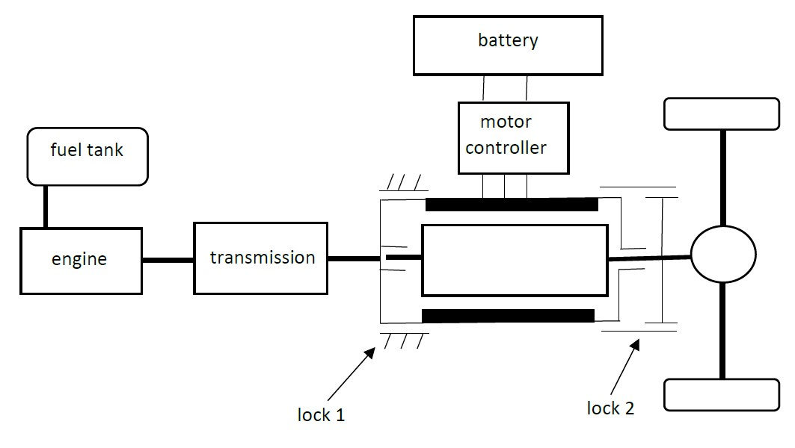

Figure 19: Vehicle with transmotor

Figure 19 visualises a hybrid vehicle equipped with a transmotor. In comparison with Figure 15, the transmotor replaces the generator/motor and the planetary gear (a planetary gear decreases the vehicle efficiency and increases the overall cost of the verhicle).

When lock 1 and lock 2 are both released (outer rotor and inner rotor are able to rotate), the combustion engine drives the outer rotor and provides power. The inverter provides electrical power to the outer rotor. The inner rotor recieves both powers and drives the vehicle. Hybrid traction is obtained.

When only lock 2 is locked, the inner rotor is locked with the outer rotor. Inner and outer rotor have the same rotational speed and are driven by the combustion engine. There is no electrical power input. Engine traction alone is obtained.

When only lock 1 is locked, the outer rotor is locked i.e. the outer rotor is not able to rotate. The combustion engine must be shut off or the clutch between engine and transmission (not shown in Figure 19) must be disengaged. There is no power input from the combustion engine. Electrical motor alone traction is obtained.

Regenerative braking is also possible using the configuration of Figure 19. When only lock 1 is locked, the outer rotor is locked. The combustion engine must be shut off or the clutch between engine and transmission (not shown in Figure 19) must be disengaged. There is no power input from the combustion engine. The transmotor behaves as a classical generator. The load is driving the inner rotor of the generator. Mechanical power is converted into electrical power. The generated electrical energy will be stored in the battery.

6: Combining torque coupling and speed coupling

6.1: Torque coupling and speed coupling using a planetary gear

6.1.1: Torque coupling

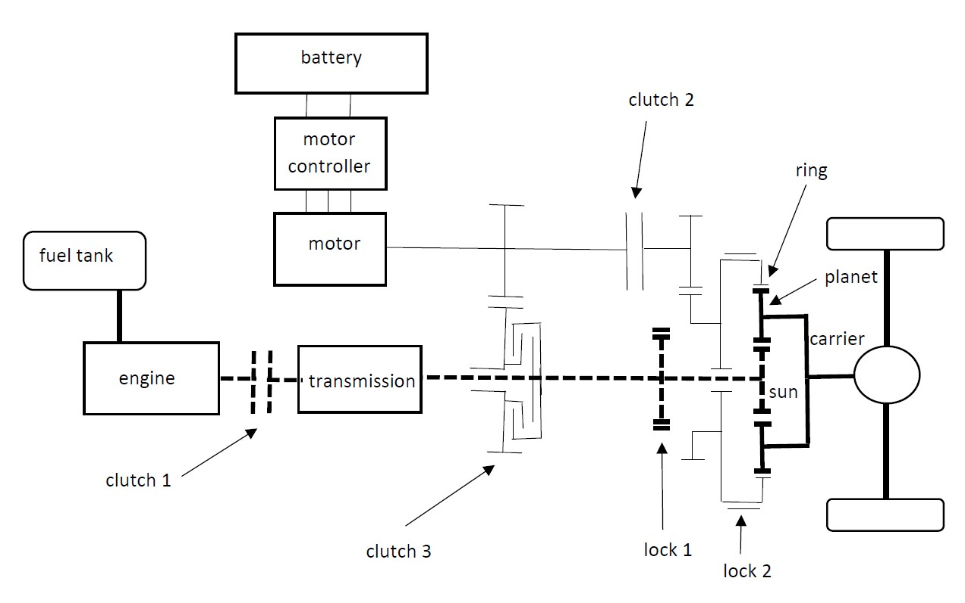

Figure 20: Combining torque and speed coupling in a hybrid vehicle

Figure 20 visualises a hybrid vehicle with a drivetrain where both torque coupling and speed coupling can be used. Torque coupling is obtained in case

* clutch 1 is engaged (there is a connection) and lock 1 is not locked (the combustion engine, the transmission and the sun gear are able to rotate),
* lock 2 locks the ring gear of the planetary unit, by the sun gear and the carrier gear the power of the combustion engine is sent to the drive shaft,
* clutch 2 is disengaged (there is no connection with the fixed ring gear) implying the electrical motor can rotate,
* clutch 3 is engaged (there is a connection) implying the electrical motor is able to drive the sun gear, the carrier gear and the drive shaft.

When considering torque coupling,

* hybrid traction is possible where combustion engine and electrical motor both drive the shaft (combustion engine and electrical motor both apply a torque to the sun),
* the ratio of the speeds of the combustion engine and the electrical motor are fixed, the torques of the engine and the motor are added.

6.1.2: Speed coupling

The same drivetrain can be used to obtain speed coupling. Speed coupling is obtained in case

* clutch 1 is engaged (there is a connection) and lock 1 is not locked (the combustion engine, the transmission, and the sun gear are able to rotate),
* lock 2 does not lock the ring gear of the planetary unit, by the sun gear and the carrier gear the power of the combustion engine is sent to the drive shaft,
* clutch 3 is disengaged (there is no connection) implying the electrical motor is not able to drive the sun gear,
* clutch 2 is engaged (there is a connection with the ring gear) implying the electrical motor drives the ring gear.

When considering speed coupling,

* hybrid traction is possible where combustion engine and electrical motor both drive the shaft,
* the speed coupling is obtained due to the planetary unit, the ratio of the torques of the combustion engine and the electrical motor are fixed, the speeds of the engine and the motor are independent of each other.

6.1.3: A large flexibility

Not only hybrid traction is possible. By appropriately engaging and disengaging the clutches, also engine alone traction and electrical motor alone traction is possible (and other modes). The choice between torque coupling and speed coupling may depend on the speed of the vehicle.

Suppose the vehicle has a low speed. When using torque coupling, the speed of the combustion engine can be too low. Speed coupling can be used to give the combustion engine a higher speed since

$$ω_{out}=k_{1}ω_{engine}+k_{2}ω_{motor}.$$

Indeed, although $ω_{out}$ is low, by giving the electrical machine a negative speed $ω_{motor}$, a larger combustion engine speed $ω_{speed}$ is possible. Although the vehicle needs a low mechanical power, a larger engine power is possible by sending power to the electrical machine which operates as a generator (power stored in the batteries).

Speed coupling can be useful at a high vehicle speed $ω_{out}$. By avoiding a really high engine speed $ω_{engine}$, high fuel consumption can be avoided. Indeed, with

$$ω_{out}=k_{1}ω_{engine}+k_{2}ω_{motor}$$

a high $ω_{out}$ is obtained by having $ω_{engine}$ and $ω_{motor}$ both positive.

Torque coupling can be used when the speed of the vehicle is not too low and not too high. Torque coupling operation mode can be suitable when a high acceleration is needed or during hill climbing. In these situations, a high total ouput torque $T_{out}$ is needed. This high $T_{out}$ is reached when $T_{engine}$ and $T_{motor}$ are both positive with

$$T_{out}=k_{1}T_{engine}+k_{2}T_{motor}.$$

6.2: Torque coupling and speed coupling using a transmotor

Instead of using a planetary unit, it is also possible to use a transmotor to allow the choice between torque coupling and speed coupling as visualised in Figure 21.

6.2.1: Torque coupling

By engaging clutch 1, by disengaging clutch 2 and locking the lock, torque coupling is obtained. The torques of the combustion engine and the electrical motor are added. Since the floating stator (outer rotor) of the transmotor is locked, the synchronous speed of the permanent magnet rotor equals the speed of the combustion engine.

6.2.2: Speed coupling

By disengaging clutch 1, by engaging clutch 2 and opening the lock, speed coupling mode is obtained. The combustion engine determines the speed of the floating stator (outer rotor) i.e. the combustion engine is driving the floating stator. The frequency imposed by the inverter on the floating stator determines the speed of the inner rotor (and the drive shaft) with respect to the floating stator. The working principle of the transmotor of Figure 18 is obtained.

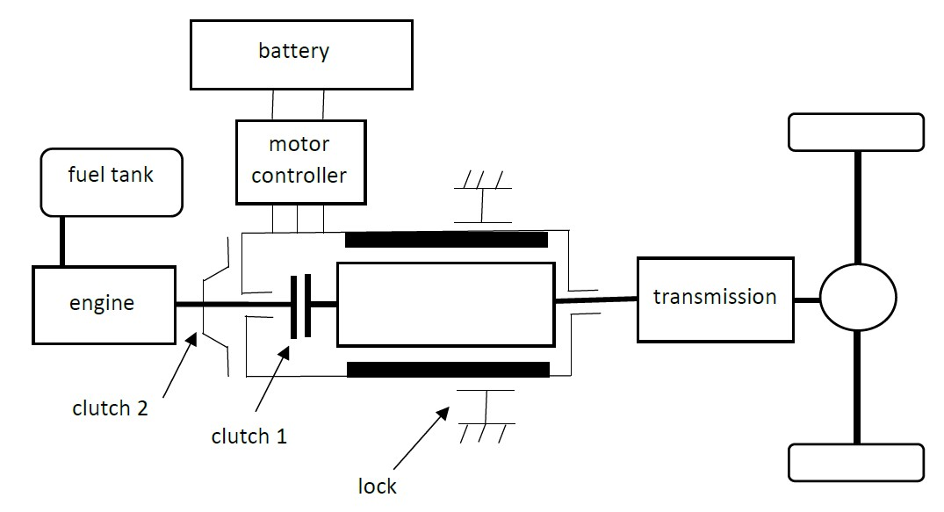

Figure 21: Combining torque and speed coupling in a hybrid vehicle

References

Ali Emadi (ed.), Handbook of Automotive Power Electronics and Motor Drives, CRC Press: Taylor & Francis, London, 2005, ISBN 978-0-8247-2361-3.

A. Ghayebloo, A. Radan, Superiority of Dual-Mechanical-Port-Machine-Based Structure for Series-Parallel Hybrid Electric Vehicle Applications, IEEE Transactions on Vehicular Technology, vol. 65, no. 2, February 2016, pp. 589-602.

H. Nasiri, A. Radan, A. Ghayebloo, K. Ahi, Dynamic Modeling and Simulation of Transmotor Based Series-Parallel HEV Applied to Toyota Prius 2004, 10th International Conference on Environment and Electrical Engineering, Rome, Italy, May 8-11, 2011.

F. Un-Noor, S. Padmanaban,L. Mihet-Popa, M. Nurunnabi Mollah, E. Hossain, A Comprehensive Study of Key Electric Vehicles (EV) Components, Technologies, Challenges, Impacts and Future Direction of Development, Energies, Energies, vol. 10, 1217, August 2017, doi:10.3390/en10081217, [www.mdpi.com/journal/energies](http://www.mdpi.com/journal/energies).