Fuel cell cars
1: Introduction
In order to increase the number of electrically driven cars, a wide variety of technical approaches exist. Battery Electrical Vehicles use a battery to store the required energy but alternatively, energy can also be stored using hydrogen. Hydrogen can be used to feed a hydrogen internal combustion engine but the use of hydrogen in combination with a fuel cell and an electrical motor is also a well known technology.
In order to reduce the use of fossil fuels, to reduce the emission of harmful exhaust gases and to make cars less noisy, the use of electrically driven cars is an important option. A Battery Electric Vehicle contains a large battery to store a sufficient amount of energy. Using power electronics, the speed of the electrical motor and the speed of the car can be adjusted to the needs of the driver.
Alternatively, the car can be equipped with a hydrogen storage tank allowing to feed the fuel cell stack. Just like a battery, the fuel cell stack is a DC voltage source. Using power electronics, the speed of the electrical motor and the speed of the car can be adjusted to the needs of the driver.
The use of fuel cells dates from the sixties of the previous century. Fuel cells have been used to power a spacecraft and also the first fuel cell car dates from the sixties. Although fuel cells were considered to be a promising technology by a lot of people, during a long time the use of fuel cells was not really practical. Fuel cells were too expensive and the power density of a fuel cell stack was too low. Due to more recent technological improvements, probably a real future arises for the use of fuel cells (also when conisdering road vehicles).
Prototypes of fuel cell cars are not new at all, but today there also exist commercial vehicles based on fuel cells (e.g. Hyundai, Toyota, Honda). Although the sales figures are still very limited, an important growth is expected.
When dealing with Battery Electric Vehicles, mainly light-duty vehicles are considered. Indeed, mainly private cars are considered. Realising the required energy storage by batteries in case of buses or trucks is far from trivial. When dealing with fuel cell equipped vehicles with hydrogen storage, quite a lot of engineers share the opinion that research is mainly needed towards heavy-duty vehicles. When using hydrogen, more energy can be stored in a smaller volume than it is the case with battery energy storage. The automotive industry used 70 MPa on-board hydrogen energy storage to reach storage densities of approximately 1.4 kWh/kg and 0.8 kWh/L. When considering lithium-ion batteries, only storage densities of approximately 0.24 kWh/kg and 0.5 kWh/L are obtained (source: J. Kurtz et al.). Of course, these energy densities are still lower than e.g. the energy densities of gasoline with 9.5 kWh/L.
2: Production of hydrogen
Hydrogen is very common in molecules like water $H_{2}O$ or $CH_{4}$ but hydrogen as a gas (i.e. $H_{2}$) is almost not available on Earth. Hydrogen as $H_{2}$ is a promising energy carrier but it is a secondary source of energy since it is almost not available on Earth. Based on e.g. $CH_{4}$ or $H_{2}O$ it is possible to produce $H_{2}$ but this production requires energy. Based on methane $CH_{4}$, a steam reforming process allows to produce hydrogen $H_{2}$. By using electrolysis, water $H_{2}O$ can be split into hydrogen $H_{2}$ and oxygen $O_{2}$.
2.1: Steam reforming
Today, the majority of the hydrogen production is based on the steam reforming process. At high temperatures (700 °C to 1100 °C), steam (water $H_{2}O$ vapor) reacts with methane to produce hydrogen.
$$CH_{4}+H_{2}O→CO+3 H_{2}.$$
Notice the formation of carbon monoxide $CO$ which is a poisonous gas. By adding a sufficient amount of steam, the carbon monoxide is converted into carbon dioxide.
$$CO+H_{2}O→CO_{2}+H_{2}.$$
The total chemical reaction equals
$$CH_{4}+2 H_{2}O→CO_{2}+4 H_{2}$$
which implies not only hydrogen but also carbon dioxide is produced. In case the hydrogen is used to drive a car using a fuel cell stack and an electrical motor, no harmful $CO_{2}$ gas is produced by the car. But the $CO_{2}$ gas is produced during the steam reforming process. Possibly the $CO_{2}$ is captured and stored implying it is not released in the atmosphere.
2.2: Electrolysis
Today, approximately 5% of the hydrogen production is based on electrolysis. In its most basic form, electrolysis is used to split up water $H_{2}O$ into hydrogen $H_{2}$ and oxygen $O_{2}$ as visualised in Figure 1. Notice in Figure 1 a bucket filled with pure water. Notice the presence of two identical electrodes (made of an inert material) and finally a DC voltage source is needed to provide the energy needed to split up the water.
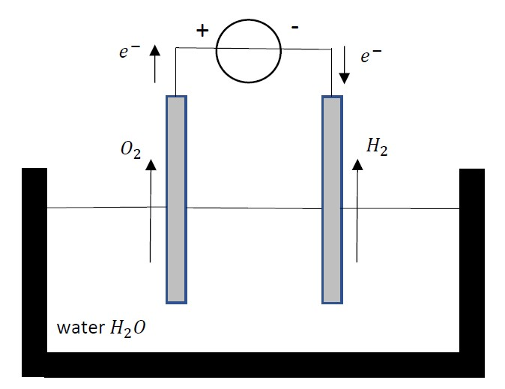
Figure 1: Electrolysis based on pure water
At the anode, electrons are extracted by the voltage source giving the reaction
$$2 H_{2}O →O_{2}+4 H^{+}+4 e^{-}$$
which accounts for the production of oxygen $O_{2}$. At the cathode, electrons are added by the voltage soure giving the reaction
$$2 H^{+}+2 e^{-}→ H_{2}$$
which accounts for the production of hydrogen $H_{2}$. The overall reaction equals
$$2 H_{2}O→2 H_{2}+ O_{2}.$$
Notice both hydrogen and oxygen are produced but the volumetric amount of hydrogen is twice the volumetric amount of oxygen. Actually, the electrolysis process using pure water as visualised in Figure 1 is a slow process (pure water is a bad electrical conductor). The process can become faster (and with a higher efficiency) by adding e.g. salt $NaCl$ or an acid to the water. Indeed, adding an electrolyte increases the conductivity.
As already mentioned, when considering hydrogen production using electrolyses, different approaches exist. The majority of the hydrogen produced by electrolysis is based on the chemical reaction (the chlorakali process)
$$2 NaCl+2 H_{2}O →{Cl}_{2}+H_{2}+2NaOH$$
which can be realised as visualised in Figure 2. Often, the hydrogen is considered to be a side product of the production of chlorine and caustic soda.
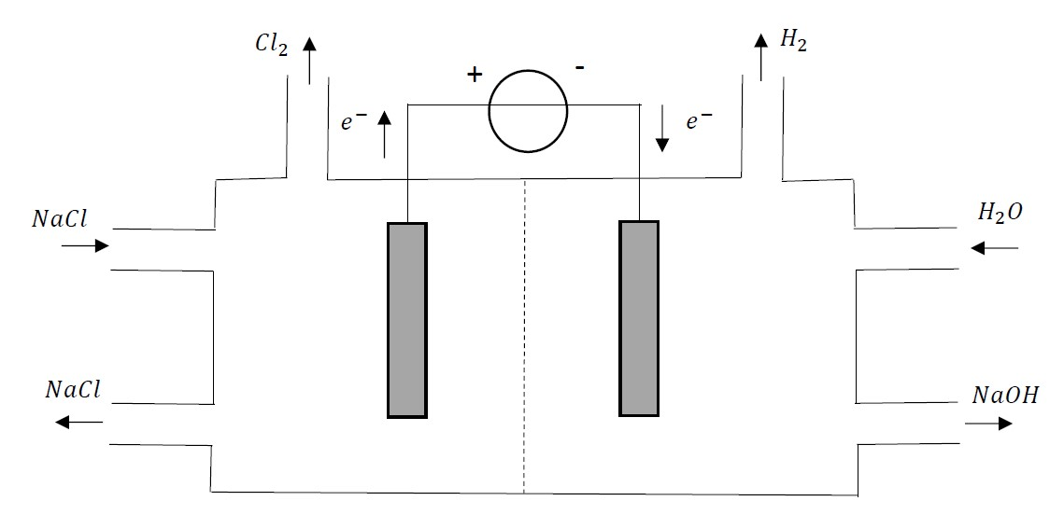
Figure 2: The chlorakali process
The configuration visualised in Figure 2 shows a bucket containing a left and a right part with a membrane (dotted line) in the middle. ${Na}^{+}$-ions can flow across the membrane in both directions but other ions like ${Cl}^{-}$ and ${OH}^{-}$ are blocked by the membrane. On the left side $NaCl$ (actually brine i.e. salt and water) enters the bucket, a part of the $NaCl$ reacts but the majority of the $NaCl$ molecules leave the bucket again. On the right side water $H_{2}O$ enters the bucket and $NaOH$ is obtained which leaves the bucket. Notice also the production of ${Cl}_{2}$ and $H_{2}$.
On the left side, $NaCl$ is split up giving $NaCl → {Na}^{+}+{Cl}^{-}$. Due to the DC voltage source, electrons are extracted from the left electrode (anode) i.e.
$$2 {Cl}^{-}→ {Cl}_{2}+2 e^{-}$$
implying chlorine gas is produced. The ${Na}^{+}$ions flow across the membrane to the right part. Additionally, the DC voltage source adds electrons $e^{-}$ by the cathode. In combination with the water, the reaction
$$2 H_{2}O+2 {Na}^{+}+2 e^{-}→2 NaOH+ H_{2}$$
implies caustic soda and hydrogen gas $H_{2}$ is obtained.
2.3: Electrolysis: primary energy source
When considering the chemical processes in Figure 1 and Figure 2, the primary energy source is the DC voltage source. The electrical energy can originate from thermal power plants (using fossil or nuclear fuels), but a lot of technicians hope to rely on renewable energy. Especially when using photovoltaic energy and energy originating from wind turbines, the power production is very time-dependent since it depends on the intensity of the sunlight and the wind speed.
Today, the majority of the power generated by photovoltaic panels and wind turbines is injected into the public electrical grid. Especially when the number of photovoltaic panels and wind turbines is increasing, the power grid faces problems to maintain the power balance in the grid. It is indeed important that the generated power always equals the consumed power:
$$P_{gen}=P_{cons}.$$
The power generated by photovoltaic panels and wind turbines is varying and that variation is not correlated with the evolution of the consumed power. Maintaining the power balance in the grid needs a sufficient number of thermal power plants operating at partial load (or even in standby) to be able adapt the total generated power $P_{gen}$ to the consumed power $P_{cons}$. Unfortunately thermal power plants operating at partial load have a lower efficiency.
From that point of view, it is useful to install photovoltaic panels and wind turbines without connecting them to the power grid. The generated energy can be used to produce hydrogen. By storing the hydrogen, energy storage is obtained. In case the time-varying renewable energy sources are still connected with the public electrical grid and in case of an excess of power (e.g. when there is a lot of sunlight and wind while $P_{cons}$ is low), the excess of energy can be used to produce hydrogen.
Of course also a series of financial aspects are relevant. In order to be able to produce hydrogen based on renewable energy sources, a number of financial aspects are important:
- the costs related with the electrical renewable energy sources (like photovoltaic panels, wind turbines) must be reasonable,
- the conversion of the electrical energy into hydrogen based energy storage must be financially affordable,
- the produced hydrogen must be stored, transported and distributed which also accounts for costs,
- in case the hydrogen is used to supply fuel cells, also the costs related with the production and the use of these fuel cells must be reasonable.
2.4: Other ways to produce hydrogen
When using electrolysis to produce hydrogen (especially in case of Figure 1), very pure (but expensive) hydrogen is obtained. Steam reforming and electrolysis are not the only ways to produce hydrogen (although they are at present the most common ones). Alternatively, hydrogen can be produced using photoelectrolysis where the sunlight is used to split the water molecules in oxygen and hydrogen. Biomass gassification is another possibility and scientists have discovered that some algae and bacteria are able to produce hydrogen.
3: Storage, transport and distribution of hydrogen
3.1: Hydrogen storage
Once the hydrogen is produced, it is a challenge to store the hydrogen in a compact and safe way. When burning hydrogen only water is produced due to the chemical reaction
$$2 H_{2}+ O_{2}→ {2 H}_{2}O.$$
By burning 1 kg of hydrogen, 120MJ of heat will be produced in case the resulting water is released as vapour. If the vapour can be condensed to liquid water, an additional 20 MJ is obtained. This 120 or 140 MJ is approximately three times the energy per unit of mass which is produced when burning gasoline or diesel. Notice however hydrogen is a thin gas at atmospheric pressure and ‘real life’ temperatures. This implies hydrogen has a low energy density per unit volume.
In order to store hydrogen in a compact way a number of approaches exist.
- The hydrogen gas can be stored in pressurized containers (e.g. at a pressure of 300 atmospheres).
- The hydrogen can be stored by absorbing it in a metal implying a metal hydride is obtained. The hydrogen can be released by heating.
- The hydrogen can be stored as a liquid by reducing the temperature to -253 °C.
3.2: Hydrogen transport over long distances
It is important to be able to transport the hydrogen over long distances. A possible scenario for the future is installing large amounts of photovoltaic panels in a sunny region like the Sahara. The generated energy is used to produce hydrogen which must be stored and transported to e.g. Europe.
Liquid hydrogen can be transported using liquid gas tankers (similar with the current transport of liquid natural gas). Of course special attention is needed for a decent thermal insulation of the tanker in order to be able to transport the cryogenic liquid. Having re-gasified the hydrogen, the hydrogen can be pumped through pipelines or it can be transported using road tankers.
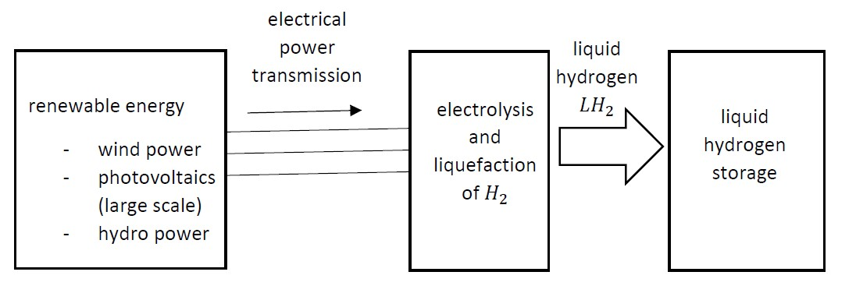
Figure 3: The hydrogen economy: part 1
3.3: Distribution of hydrogen
Finally, the hydrogen needs to be distributed to the consumers. The applications of hydrogen are very broad.
- The hydrogen can be used in private households for cooking or heating.
- The hydrogen can supply fuel cells to provide electrical energy and heat. The fuel cells can be stationary and can provide a large power if necessary.
- The hydrogen can supply the fuel cell stack in a road vehicle allowing the use of an electrical motor to drive the vehicle. Alternatively, a hydrogen fuelled internal combustion engine can be used.
3.4: Hydrogen economy
The global approach where the hydrogen is produced, transported over large distances and distributed to the consumers is the so-called ‘hydrogen economy’. Figure 3 visualises a first part of this hydrogen economy where the hydrogen is produced and stored (liquid hydrogen storage after the liquefaction process).
Figure 4 visualises a second part of the hydrogen economy where liquified hydrogen is transported over long distances. After a second liquified hydrogen storage, the liquified hydrogen is distributed and finally converted back into hydrogen gas. The hydrogen gas is distributed to a broad range of consumers by using road tankers or pipelines. Although there is a very broad range of consumers (Figure 5), it is expected that fuel cell vehicles can become an important application of this hydrogen economy.
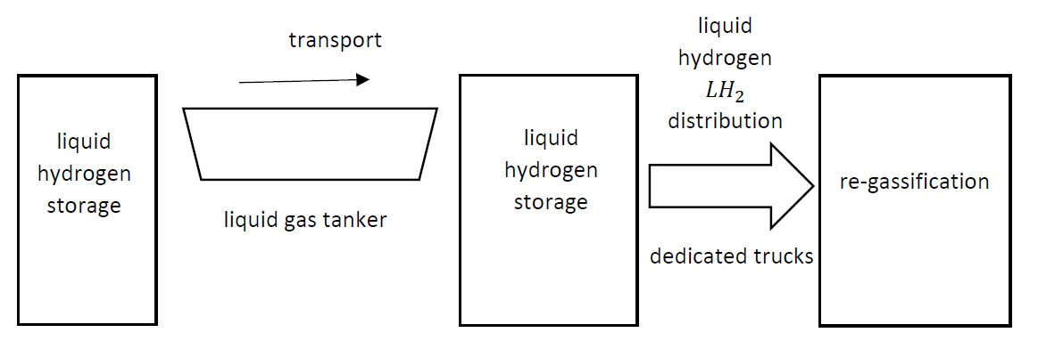
Figure 4: The hydrogen economy: part 2
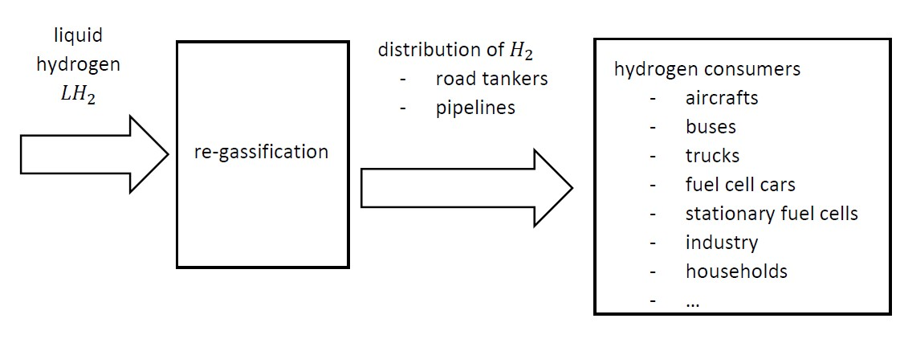
Figure 5: The hydrogen economy: part 3
4: Fuel cell vehicles
Figure 6 visualises a Fuel-Cell Electric Vehicle (FCEV). The wheel axle is driven by an electrical motor using a transmission to obtain the required speed. The use of a Proton Exchange Membrane Fuel Cell where the fuel cell stack is fed by hydrogen is the most popular one. A hydrogen tank is needed to store the hydrogen.
In case no harmful emissions occur to produce the hydrogen, a FCEV is a zero emission car which is useful in e.g. urban areas. In comparison with the charging process of a battery, refueling with hydrogen is fast (it only takes a few minutes).
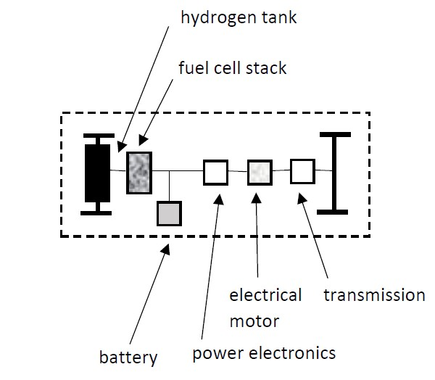
Figure 6: Fuel-Cell Electric Vehicle
4.1: Fuel-cell technologies
There exist a broad range of fuel-cell types each having their properties, advantages and disadvantages. Not all types of fuel-cells will be discussed here, we restrict ourselves to a selection.
4.1.1: Proton Exchange Membrane Fuel Cell
The working principle of a Proton Exchange Membrane Fuel Cell (PEMFC) is visualised in Figure 7.
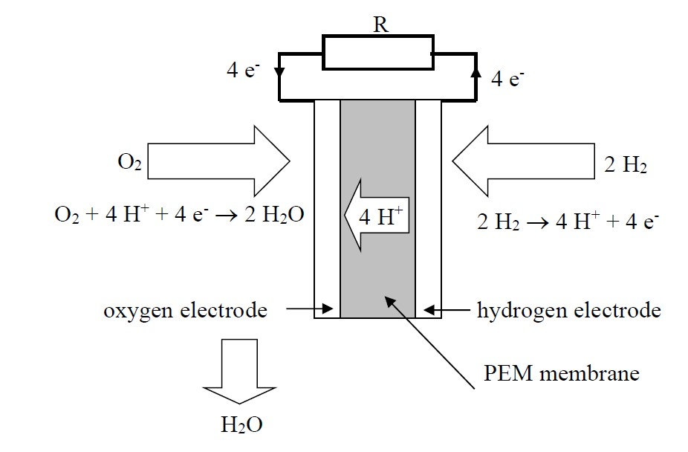
Figure 7: Working principle of a Proton Exchange Membrane Fuel Cell
The PEMFC contains an oxygen electrode and a hydrogen electrode. Between these electrodes, a Proton Exchange Membrane allows a flow of protons i.e. $H^{+}$ ions. Hydrogen gas is supplied to the hydrogen electrode and this hydrogen is split in $H^{+}$ ions and electrons $e^{-}$ due to a catalyst (platinum). By crossing the membrane, the $H^{+}$ ions move to the oxygen electrode. Notice also the electrical load (modelled by a resistor R in Figure 7) and electrons move from the hydrogen electrode to the oxygen electrode i.e. a DC current is flowing in the electrical load. $H^{+}$ ions and electrons $e^{-}$ move to the oxygen electrode and by adding oxygen, water $H_{2}O$ is obtained (also here platinum is needed as a catalyst).
The PEMFC is a low temperature fuel cell which operates at temperatures between 40 °C and 60 °C. Due to the low temperature, the PEMFC starts up quickly which is important in case of a road vehicle. A PEMFC converts the chemical energy available in the hydrogen into electrical energy (with an efficiency of approximately 50% to 60%) and heat. In case also the heat is used, the CHP (Combined Heat and Power) principle is obtained.
Notice the electrochemical reaction between hydrogen and oxygen generates only a limited voltage (typically even less than 1 V). This implies a series connection of individual cells is needed (a layered structure is used) to obtain the required voltage level.
4.1.2: The Alkaline Fuel Cell
The Alkaline Fuel Cell (AFC) is also a low temperature fuel cell like the PEMFC. The AFC has a somewhat higher efficiency than the PEMFC (when considering electrical energy as the useful output) i.e. efficiencies of 70% are potentially possible. The AFC has been used in the sixties in the Apollo-series missions and also in the Space Shuttle. The AFC is also useful in the transportation sector.
The working principle of an AFC is visualised in Figure 8.
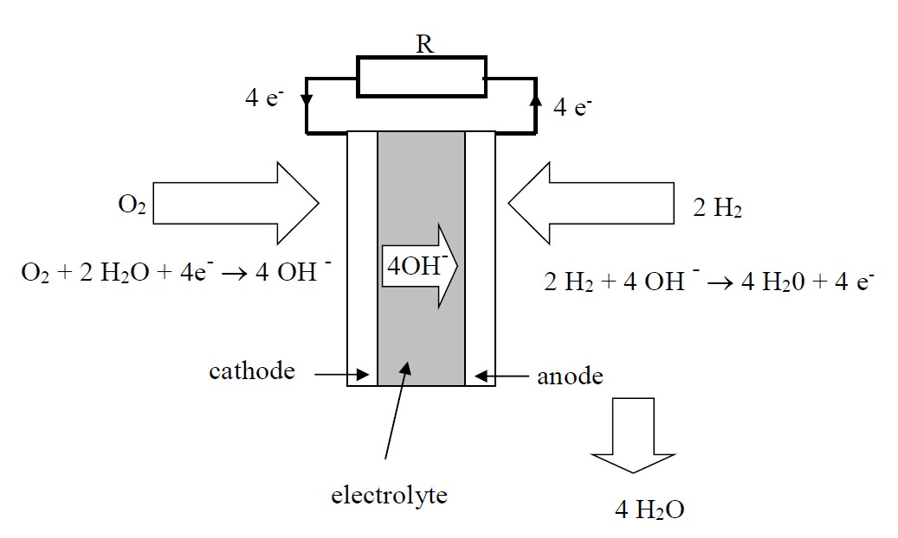
Figure 8: Working principle of an Alkaline Fuel Cell
The AFC contains an anode and a cathode. Between these electrodes, an electrolyte allows a flow of hydroxyl ${OH}^{-}$ ions. Hydrogen gas is supplied at the anode and in combination with hydroxyl ions water and electrons $e^{-}$ are obtained. Notice also the electrical load (modelled by a resistor R in Figure 8) and electrons move from the anode to the cathode i.e. a DC current is flowing in the electrical load. At the cathode not only oxygen is supplied, but also water is needed. The electrons from the electrical load are needed to obtain the desired hydroxyl ${OH}^{-}$ ions. Also in case of the AFC, platinum is used as a catalyst.
4.1.3: Direct Methanol Fuel Cell
The Direct Methanol Fuel Cell (DMFC) visualised in Figure 9 does not use hydrogen as energy source as it is the case for the PEMFC or the AFC. Methanol $CH_{3}OH$ is used as energy source and methanol has the advantage to be more energy-dense than hydrogen. Unfortunately, the DMFC has a much lower efficiency (approximately 10%) than a PEMFC or an AFC. When engineers would be able to increase the efficiency of the DMFC, much more applications would arise and possibly a methanol economy instead of a hydrogen economy could be built out.
The DMFC contains an anode and a cathode. Between these electrodes, a Proton Exchange Membrane allows a flow of protons i.e. $H^{+}$ ions. Methanol $CH_{3}OH$ is supplied to the anode and in combination with water, $H^{+}$ ions and electrons $e^{-}$ are obtained in combination with ${CO}_{2}$. Notice indeed, that ${CO}_{2}$ exhaust is obtained (contrary to the PEMFC or the AFC).
By crossing the membrane, the $H^{+}$ ions move to the cathode. Notice also the electrical load (modelled by a resistor R in Figure 9) and electrons move from the anode to the cathode i.e. a DC current is flowing in the electrical load. $H^{+}$ ions and electrons $e^{-}$ move to the cathode and by adding oxygen, water $H_{2}O$ is obtained (also here platinum is needed as a catalyst).
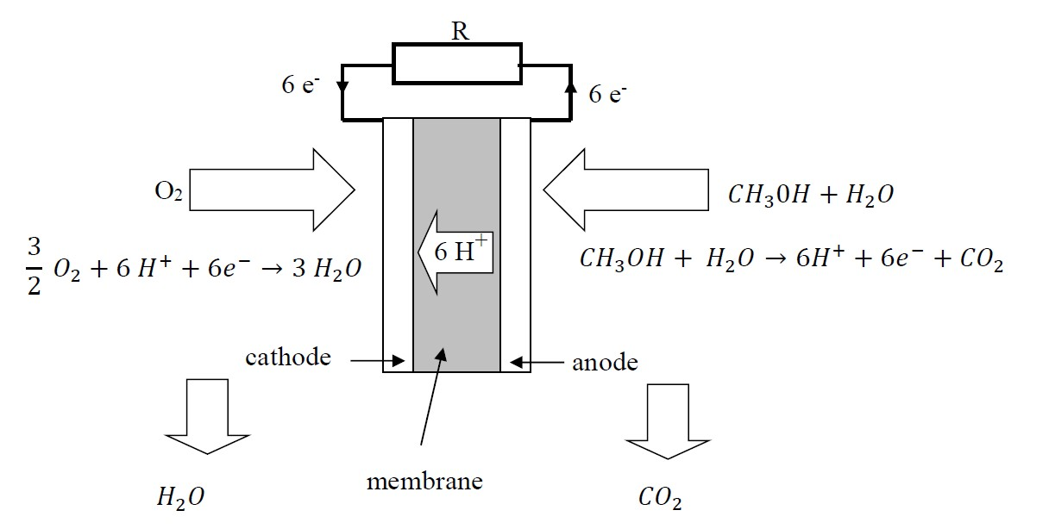
Figure 9: Working principle of the Direct Methanol Fuel Cell
Due the compact energy storage using methanol, the DMFC is used in mobile phones, laptops… where smaller powers and smaller amounts of energy are needed (the low efficiency must be taken into consideration). Although some references mention the use of DMFC in transport systems, the PEMFC and the AFC are more important fuel cell types here.
4.1.4: Other fuel cell types
The PEMFC, the AFC and the DMFC are low temperature fuel cell types. Although there exist other types of low temperature fuel cells, they are the most important types. There also exist so-called high temperature fuel cells like the Phosforic Acid Fuel Cell (PAFC), the Protonic Ceramic Fuel Cell (PCFC), the Molten Carbonate Fuel Cell (MCFC) or the Solid Oxide Fuel Cell (SOFC). These high temperature fuel cells are used in large scale energy applications including CHP applications (Combined Heat and Power). Due to the long start-up times of these high temperature fuel cells, they generally have no applications when driving road vehicles.
4.2: The drivetrain of a Fuel-Cell Electric Vehicle
A global overview of a drivetrain of a Fuel-Cell Electric Vehicle is shown in Figure 10. Notice first of all the fuel cell stack which is a DC voltage source which provides the power/energy needed to drive the vehicle. The fuel cell stack is almost always a PEMFC and notice also hydrogen storage is needed (e.g. using a dedicated high pressure tank). A DC to DC converter is used to adjust the DC voltage level of the fuel cell to the desired value and using an inverter the electrical motor (it is indeed an AC motor) is fed. The output voltage of the inverter has an adjustable RMS value and an adjustable frequency which allows to control the motor behaviour (e.g. the speed).
The configuration of Figure 10 also contains battery energy storage. When braking the car, the kinetic energy is converted into electrical energy by the electrical motor/machine which behaves as a generator. The generated electrical energy is stored in the battery. When needed, it is also possible to charge the battery using energy from the fuel cell.
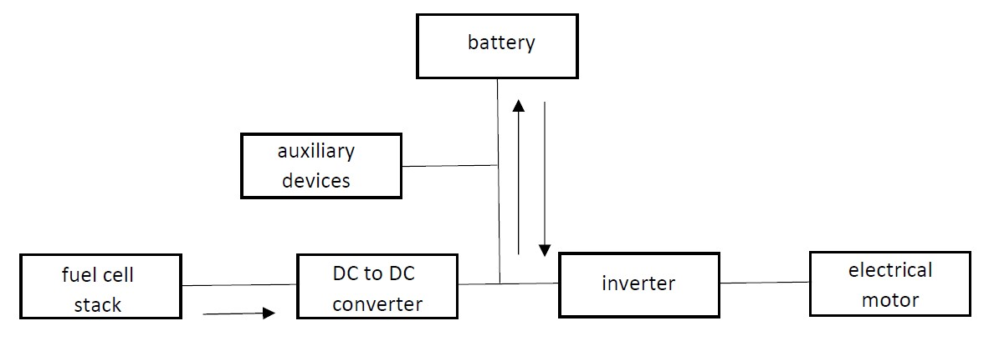
Figure 10: Drivetrain of a Fuel-Cell Electric Vehicle
The battery is also able to assist the fuel cell when the vehicle needs a large power (e.g. during acceleration). Possibly in parallel with the battery, additional supercapacitors are available. Also these supercapacitors can store and provide energy (supercapacitors are well suited to provide large power peaks).
4.2.1: Plug-in Fuel Cell Vehicles
In the configuration of Figure 10, all energy originates from hydrogen. Alternatively, there also exist plug-in fuel cell vehicles (PFCV). Such a PFCV has a larger battery and a smaller fuel cell. If the hydrogen is made of renewable sources and the electrical energy needed to charge the battery comes from renewable sources as well, the vehicle configuration supports the introduction of renewable energy in the society.
5: Challenges and obstacles when introducing Fuel-Cell Electric Vehicles
A breakthrough of fuel cell based vehicles needs a decent hydrogen distribution system as it is available for diesel or gasoline today. At present, the number of refueling points is still too limited. At the other hand side, refueling with hydrogen is a fast process requiring only a few minutes (contrary to charging a battery which takes a lot of time).
Quite a lot of people share the opinion that fuel cell vehicles mainly have a future when considering heavy-duty vehicles like buses. The supply of hydrogen is very important and buses have the opportunity to be able to refuel in one central place i.e. only one single refilling point is needed. Moreover, fuel cells are expensive (although the prices are decreasing, they are still expensive). The large investment implies the fuel cell vehicles need to be used for many hours each day in order to be cost-effective. Additionally, a breakthrough of fuel cells will imply larger production numbers and mass production. This mass production is expected to decrease the investment costs when constructing a fuel cell car.
Moreover, the durability of a fuel cell stack must be sufficiently high (especially since a fuel cell stack is expensive). All components of the fuel cell degrade over time from usage. The degradation accelerates when the fuel cell is exposed to extreme conditions or when the performance limits are exceeded. By overdimensioning the system, it is possible to prevent an exceedance of these limits but this overdimensioning accounts for a further increase of the investment costs.
To avoid extreme conditions in the fuel cell and increase the lifespan, various sensors are used to monitor the main physical quantities. It is important to maintain the optimal operational conditions. Real-time controllers allow to diagnose the health status of the fuel cell.
In the early stage of fuel cell technolgy, fuel cells barely survived a few hundred hours of operation. Today, attempts are made to reach lifespans of 10 000 hours (the use of durable materials is also needed).
Another aspect is the uncertainty about hydrogen safety. For instance, hydrogen tanks can explode since the hydrogen is possibly stored at a pressure of 70 MPa (700 times the atmospheric pressure). Moreover, hydrogen is flammable when it is mixed with oxygen. It is a challenge to construct decent hydrogen tanks. In case of a car crash, it is important the hydrogen tank deforms and does not crack which prevents an escape of the hydrogen. In case the hydrogen tank is exposed to a fire (and a temperature rise occurs), a thermally activated pressure-relief device is needed. This thermally activated pressure-relief device will open an emergency vent when the temperature is too high.
References
G. Boyle, Renewable Energy: Power for a Sustainable Future, Oxford University Press, 2012, ISBN 978 0 19 954533 9.
EG & G Technical Services, Fuel Cell Handbook, U.S. Department of Energy, 2004.
C. Gearhart, Hydrogen: What’s Different Now, IEEE Electrification Magazine, vol. 6, no. 1: Hydrogen Fuel Cells for Transportation, March 2018, pp. 4-7.
G. Hoogers (ed.), Fuel Cell Technology Handbook, CRC Press, London, 2003, ISBN 0-8493-0877-1.
Jungik Kim, Saehoon Kim, Obstacles to the Success of Fuel-Cell Electric Vehicles, IEEE Electrification Magazine, vol. 6, no. 1: Hydrogen Fuel Cells for Transportation, March 2018, pp. 48-54.
J. Kurtz, M. Peters, M. Muratori, C. Gearhart, Renewable Hydrogen – Economically Viable: Integration in the U.S. transportation sector, IEEE Electrification Magazine, vol. 6, no. 1: Hydrogen Fuel Cells for Transportation, March 2018, pp. 8-18.
T. E. Lipman, A. Z. Weber (eds.), Fuel Cells and Hydrogen Production, A Volume in the Encyclopedia of Sustainable Science and Technology, 2nd edition, Springer, New York, 2019, ISBN 978-1-4939-7788-8.
Y. Manoharan, S. E. Hosseini, B. Butler, H. Alzharani, B. Thi Fou Senior, T. Ashuri, J. Krohn, Hydrogen Fuel Cell Vehicles: Current Status and Future Propect, Applied Sciences, vol. 9, 2296, June 2019, doi:10.3390/app9112296, www.mdpi.com/journal/applsci.
E. Muljadi, S. Hossain, Powering Transportation with Hydrogen Fuel Cells, IEEE Electrification Magazine, vol. 6, no. 1: Hydrogen Fuel Cells for Transportation, March 2018, pp. 2-3.
Bandi Mallikarjuna Reddy, Paulson Samuel, Narapureddy Siva Mohan Reddy, Gorvernment Policies Help Promote Clean Transportation in India, IEEE Electrification Magazine, vol. 6, no. 1: Hydrogen Fuel Cells for Transportation, March 2018, pp. 27-36.
F. Un-Noor, S. Padmanaban,L. Mihet-Popa, M. Nurunnabi Mollah, E. Hossain, A Comprehensive Study of Key Electric Vehicles (EV) Components, Technologies, Challenges, Impacts and Future Direction of Development, Energies, Energies, vol. 10, 1217, August 2017, doi:10.3390/en10081217, www.mdpi.com/journal/energies.
References: websites
Alkaline Fuel Cell: https://en.wikipedia.org/wiki/Alkaline_fuel_cell
Direct Methanol Fuel Cell: https://en.wikipedia.org/wiki/Direct_methanol_fuel_cell
Fuel Cells: https://en.wikipedia.org/wiki/Fuel_cell
Hydrogen: pdf document retrieved from https://www.need.org/Files/curriculum/infobook/HydrogenS.pdf
Hydrogen: https://en.wikipedia.org/wiki/Hydrogen
Hydrogen production: https://en.wikipedia.org/wiki/Electrolysis_of_water and https://en.wikipedia.org/wiki/Chloralkali_process

