Considerations by the introduction of electric vehicles
1: Introduction
In a lot of countries, an electrification of the fleet of cars is going on. When designing the drivetrain, several alternatives arise which includes the use of different energy storage solutions. Often, a distinction is made between six types of drivetrains.
- ICE: only an internal combustion engine is used to drive the car. At present, this is the most common type of drivetrain. It is also still the most common type of drivetrain used in newly sold cars. Athough the use of an ICE alone is still dominant, the rise of other types of drivetrains imply the market share of entirely ICE driven cars will decrease in the future.
- HEV: hybrid electrical vehicle. The drivetrain combines the use of a combustion engine and an electrical motor in order to combine the advantages of both technologies. Several approaches exist but an important distinction is the difference between a series HEV drivetrain and a parallel HEV drivetrain. Energy is stored using fossil fuels and a battery.
- PHEV: plug-in hybrid electrical vehicle. Similar with a HEV, the drivetrain combines the use of a combustion engine and an electrical motor. It is important the car can be connected with the electrical power grid which allows additional charging of the battery.
- REEV: range extended electrical vehicle. The car is only driven using an electrical traction motor fed by a battery. The battery can be charged using a plug-in connection with the electrical power grid. There is also an internal combustion engine which is used to drive an electrical generator which also allows to charge the battery (which feeds the electrical traction motor). Instead of a battery, also a fuel cell can be used.
- BEV: battery electrical vehicle. The car is only driven using an electrical motor fed by a battery. There is no internal combustion engine implying the battery is charged using a plug-in connection with the electrical power grid.
- FCEV: fuel cell electrical vehicle. The car is only driven by an electrical motor i.e. there is no internal combustion engine. Instead of a battery, a fuel cell is used to feed the electrical motor. The energy is stored using hydrogen. By making a plug-in connection with the electrical power grid, hydrogen can be produced. Alternatively, hydrogen can be bought at a hydrogen refuelling station.
At present, ICE based drivetrains are dominant but conventional HEV vehicles (e.g. the Toyota Prius) gain importance. When considering BEVs, the cars developed, manufactured and sold by Tesla are well known. But (almost) all car manufacturers perform research in the development of an increasing electrification of their drivetrains. The future of the market is unclear implying that different manufacturers have different opinions on that future. There are important differences in the enthusiasm with which the manufacturers perform reseach in the different types of drivetrains. A typical distinction is the choice between battery based or fuel cell based (using hydrogen) developments.
2: Introducing electrical vehicles in the society
The electricifation of the fleet of cars in a society is a long term evolution. From the point of view of the consumers, buying and using these newer types of cars, today mainly the so-called “early EV adopters” are important. In general, these “early EV adopters” are high-income and well-educated consumers. Basically a distinction can be made between the “trendy greens” and the “TCO sensitives”. The “trendy greens” use some type of electrical vehicle because they are environmentally conscious, they are willing to try new technologies and they like to be trendy. The “TCO sensitives” mainly care about the total cost of ownership (TCO). They are willing to change their travel habits in order to save money. Of course, often a combination of the “trendy green” and the “TCO sensitives” their motivations is noticed.
In order to reduce emissions of ${CO}_{2}$ in the atmosphere or in an attempt to be less dependent on the use of fossil fuels, a lot of governments stimulate the electrification of the fleet of cars. Several approaches exist. For instance in urban areas, electrical vehicles have preferential parking permits or they have the permission to drive in taxi and bus lanes (especially during rush hours this accounts for a considerable time saving). The financial aspect is also important. From a technical point of view, electrical vehicles are still more expensive than cars having only an internal combustion engine. By giving subsidies when buying an electrical vehicle, the price gap can be reduced. Additionally, exemptions from purchase tax, VAT, registration tax… can be an important incentive. During the life time of the car, exemptions from circulation tax, toll road charges… are also important incentives. Governments can also impose fleet emission regulations which discourages the use of traditional cars having only an internal combustion engine (or additional taxes… can be imposed).
Governments can also stimulate the use of electric vehicles by providing the required infrastructure (electrical charging stations, appropriate parking spots…). By stimulating the use of electrical cars, also all car manufacturers are stimulated to develop, manufacture and sell electric cars. In case a country has its own automotive industry, research and product development are important to pioneer the technology and keep the value chain in the country.
The drivers of the cars are not always the owners. An important part of the passenger cars in Europe belong to a corporate fleet. Also these companies can be stimulated to buy (more) electrical vehicles. Especialy when the cars have predictable driving patterns, the use of electrical vehicles can be a possibility. Due to the predictable driving patterns, the range requirements are known. This (partially) remedies the main advantage of a BEV which is battery fed i.e. the limited range before recharing of the battery is needed.
As already mentioned, the total cost of ownership (TCO) of a car is very important. Governments have an impact by giving subsidies, reducing taxes… But also the pure financial aspects of the technical solutions are very important. The evolution of (fossil) fuel prices and the evolution of battery pack prices (batteries are expensive which implies a reduction of the battery pack prices is very important) have a major impact. Charging infrastructure (slow and fast chargers) for the batteries is mandatory. Not only a standardization of the battery charging infrastructure is important but also the cost of installing, using and maintaining the charging infrastructure has a huge impact. The price of a $kWh$ is also important.
How fast the electric power trains will dominate the fleet of cars is unknown. But it is (almost) sure electric vehicles will become an important part of the everyday life.
3: Overview of the main drivetrains
3.1: Drivetrain based on an internal combustion engine
At present, the majority of the cars are entirely driven by an internal combustion engine (ICE) as visualised in Figure 1. An internal combustion engine is driving the wheel axle and a transmission (gearbox) is needed since the speed of rotation of the combustion engine is much higer than the speed needed by the wheel axle.
In order to reduce the dependence on fossil fuels and to obtain a reduction of exhaust gases (especially in urban areas a better air quality is desired), the use of this type of drivetrain will be discouraged in the future. Notice however the use of the drivetrain in Figure 1 also has a number of advantages. Fossil fuels are stored in a tank which allows a very compact energy storage (implying a large range). Additionally, refueling gasoline or diesel goes very fast and there is an existing infrastructure of petrol stations (i.e. there is no dependence on electric infrastructure including battery charging installations). Research is going on to reduce the fuel consumption of internal combustion engines (including automatic start/stop), to reduce the emission of exhaust gases…
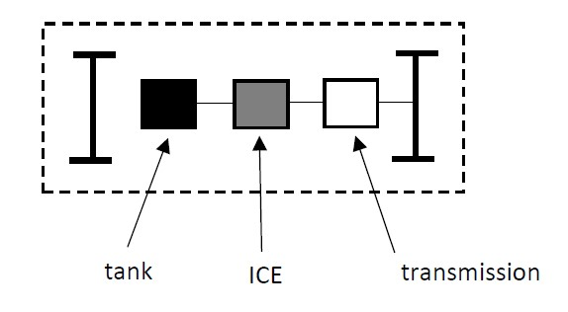
Figure 1: Drivetrain based on an internal combustion engine
3.2: Hybrid Electric Vehicle and Plug-in Hybrid Electric Vehicle
Figure 2 visualises a Plug-in Hybrid Electric Vehicle. Notice the transmission which drives the wheel axle. The transmission is driven by an internal combustion engine and an electrical motor (a parallel configuration is visualised in Figure 2). The combustion engine is the primary mover which is supported by a somewhat smaller electrical motor.
The combustion engine also drives an electrical generator. By converting mechanical energy into electrical energy a battery will be charged. The battery allows the use of an electrical motor and a power electronic converter is used to control the speed of the electrical motor.
In case of a Plug-in Hybrid Electric Vehicle (PHEV), the electrical power grid infrastructure allows to charge the battery in e.g. a garage. In case the plug-in facility is not available, a Hybrid Electric Vehicle (HEV) is obtained.
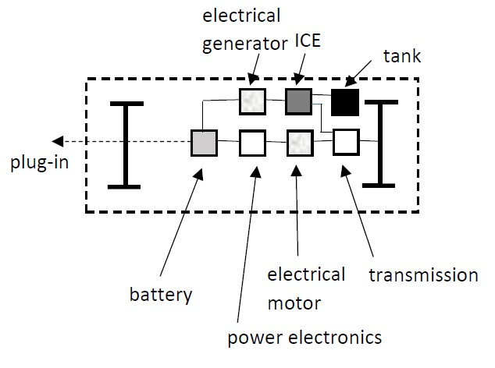
Figure 2: (Plug-in) Hybrid Electric Vehicle
By combining an electrical motor and an internal combustion engine, a higher efficiency for the combustion engine can be obtained. A reduction of the emission of exhaust gases is also possible. Although the combustion engine is still the primary source of propulsion, fully electric driving is possible (e.g. at a lower speed or in case of a lower distance in an urban area).
Due to the fuel tank and the combustion engine, it is still possible to use the existing infrastructure of petrol stations. Due to the compact energy storage, a large range is still available. This large range is not obtained in case of fully electric driving. The combustion engine is still the primary source of energy i.e. the car still mainly relies on fossil fuels and exhaust gases are produced.
3.3: Range Extended Electric Vehicle
Figure 3 visualises a Range Extended Electric Vehicle (REEV). Actually, a series hybrid configuration is obtained. Notice the presence of a fuel tank which allows the use of an internal combustion engine to drive an electrical generator. The speed of the combustion engine is not related with the speed of the electrical motor (and the speed of the car). This allows to choose an optimal working point for the combustion engine which increases the efficiency, reduces fuel consumption and reduces the emission of exhaust gases.
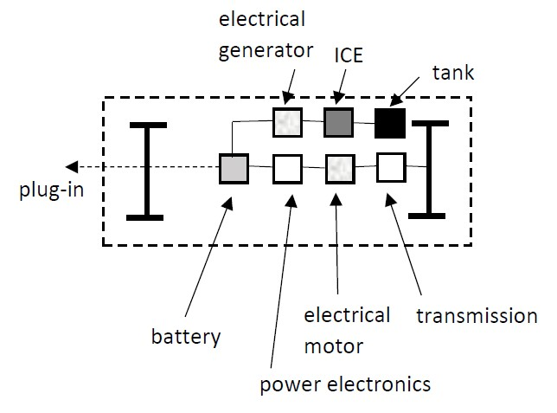
Figure 3: Range Extended Electric Vehicle
The electrical generator converts mechanical energy into electrical energy to allow battery charging. Battery charging is also possible by using a plug-in connection with the electrical power grid. The battery allows the use of an electrical motor and a power electronic converter is used to control the speed of the electrical motor.
3.4: Battery Electric Vehicle
Figure 4 visualises a Battery Electric Vehicle (BEV). A configuration without a combustion engine is obtained i.e. pure electric traction is obtained. A large battery is needed to store a sufficient amount of energy which allows to feed the electrical motor (very often lithium-ion batteries are used). A power electronic converter is used to control the speed of the electrical motor.
It remains a challenge to store a sufficiently large amount of energy to obtain an acceptable range. Increasing the range of a BEV is still a technical challenge. Batteries are charged using slow and fast chargers fed by the electrical power grid. Even with fast chargers, charging the battery sufficiently fast remains a technical challenge. Even with fast chargers, charging times of 20 to 30 minutes must be taken into account (in case of slow charging up to eight hours of charging can be needed). At present, still a lot of countries lack charging infrastructure and investments are needed to increase the number of chargers.
When neglecting the environmental impact of the electrical energy production, a BEV is a zero emission car. The efficiency of an electrical motor is much higher than the efficiency of an internal combustion engine. In case the electrical energy is generated using thermal power plants, the rather low efficiencies of these power plants must be taken into consideration. Actually, the final goal is generating the electrical energy using renewables like solar energy, wind energy or hydroelectric energy.
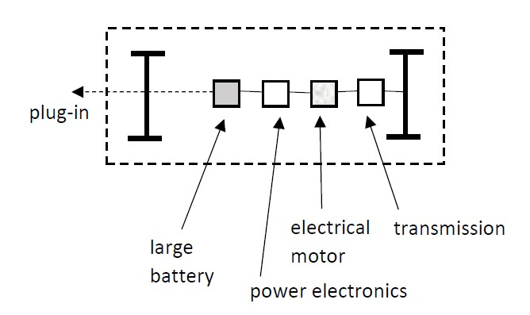
Figure 4: Battery Electric Vehicle
3.5: Fuel-Cell Electric Vehicle
Figure 5 visualises a Fuel-Cell Electric Vehicle (FCEV). The wheel axle is driven by an electrical motor using a transmission to obtain the required speed. The use of a Proton Exchange Membrane Fuel Cell where the fuel cell stack is fed by hydrogen is the most popular. A hydrogen tank is needed to store the hydrogen.
Also with the Fuel-Cell Electric Vehicle it is a challenge to obtain a sufficiently large range. Since hydrogen is a very thin gas, even with high storage pressures ranging from typically 350 to 700 bar, the energy storage capacity is limited.
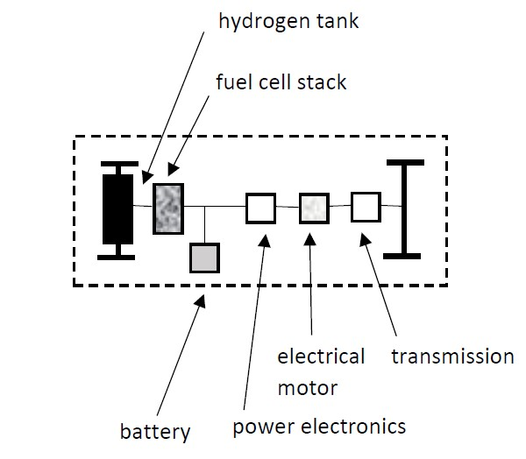
Figure 5: Fuel-Cell Electric Vehicle
In case no harmful emissions occur to produce the hydrogen, a FCEV is a zero emission car which is useful in e.g. urban areas. In comparison with the charging process of a battery, refueling with hydrogen is fast (it only takes a few minutes). At present, the infrastructure to generate, transport and distribute hydrogen is still missing in the vast majority of the countries. When considering hydrogen based infrastructure, safety issues need to be taken into account.
4: Battery charging
4.1: Lithium-ion batteries
When considering a HEV, a PHEV, a REEV and especially a BEV, the use of batteries is very important (even in the FCEV of Figure 5 some battery energy storage is considered). At present, a lot of research is going on to improve the battery technology. Batteries must be reliable and must be able to store a sufficient amount of energy in a compact volume (with a more or less limited weight). Batteries must have a sufficiently large round-trip efficiency i.e. the losses while charging and discharging the battery must be limited. Batteries are quite expensive (price drops are welcome) implying also a long life expectancy is desired.
At present, the lithium-ion battery technology is dominant and a distinction exists between the use of small-format cells and large-format cells. The small-format cells (which are used in the BEVs of Tesla) are actually lithuim-ion batteries which are already used for consumer electronics. This implies these small-format cells are produced at a large scale which reduces the price. An appropriate battery management systems (BMS) with decent cooling is very important. When (over)-heating of the cell occurs, oxygen dissociates which can create a self-sustaining thermal reaction.
The vast majority of the BEV manufacturers use large-format cells. The energy density is lower implying they are less vulnerable to overheating. Unfortunately, they are more expensive since they do not benefit from the large scale production like the small-format cells do.
The high purchase price of electric car configurations still hampers their breakthrough. Infrastructure costs (e.g. installing a charging point in the garage), maintenance costs, fuel costs, insurance costs… all have an impact on the total cost of ownerschip (TCO) but the price of the battery packs is really an important part of the total cost of ownership. A reduction of the battery prices is mandatory in the future.
4.2: Charging infrastructure
Petrol stations are widespread along the world allowing to fill the tank with gasoline, diesel… This infrastructure is useful for drivetrains having only an internal combusion engine, for (plug-in) hybrid electric vehicles and for range extended electrical vehicles. A fuel-cell electric vehicle needs hydrogen refueling stations which are not commonly available.
Also when considering the infrastructure needed to charge batteries, still a lot of infrastructure is missing. PHEV, BEV (and possibly also a REEV) need battery chargers. When using wired charging, plugging in of the car is often performed at an appropriate station. The appropriate charging station can be provided by the public sector, provided by private companies (e.g. intended to be used by their employers during the working hours or intented to be used by customers who pay for the service) or be owned by the car driver himself (charging at home which is commonly slow charging).
In order to obtain the situation that electric vehicles are not only used for local urban travel i.e. to allow intercity travel, fast charging stations are needed along the highways. Due to the lack of fast charging stations along the highways, BEVs are often the second car of a household. The BEV is used for daily use when crossing shorter distances and the ‘first’ car is used for longer intercity trips.
The time needed to charge a battery mainly depends on the power level extracted from the grid and the battery size (i.e. the amount of energy to be stored in the battery). As already mentioned, a distinction exists between slow and fast chargers.
Multiple types of plugs and sockets are used implying standardisation is very important and needed. In case of slow charging, a European standard plug (Type 2 “Mennekes”) is most common. In case of fast charging, three standards are important: the Tesla Supercharger, the European/US CCS “Combo” and the Japanese CHAdeMO.
The existence of charging stations with standardised plugs and sockets is very important. But also identification and payment systems must be accessible for as much drivers as possible. The use of open source protocols is needed to allow the use of the same identification, communication and payment systems for all charging stations (also if these charging systems are owned by different organisations). A cooperation between governments and private organisations can boost the development of the required infrastructure.
4.3: Alternatives to wired battery charging
Instead of using charging stations which allow to charge the batteries, batteries can also be swapped. When reaching a battery swapping station, the partially discharged battery of the car is removed and another fully charged battery is inserted. Such a fast battery swapping approach avoids the long battery charging times.
Another interesting approach is the use of wireless charging. By mounting coils in the road and feeding them with an alternating current, electromagnetic fields are generated. The energy in these electromagnetic fields are used to charge the battery of the car while driving (again avoiding battery charging times in e.g. a garage). Research is going on and it has only been realised in a few pilot locations.
5: Conclusions
The use of Plug-in Hybrid Electric Vehicles, Hybrid Electric Vehicles, Range Extended Electric Vehicles, Battery Extended Vehicles and Fuel-Cell Electric Vehicles has a future. An overview of these drivetrain types has been considered. The need to have battery charging instructure is also discussed. Other chapters will discuss technical details.
References
Amsterdam Roundtables Foundation, E Volution: Electric vehicles in Europe: gearing up for a new phase?, Amsterdam Roundtable Foundation and McKinsey & Company, Amsterdam, The Netherlands, April 2014.

