Charging the batteries of electric vehicles
1: Introduction
The rise of electric vehicles which need battery based energy storage implies the need for a decent charging infrastructure. Several charging modes exist and an overview of these modes and the technical aspects are considered.
At present, the majority of the cars (traditional cars) use an internal combustion engine to drive the car. By filling the tank of the car with gasoline or diesel (which only requires a few minutes) actually a MJ energy transfer occurs. Indeed, one liter of gasoline accounts for 34.2 MJ and one liter of diesel accounts for 35.8 MJ.
Suppose a car has a tank filled with 50 liters of gasoline. This accounts for 1710 MJ which equals 475 kWh (1 kWh = 3.6 MJ). Suppose a battery is used instead of gasoline and the battery is charged using a single phase grid of 230V and a current of 16A is extracted from the grid (with a unity power factor). The battery is charged with a power of 3.68 kW implying 129 hours are needed to store the desired 475 kWh. This numerical example shows it is a challenge to build charging infrastructure which charges the batteries with an acceptable speed.
1.1: Time needed to charge a battery
It is quite realistic to assume that an electrical vehicle consumes approximately 0.2 kWh to drive 1 km. In case of a 1 kW charger, 1 hour charging is needed to provide a range of 5 km i.e. a charging speed of 5 km/h is obtained.
Suppose the charging infrastructure is fed by a single phase AC grid with an rms voltage of 230V. Suppose a 16 A current (with a unity power factor) is extracted from the grid. Charging occurs with a power of 3.68 kW implying a charging speed of 18.4 km/h. Actually this charging procedure can be considered to be slow.
The so-called ‘semi-fast’ charging can occur in case of a single phase AC grid of 230 V with a current of 32 A. A charging power of 7.36 kW implies a charging speed of 36.8 km/h. A three phase grid with a 400 V line voltage and a current of 16 A implies a charging power of 11.1 kW which gives a charging speed of 55.4 km/h. When using the same three phase grid with a line voltage of 400 V, a current of 32 A allows a charging power of 22.2 kW. In that situation, a charging speed of 110.9 km/h is obtained.
Fast charging assumes charging powers which exceed 50 kW. In such a situation, charging speeds which exceed 250 km/h are obtained. Especially this ‘fast charging’ approach needs an appropriate charging unit in combination with a power grid which is able to supply these powers.
2: Charging batteries of an electrical vehicle
A distinction is made between four charging modes:
- Mode 1: slow charging from a regular 16 A socket (single phase or three phase). Charging mode 1 is simple and cheap and applicable everywhere (from a technical point of view). Since no protection device is mounted into the cable, the electrical installation must take care of the safety regulations (e.g. overload protection and earth leakage protection). In case the battery of a car must be charged, the rectifier and the battery charger are mounted in the car. Notice however that in a lot of countries ‘mode 1’ charging is not allowed for electric vehicles.
- Mode 2: slow charging from a regular socket (single phase or three phase). AC currents up to 32 A are possible but quite often the maximally consumed current is lower (e.g. 10 A). Charging mode 2 is simple and cheap and applicable everywhere. A protection device is built into the cable. The ICCB (In Cable Control Box) contains an overcurrent protection and a residual-current circuit breaker. The rectifier and the battery charger are mounted in the car (there is an AC connection with the car). Notice however that slow charging of the battery occurs i.e. loading the battery can take several hours.
- Mode 3: slow or fast charging using a dedicated EV multi-pin socket. The socket is a fixed part of the electrical installation. The multi-pin socket contains control and protection functions (overcurrent protection and protection against residual currents). The control function realises communication between the socket and the car in order to allow a safe charging process. The rectifier and the battery charger are mounted in the car (there is an AC connection with the car). When applicable, it is an option to charge the battery during the night when electrical energy is cheaper.
- Mode 4: fast charging using special charger technology (e.g. CHAdeMO). The rectifier and the battery charger are integrated in the charging point. This implies no rectifier and charger are needed inside the car i.e. there is a DC connection with the car. A mode 4 charger is expensive implying it is normally not available at home. Mode 4 chargers are typically available in public parking lots... The large powers also require an electrical grid which is able to provide these powers (e.g. a three phase grid with 400 V line voltage able to provide currents of 80 A). When using lithium-ion batteries, fast charging does not have a negative impact on the life expectancy of the battery (e.g. by loading a 24 kWh battery with a power between 36 and 48 kW no problems arise, in case the power is too high still a decrease of the life expectancy will occur).
2.1: Charging procedure with proximity pilot and control pilot
Figure 1 visualises charging infrastucture used to charge the batty of an electric vehicle. Notice the charging point with a socket outlet which allows to plug-in a cable. The other side of the cable contains a connector which allows to connect with the vehicle inlet.
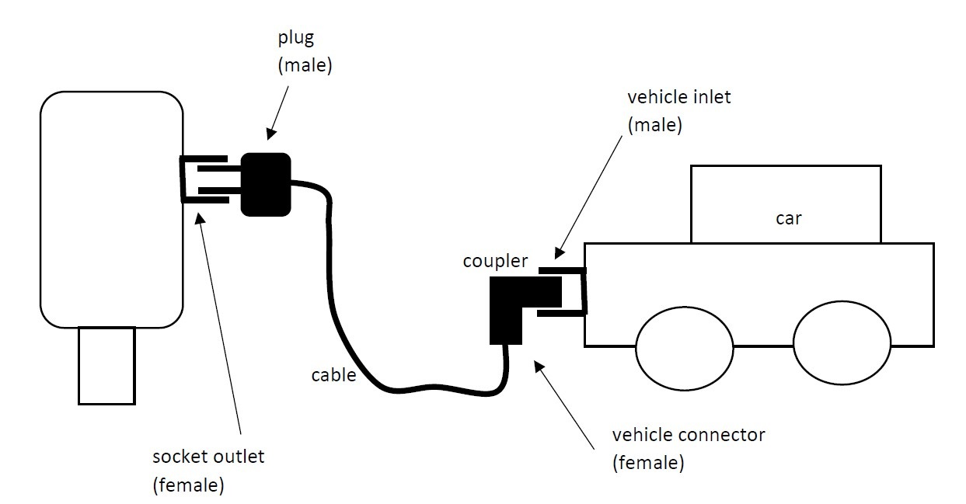
Figure 1: Charging infrastructure
When considering mode 3 charging, Figure 2 visualises the conductors of a dedicated EV multi-pin socket/plug. Notice the neutral conductor N and the phase conductors L1, L2, L3 (in case of three phase charging) which allow to transport the AC power (energy) from the socket/plug to the connector/inlet of the electrical vehicle used to charge the battery. Notice also the control pilot CP and the proximity pilot PP. Notice also the protective earth conductor PE.
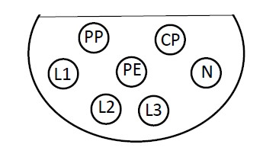
Figure 2: Conductors of a dedicated EV multi-pin socket/plug
Figure 3 visualises the connection between the socket/plug and the connector/inlet of the car with the cable. In the present text, we will restrict ourselves to the basic CP and PP applications. Between PP and PE, a resistor $R_{PP}$ has been mounted in the plug. The resistance of this resistor $R_{PP}$ gives information concerning the maximum current which is allowed in the cable.
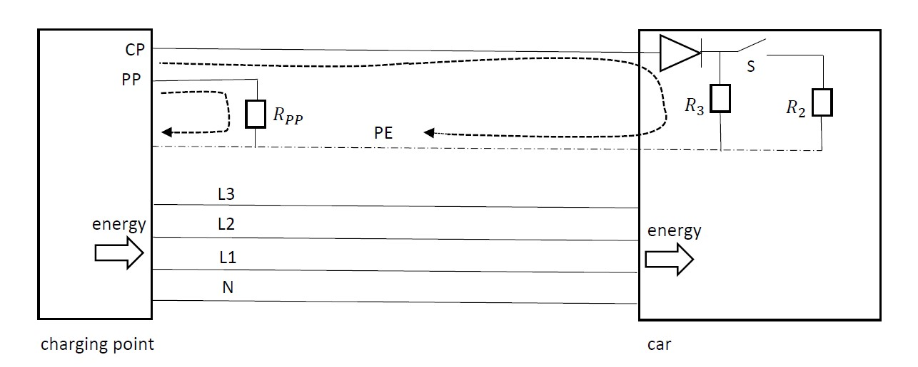
Figure 3: Connection between charging point and car
The proximity pilot PP is not a wire run in the cable (contrary to the control pilot CP which is a dedicated wire in the cable), only a resistor $R_{PP}$ in the plug is connected between PP and PE. The larger $R_{PP}$, the smaller the allowed current in the cable as listed in Table 1.
Allowed cable current | PP resistance $R_{PP}$
$$13 A$$ | $$1.5 kΩ$$
$$20 A$$ | $$680 Ω$$
$$32 A$$ | $$220 Ω$$
$$63 A$$ | $$100 Ω$$

Table 1: PP resistor indicating the allowed cable current
The CP is used to communicate with the electric car as visualised in Figure 4 (and Figure 3). The charging point contains an oscillator generating a PWM voltage with an amplitude of 12 V. The resistance $R_{1}=1 kΩ$. In case the vechicle is not connected with the cable, resistances $R_{2}$ and $R_{3}$ are not present implying the voltage measurement provides a $V_{a}=12 V$. In case the vehicle is connected with the cable and switch S is open, a series connection of $R_{1}=1 kΩ$ and $R_{3}=2.74 kΩ$ is obtained. When neglecting the voltage drop across diode D, $V_{a}≅9 V$ is obtained. An open switch S is an indication from the vehicle that the vehicle is not ready to charge the battery. When the vehicle is ready to charge the battery, switch S will be closed which implies $R_{2}=1.3 kΩ$ is connected in parallel with $R_{3}$. In that situation, $V_{a}≅6 V$ implying the battery can be charged (in case $R_{2}=270 Ω$, , $V_{a}≅3 V$ which means the battery is ready to be charged and ventilation is needed during the charging process).
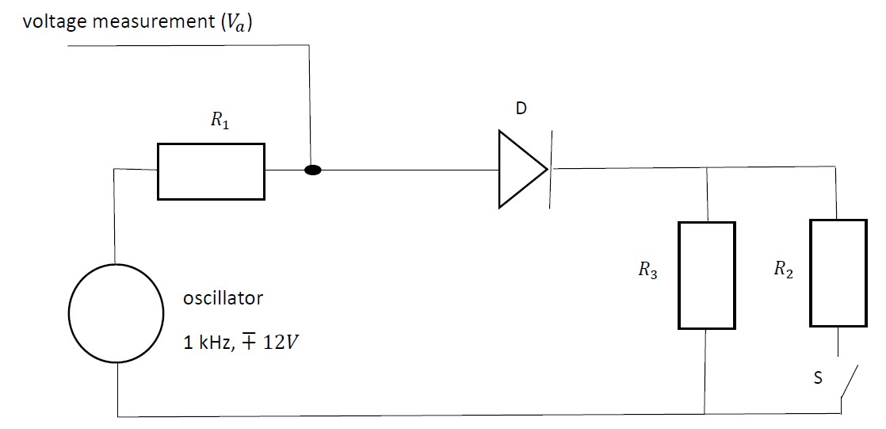
Figure 4: Working principle of the control pilot CP
2.2: Mode 4 fast charging approaches
When considering fast charging, mainly four standards are important:
- ChAdeMo (CHArge de MOve) used by Nissan, Peugeot, Citroën, Kia,…
- CCS (Combined Charging System) used by BMW, GM, Daimler, Volkswagen, Ford,…
- Tesla Superchargers used by Tesla,
- Guobiao recommended standard 20234 (China).
CHAdeMO is a Japanese standard using a DC connection to charge the battery of the vehicle. In case of a 500 VDC voltage with a current of 125 A, a power transfer of 62.5 kW can be realised. The newer CHAdeMO 2.0 version allows a power transfer of 400 kW by using 1000 VDC and 400 A.
The CCS standard also allows high-power DC fast charging. Powers between 80 kW and 350 kW are realistic. There also exists a CCS 2.0 version and a CCS 3.0 version (which will be backwards compatible) is expected. The CCS 3.0 version is intended to allow reverse power transfer, inductive charging and wireless charging communication.
The Tesla Supercharger allows powers between 72 kW and 250 kW (Supercharger V3) using a voltage level of 480 VDC. The Tesla Supercharger allows to charge the Tesla Model S, Tesla Model X and Tesla Model 3.
3: Charging a lithium-ion battery
With some simplification, charging a battery contains two important phases as visualised in Figure 5. During the first phase, the battery will be charged using a constant charging current. This constant charging current is high implying a battery charging process which is as fast as possible. Having reached a specified voltage level, the battery is further charged by applying a constant voltage level. As the state of charge of the battery increases, the charging current will decrease.
The transition from constant current charging to constant voltage charging usually occurs when the battery reaches a state of charge which equals 80% of the total battery capacity. Below a state of charge of 80%, the battery will be charged as fast as possible. Above the state of charge of 80%, the charging speed gradually decreases.
In case of fast charging, only the first phase of the charging process is considered. In case the charging current is not too high, no damage occurs to the battery. Despite this observation, it is really bad for the battery if only fast charging is used. It is important that from time to time also (slower) charging with a constant voltage is performed.
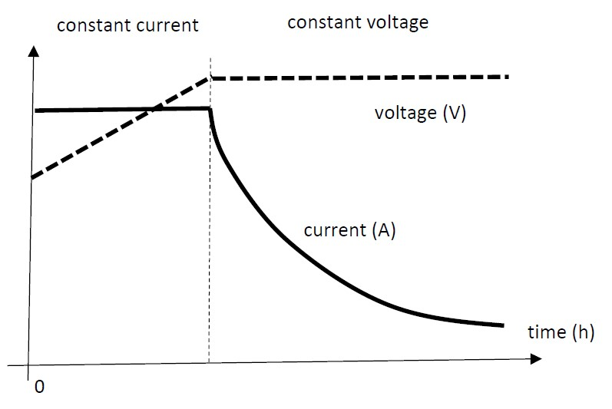
Figure 5: Charging process of a lithium-ion battery
4: Alternatives to battery charging
Since charging a car battery requires quite a lot of time (even in the case of ‘fast’ charging), alternatives which allow to save time are welcome. Two typical alternatives are battery swapping and wireless battery charging.
4.1: Battery swapping
When the state of charge of a car battery is low, the battery can be replaced by a fully charged battery (with a high state of charge) which allows the driver to continue its itinerary. This approach accounts for a number of advantages.
- Battery swapping only requires a few minutes.
- After swapping the battery, a fully charged battery is available. When sufficient battery swapping stations are available, actually an unlimited driving range is obtained.
- The driver does not own the battery. The battery swapping company owns the batteries and the company is responsible for charging the batteries. Taking care of the battery life, providing the charging infrastructure, providing a sufficient number of batteries, … are the responsabilities of the battery swapping company.
- The battery swapping company can also discharge a number of batteries and inject power into the public power grid. By combining grid to vehicle (G2V) and vehicle to grid (V2G) power exchanges, the Smart Grid philosophy can be supported. When there is an excess of electrical power in the grid (e.g. during the night when the power consumption is low in combination with a large power production of e.g. wind turbines), the battery swapping company consumes (cheap) power and charges the batteries. Where there is a lack of electrical power in the grid (e.g. during the day when the power consumption is high in combination with only limited power production by e.g. wind turbines), the battery swapping company injects (expensive) power in the grid by discharging batteries.
When considering battery swapping, there are also a number of disadvantages.
- A sufficient number of battery swapping stations must be available to provide the desired ‘unlimited driving range’.
- The investment costs to provide the required battery swapping stations are high (charging infrastructure, a sufficient number of batteries, swapping infrastructure,…). Finally, all costs made by the battery swapping company must be billed to drivers.
- Standardization of the swapped batteries is mandatory but not obvious. For each car, more than one identical battery is needed.
4.2: Wireless charging
Wireless charging is based on electromagnetic induction. A primary coil is placed on the surface or beneath it. By sending an AC current in the primary coil, an electromagnetic field is obtained which allows to transfer energy to a secondary coil. Voltages are induced in the secondary coil which is mounted under the vehicle. This means the primary coil is the transmitter which is fed by a power supply. The secondary coil is the receiver and using a system controller, it is possible to charge the battery.
The use of wireless charging, also called inductive charging, has a number of advantages.
- There is no physical contact with the verhicle avoiding wear. Since there is no physical contact, high safety properties are obtained.
- Flexible power ratings are possible.
- The approach is weather resistant. Even the presence of snow, dust, sand… has no negative impact.
- Ideas exist concerning the realisation of wireless charging while the car is in motion (dynamic charging) by integrating several primary coils inside the paving.
The use of wireless charging also accounts for a number of disadvantages.
- Although there is no wired connection with the car, a fixed grid connection is needed with the primary coil.
- The transfer efficiencies are quite low. Research is going on to increase the efficiency (using thin coils, using sufficiently high frequencies, optimizing drive electronics..).
- The infrastructure needed to realise wireless charging is expensive in comparison with traditional wired charging.
- A breakthrough of the system requires a sufficient number of wireless charging stations and a sufficient number of induction-recharge ready electrical vehicles. At present, both are uncommon.
5: Battery charging and the integration of renewables
An increased use of electrical vehicles implies an increased need for electrical energy. In case this electrical energy has been generated by e.g. thermal power plants using fossil fuels, they will emit ${CO}_{2}$. In case the additional emissions of ${CO}_{2}$ are the same or larger than the ${CO}_{2}$ emissions of the combustion engine, the transition from combustion engine driven to electrically driven vehicles is not useful or it is even harmful (from the point of view of the total ${CO}_{2}$ impact on the climate). This implies it is useful to generate the electrical energy in an environmentally friendly way.
The integration of photovoltaic panels in the electrical vehicle charging system is an option. The price reductions of the photovoltaic panels imply this option also becomes possible from an economical point of view. Moreover, photovoltaic systems do not require a lot of maintenance (e.g. no moving parts).
A distinction can be made between grid connected systems and standalone systems (no connection with an existing power grid). Standalone systems are used e.g. in remote areas where no grid is available. In more densely populated areas, grid connected systems are commonly used.
An increased use of electric vehicles, with batteries charged with energy originating from the public power grid, is an additional load for that electrical grid. This is especially the case during the day when the electrical power consumption is already high. In case the power needed by the charging points originate from photovoltaic panels, no additional load of the power grid occurs.
Instead of mainly charging the batteries during the night, it is an option to charge the batteries mainly during the day. During the day, the electrical vehicle is parked idly in the parking area implying time is available for charging. Especially in hot climate countries having a lot of sunlight, the photovoltaic panels provide the needed power. When the panels provide more power than needed by the batteries, the excess of power can be injected into the grid when the electricity tariff is high.
In case the solar irradiance is small, the photovoltaic panels are not able to supply the power needed by the battery charging infrastructure. The power grid must provide part of the power which is an additional load for that grid.
5.1: Grid connected battery charging infrastructure integrating photovoltaic panels
A typical battery charging system which integrates photovoltaic panels is visualised in Figure 6. The installation contains three main components.
- A DC-DC converter which contains a maximum power point tracker (MPPT) ensures the photovoltaic array provides the maximum power with the available solar irradiance.
- A bidirectional charger which allows to charge or to discharge the battery of the electric vehicle.
- A bidirectional DC to AC inverter allows to inject power into the public AC power grid. In case charging the battery needs more power than generated by the photovoltaic array, power can be extracted from the grid.
Notice the presence of a DC bus which is connected with the DC-DC converter, the bidirectional charger and the DC to AC inverter. A computer system or microcontroller functions as a central controller. The central controller determines the power flows of the DC-DC converter, the bidirectional charger and the DC to AC inverter.
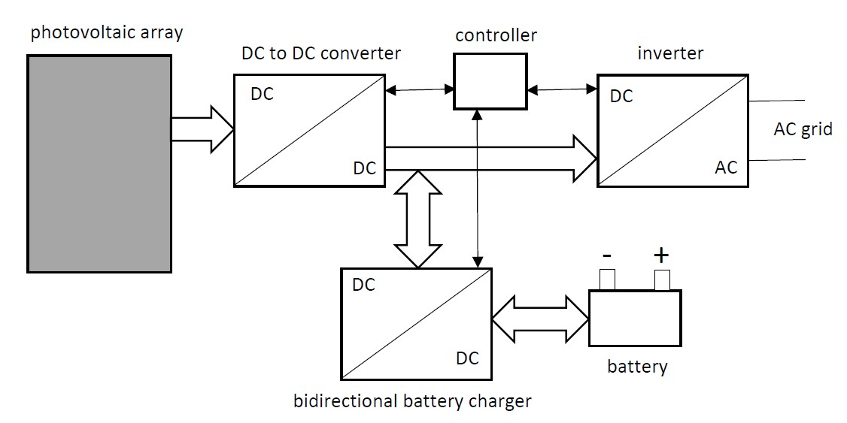
Figure 6: Grid connected battery charging infrastructure integrating photovoltaics
5.2: Modes of operation
Considering the charging infrastructure of Figure 6, mainly five modes of operation exist. In Figure 7, a first mode of operation is visualised where all power generated by the photovoltaic array is injected into the battery. No power exchange with the public power grid occurs. In case the solar irradiance changes, the generated power changes and the power injected in the battery changes. The DC to DC converter and the battery charger are used.
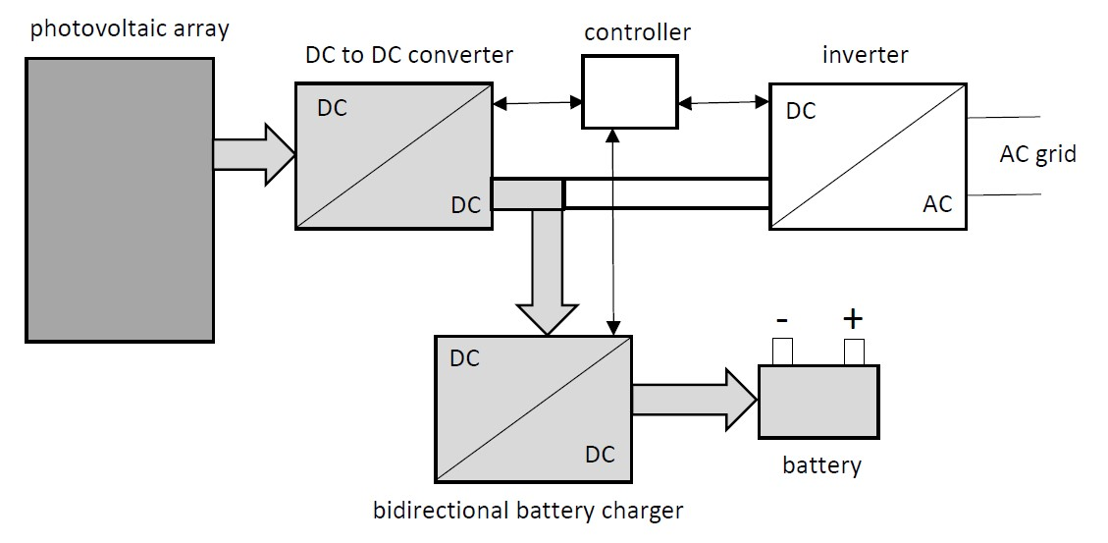
Figure 7: Battery charging using energy from photovoltaic panels
Figure 8 visualises a mode of operation where all power generated by the photovoltaic array is injected into the battery. Additionally, also the grid contributes to the battery charging power. The power derived from the grid depends on the power generated by the photovoltaic array. Since the solar irradiance changes, also the power generated by the photovoltaic array changes. By monitoring the power originating from the photovoltaic array, the power originating from the grid can be adjusted to ensure the required power/energy for the battery of the electrical vehicle.

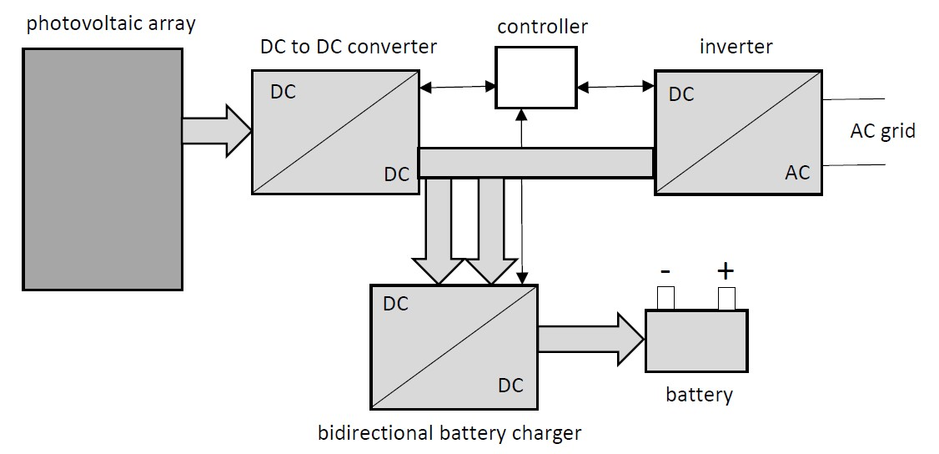
Figure 8: Battery charging using energy from photovoltaic panels and the grid
In case the photovoltaic array is not able to generate power (e.g. during the night), it is still possible to charge the battery using the grid connection. The AC power is converter into DC power. The DC voltage is converted by the battery charger in order to obtain a voltage suitable to charge the battery (see Figure 9).

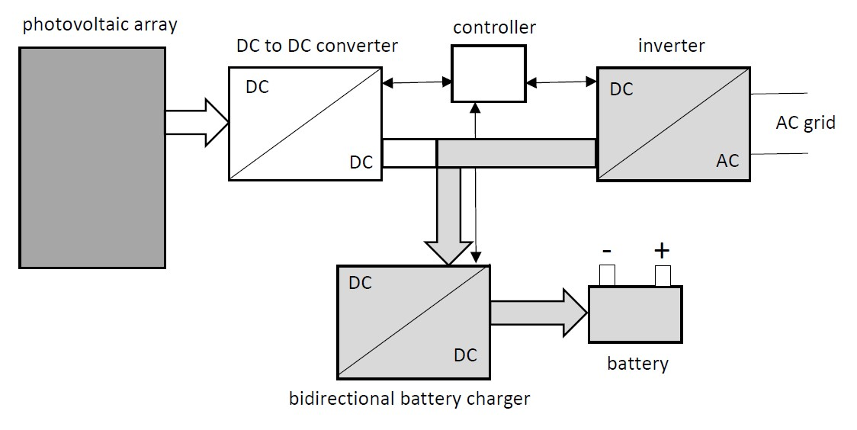
Figure 9: Battery charging using energy from the grid
Figure 10 visualises the situation where no electric vehicle is available. The power generated by the photovoltaic array will be entirely injected into the AC power grid. Even if a vehicle is available, it can be useful to use this mode of operation. This situation occurs when the battery is already fully charged or when the feed-in-tariff for the power grid is sufficiently high. This high feed-in-tariff implies the decision to sell the electrical energy instead of charging the battery.

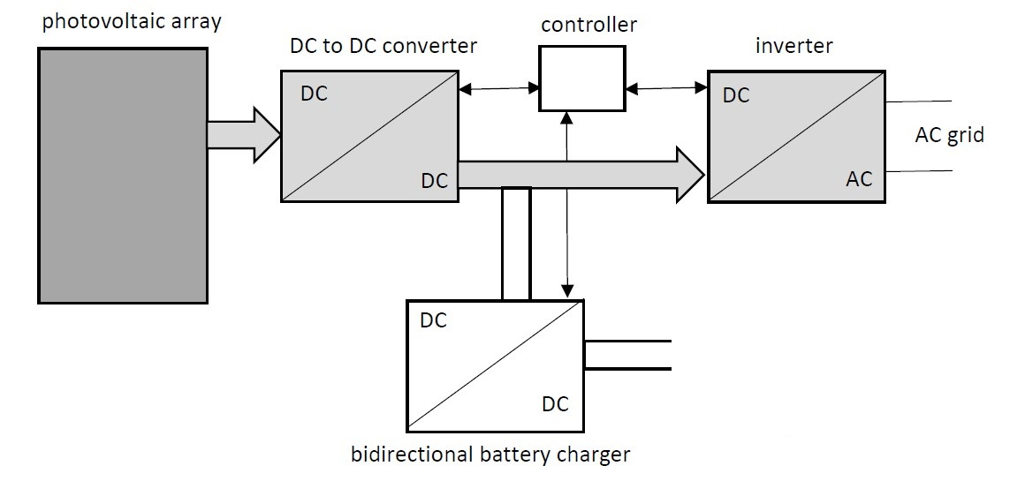
Figure 10: Injection of all power into the AC power grid
Finally, Figure 11 visualises a situation where no power is generated by the photovoltaic array. Instead of charging the battery of the car, the battery is discharged and the power is injected into the AC power grid. This Vehicle to Grid mode (V2G) allows to support the power balance of the grid. This situation will mainly occur during the day when the feed-in-tariff of electrical power is high.
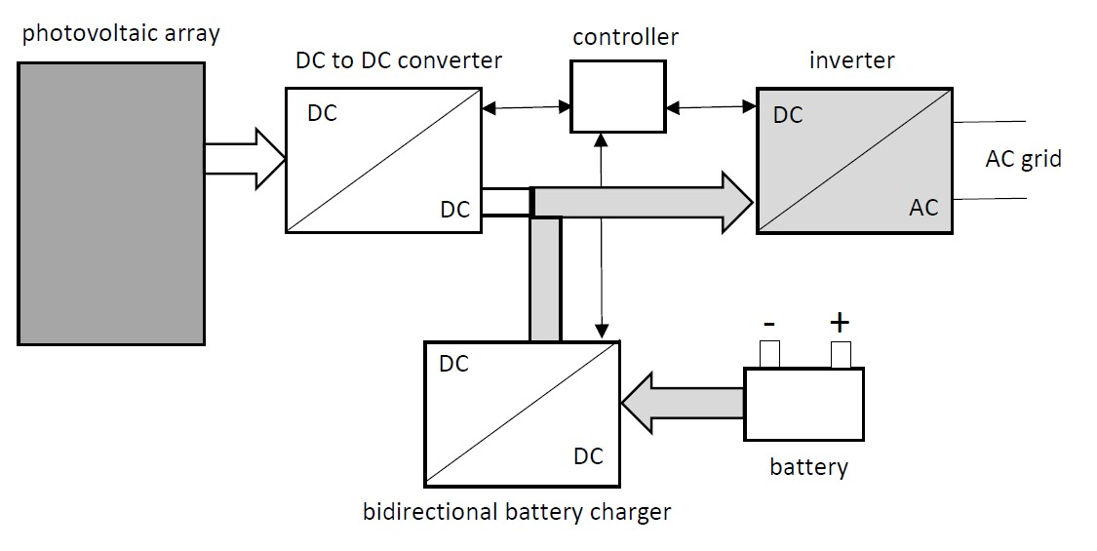

Figure 11: Discharging the battery to inject power into the AC power grid
5.3: Photovoltaic standalone charging infrastructure
In case there is no connection with a power grid, a standalone system is obtained. Using the power of a photovoltaic array, it is still possible to charge the battery of a vehicle. It is possible to realise a connection (without additional storage) between the photovoltaic array and the electric vehicle (containing a battery). Especially when the solar irradiance is small, the generated power will be small and the charging of the battery will be too slow.
As visualised in Figure 12, standalone battery charging systems generally have a sufficiently large energy storage device (which is e.g. a stationary lead acid battery). When the photovoltaic array produces power, the DC to DC converters (the DC to DC converter connected with the photovoltaic array also has a maximum power tracker) allow to charge the battery of the electrical vehicle. When the photovoltaic array produces more power than needed to charge the lithium ion battery of the vehicle, the excess of power will be stored in the large energy storage device (e.g. a lead acid battery). If sufficient energy has been stored in the lead acid battery, it is even possible to charge the battery of the vehicle without power originating from the photovoltaic array. This implies it is also possible to charge the battery of the vehicle during the night.
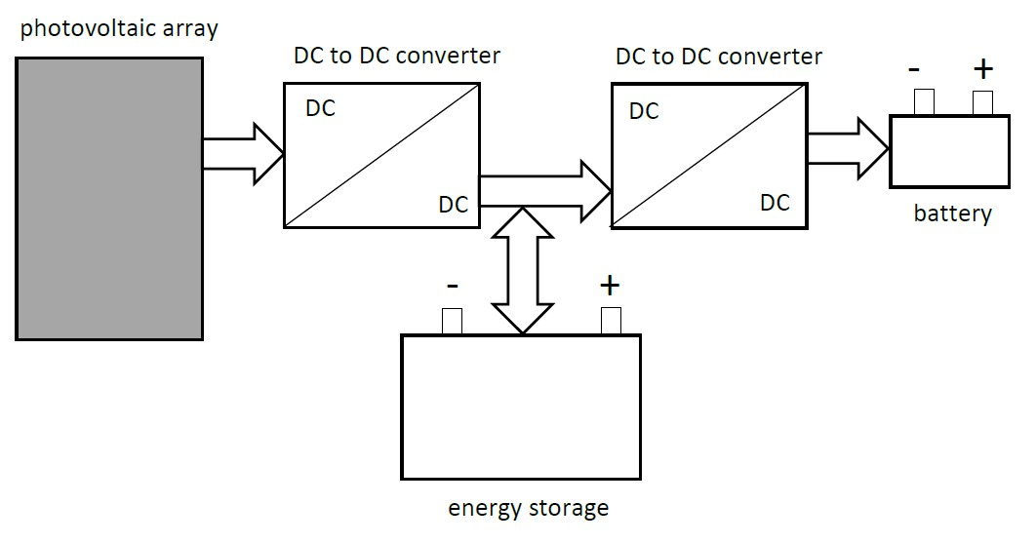
Figure 12: Standalone photovoltaic based battery charging system
When considering standalone photovoltaic based battery charging systems, not only the configuration of Figure 12 is possible. Figure 13 visualises a hybrid system. Using a lead acid battery with a large storage capacity (upper part of Figure 13), it is possible to charge the lithium ion battery of the electrical vehicle (also during the night). This approach is not new and corresponds with the approach of Figure 12.
The configuration of Figure 13 also uses the power generated by the photovoltaic array to produce hydrogen (lower part of Figure 13). The hydrogen allows to store energy. Using a fuel cell fed by hydrogen, a DC voltage is obtained. Using a DC to DC converter, it is possible to charge the battery of the vehicle.

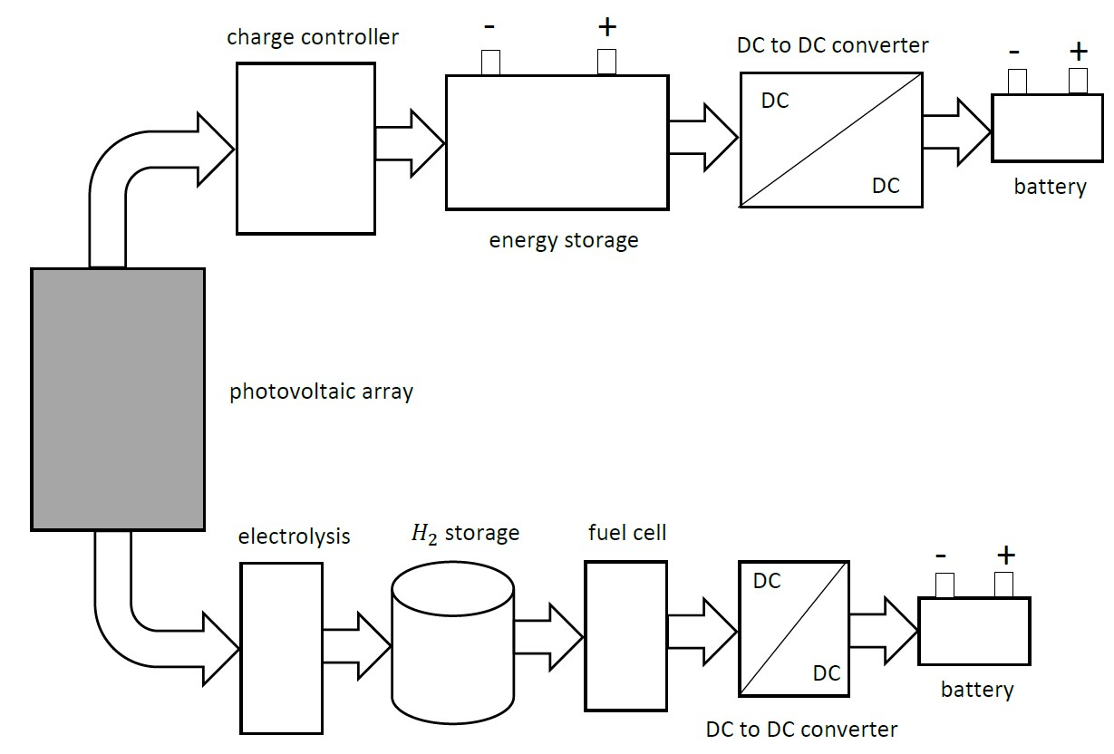
Figure 13: Hybrid photovoltaic based battery charging system
References
A.R. Bhatti, Z. Salam, M.J. Bin Abdul Aziz, K.P. Yee, R.H. Ashique, Electric vehicles charging using photovoltaic: Status and technological review, Renewable and Sustainable Energy Reviews, vol. 54, 2016, pp. 34-47.
D. Dobrzanski, Overview and characteristics of the EV fast charging connector systems, Maszyny Elektryczne, Zeszyty Problemowe, no. 3, 2017 (115), pp. 91-96, retrieved from http://www.komel.katowice.pl/ZRODLA/FULL/115/ref_15.pdf.
D’Ieteren, Info: De elektrische wagen, May 2013, retrieved from http://dbtechnology.be/wp-content/uploads/2014/02/De-elektrische-wagen.pdf (in Dutch).
J.S. Johansen, Fast-Charging Electric Vehicles using AC, master’s thesis, Technical University of Denmark, September 2013.
J. Martinez-Lao, F.G. Montoya, M.G. Montoya, F. Manzano-Agugliaro, Electric vehicles in Spain: An overview of charging systems, Renewable and Sustainable Energy Reviews, Elsevier, vol. 77, 2017, pp. 970-983.
B. Rotthier, P. Blockx, P. Van den Bossche, J. Cappelle, Thuis elektrisch opladen: hoe uw wagen verschilt van uw smartphone, retrieved from https://evladen.be/theobrochure.pdf (in Dutch).
References: websites
CCS: Combined Charging System: https://en.wikipedia.org/wiki/Combined_Charging_System
CHAdeMO: https://en.wikipedia.org/wiki/CHAdeMO
Tesla Supercharger: https://en.wikipedia.org/wiki/Tesla_Supercharger

