Challenges when introducing electric vehicles
1: Introduction
A lot of people share the opinion that electrical propulsion (also when talking about cars used for passenger transport) has an important future. Sometimes overenthusiastic people neglect the challenges when introducing an electric fleet of cars.
The development of decent batteries is mandatory. Batteries must be able to store a sufficient amount of energy in a compact volume and the weight must be acceptable. The efficiency when charging and discharging the battery needs to be sufficiently high. The use of the battery must be reliable and safe. A large life expectancy is also important. Finally, the choice of the raw materials determines the price of the battery.
Batteries need to be charged implying the need of a decent electrical grid infrastructure including a proliferation of charging stations. A high energy efficiency is needed while charging the battery. Also the propulsion systems of the car, i.e. the electric motor and the power electronic converter, need a high efficiency. The efficiency of the gearbox is an important parameter.
The introduction of full electric vehicles where the motor and the power electronic converter are fed by a battery (or a fuel cell) will gain importance but a lot of engineers and scientists share the opinion that the use of an internal combustion engine will not disappear that fast. When considering internal combustion engines, improvements concerning efficiency and a reduction of the emission of exhaust gases are expected. Not only conventional internal combustion engine cars but especially hybrid electric vehicles have a future.
Whatever technology has been used, the car needs a good dynamic (i.e. acceleration and top speed) performance. The car must be able to operate in harsh environments (changing ambient temperatures, rain, snow, …) and the noise production must be limited (e.g. reducing vibrations).
2: All-climate battery technology
A large number of different battery technologies exist. A description of all these battery technologies, including their advantages and disadvantages, is beyond the scope of the present text. Whatever battery technology has been used, the car drivers
- need a sufficiently large range (especially “range anxiety”, i.e. the fear that the battery will be discharged before reaching the destination, discourages the use of electric vehicles),
- need fast charging stations (e.g. with charging powers up to 350 kW, a 60 kWh battery can be charged in approximately 10 minutes),
Reaching this large range and realising a fast charging behaviour is especially a challenge in case of cold weather. Due to the low temperatures, the range decreases and the required charging time increases. Efforts are made to develop so-called all-climate battery technology to have a sufficienly large range and a sufficiently small charging time.
The all-climate battery we consider here, is a self-heating lithium-ion battery. This battery can warm up rapidly (e.g. needing only tens of seconds) from the low ambient temperature to room temperature. Once warmed up, the desired large range and the fast charging behaviour are obtained.
2.1: Lithium-ion batteries
Rechargeable lithium-ion batteries are used in a large range of applications. They can be found in laptops, MP3 players, cellphones… but they are also used in electric vehicles. By using lithium-ion batteries, a quite compact energy storage is obtained.
A lithium-ion battery contains a number of cells. Each cell contains a cathode (positive electrode), an anode (negative electrode) and an electrolyte. The positive electrode is typically made of lithium-cobalt oxide ($LiCoO_{2}$) (the positive electrode can also be made of lithium iron phosphate $LiFePO_{4}$) and the negative electrode is made of carbon (graphite). Different electrolytes are used but the electrolyte is not that important to understand the working principle of the battery.
To load the battery, a DC voltage source $U_{DC}$ is needed as visualised in Figure 1. Due to this voltage source, electrons are extracted from the $LiCo0_{2}$ electrode and send to the carbon electrode. Lithium ions ${Li}^{+}$ flow from the $LiCo0_{2}$ electrode to the carbon electrode through the electrolyte. More precisely, during the charging process of the battery the chemical reaction equals
$$LiCoO_{2}→CoO_{2}+{Li}^{+}+e^{-}.$$
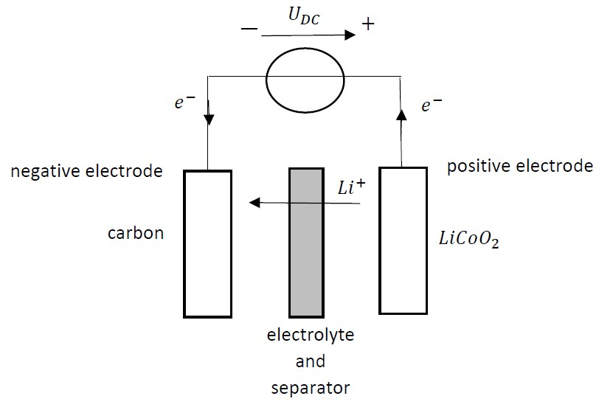
Figure 1: Charging a lithium-ion battery
The carbon electrode ($C_{6}$) is receiving ${Li}^{+}$ ions and electrons $e^{-}$ implying the chemical reaction
$$C_{6}+{Li}^{+}+e^{-}→LiC_{6}.$$
By combining these two reactions, the charging reaction equals
$$C_{6}+LiCoO_{2}→LiC_{6}+CoO_{2}.$$
The discharging process of the lithium-ion battery is visualised in Figure 2 and the chemical reactions equal
$$LiC_{6}→C_{6}+{Li}^{+}+e^{-}$$
and
$$CoO_{2}+{Li}^{+}+e^{-}→LiCoO_{2}.$$
By combining these two reactions, the discharging reaction equals
$$LiC_{6}+CoO_{2}→C_{6}+LiCoO_{2}$$
which restores the original carbon electrode and $LiCo0_{2}$ electrode.

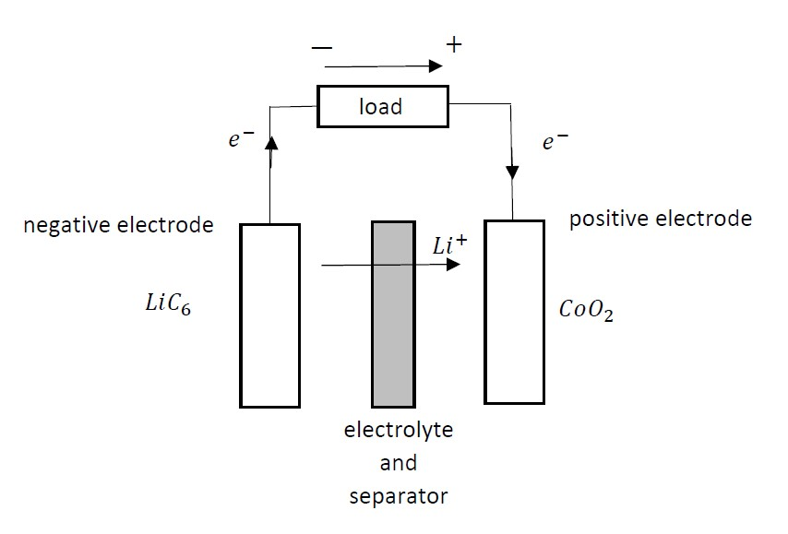
Figure 2: Discharging a lithium-ion battery
2.2: Properties of lithium-ion batteries
Lithium-ion batteries need an electronic controller to regulate the charging and the discharging processes. The controller avoids overcharging and overheating in order to prevent an explosion of the battery. Due to the remaining danger of a “thermal runaway” of the lithium-ion battery (especially in case of overcharging or an internal malfunction causing a short circuit), they are not allowed on passenger airplanes. Lithium-ion batteries are used in electrical vehicles and the risks are acceptable (also when using gasoline, safety isssues arise).
In comparison with the traditional lead-acid batteries, lithium-ion batteries are much more compact and lightweighted. Lithium-ion batteries are reliable and they don’t suffer from the so-called memory effect as it is the case for e.g. a nickel-cadmium battery (nickel-cadmium batteries need to be fully discharged from time to time). Lithium-ion batteries need no cadmium which is known to be a toxic heavy metal.
Lithiun-ion batteries are often used in electrical vehicles. In order to obtain a large range, it is important to be able to harvest the braking energy. Harvesting the braking energy using a lithium-ion battery is only possible when the battery is not too cold. This appropriate temperature property can be obtained by using a so called all-climate battery.
2.3: Structure of an all-climate battery
As already mentioned, the cell of a lithium-ion battery contains a cathode, an anode and an electrolyte. When considering an all-climate battery, a fourth component has been added i.e. a thin nickel foil inside the cell. Figure 3 visualises the working principle of an all-climate battery. The nickel foil is coated with thin materials on both sides accounting for electrical insulation. The nickel foil is sandwiched between two anode layers.
The all-climate battery cell has three terminals. There are positive and a negative terminals as it is the case in all batteries (indicated by + and – in Figure 3). But additionally, a third terminal is available which is called the activition terminal (ACT).
The working principle of an all-climate battery is straightforward. In case no heating is needed, the switch S will be open and a traditional battery operation is obtained. In Figure 3, the Thevenin equivalent circuit of the battery is shown. The battery is feeding an electrical load or a charger is charging the battery.
In case heating is needed (e.g. the cell temperature equals $-20°C$), the swith S will be closed. All current generated by the cell flows in the nickel foil (represented by $R_{Ni}$ in Figure 3) which produces heat to warm up the cell. When the cell temperature reaches a sufficiently high temperature (e.g. $-5°C$) no additional heating is needed and the switch S can be opened again. Heating up the battery cell from e.g. $-20°C$ to $-5°C$ only needs a number of seconds (e.g. 15 seconds).
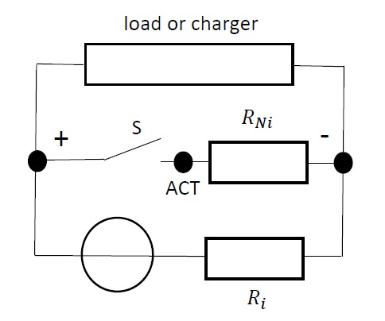
Figure 3: All-climate battery
The all-climate battery, visualised in Figure 3, realises an internal heating of the battery. This approach is more appropriate than external heating of the battery. When using external heating, the heating speed is much lower since it is important to prevent local overheating near the surface of the cell. Heating is speeding up by using more heating power but this accounts for hot spots near the surface.
3: Extreme fast charging of car batteries
To realise a breakthrough of electric vehicles, it is not sufficient to have decent batteries which allow a compact energy storage. It is also important that these batteries can be charged sufficiently fast. In order to a obtain fast charging (or extreme fast charging) of the batteries, also adequate charging infrastructure is needed. The charging infrastructure will extract large powers from the power grid implying also a decent electrical power grid is needed. Possibly, even a medium voltage grid connection is used.
When speaking about fast (or extreme fast) charging, charging powers of 50 kW or even 350 kW are considered (in case of 350 kW, only a limited number of minutes are needed to charge the car battery). In such a situation, the power to the vehicle battery is provided by a DC connection. A power converter is used which is situated outside the vehicle.
3.1: Fast DC battery chargers
A DC battery charger can be built as visualised in Figure 4. The charger contains two power conversion stages. The first stage is a three phase rectifier and the second stage is a DC to DC converter which also realises a galvanic isolation. In order to avoid (or reduce) power quality problems in the three phase AC grid, it is important the rectifier consumes a current which is sine shaped i.e. a Pulse With Modulated rectifier can be used as discussed in the present text. Notice also the presence of an input filter in order to further improve the shape of the grid current.
The rectified voltage is converted to the required voltage level by using a DC to DC converter. The DC to DC converter realises a galvanic isolation. This galvanic isolation is important since the vehicle battery is not grounded. Finally, also an output filter has been used to obtain a more constant DC voltage.
The main structure of such a DC to DC converter is visualised in Figure 5. First, the DC voltage is converted to an AC voltage (e.g. in the kHz range which allows the use of a compact transformer) (in case of a 50 Hz voltage, a heavier and more spacious transformer is needed). A transformer changes the voltage level and provides the galvanic isolation. Finally, an AC to DC converter provides the desired DC voltage level.
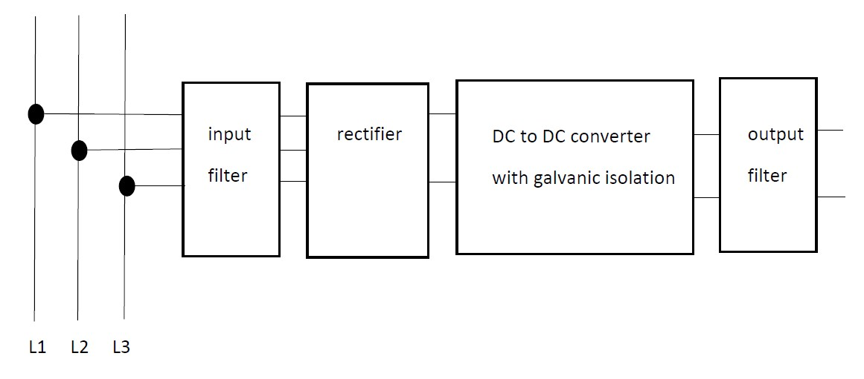
Figure 4: Block diagram of a fast DC battery charger
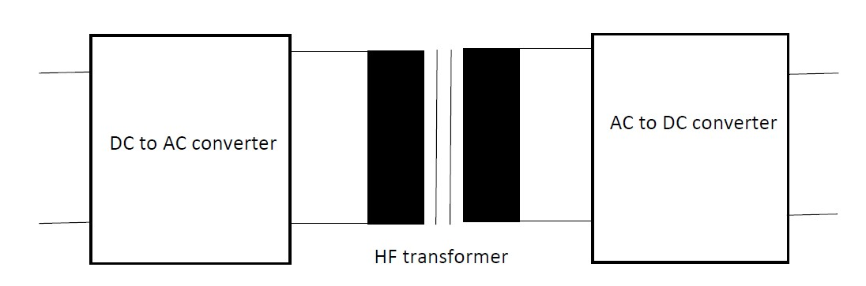
Figure 5: DC to DC converter with galvanic isolation
When considering the fast DC battery chargers, typically the charging procedure starts with handshaking between the battery charger and the car. After insulation testing and communication concerning the maximum charging parameters, the car is able to close the contactor and the real battery charging can start. The charging process typically contains two important phases. During a first phase, the battery will be charged using a constant current (this charging current is high implying a fast battery charging process). During a second phase, the battery will be charged using a constant voltage (as the state of charge of the battery increases, the charging current decreases and the charging process slows down).
3.2: Pulse Width Modulated rectifier
Although several configurations exist, Figure 6 visualises a typical Pulse Width Modulated rectifier (PWM). Notice first the rectifier providing a rectified voltage $v_{g}\left(t\right)$ which is visualised in Figure 7. One of the goals is extracting a current $i_{g}\left(t\right)$ which has the same shape as $v_{g}\left(t\right)$. This implies the sinusoidal AC voltage provides a sinusoidal current (and a unity power factor is obtained since the AC current and the AC voltage have the same phase).
In order to obtain the desired $i_{g}\left(t\right)$-shape, a controller is needed. The current $i_{g}\left(t\right)$ is measured and compared with the required reference current $i_{g,ref}\left(t\right)$. By opening and closing the switch S in Figure 6, the current $i_{g}\left(t\right)$ (which is visualised in Figure 7) will be obtained which is a good approximation of the required reference current $i_{g,ref}\left(t\right)$. By closing the switch S, the current $i_{g}\left(t\right)$ increases. By opening the switch S, the current $i_{g}\left(t\right)$ decreases. The reference current $i_{g,ref}\left(t\right)$ equals
$$i_{g,ref}\left(t\right)=\frac{v_{g}\left(t\right)}{R_{AC}}$$
where $R_{AC}$ is the appropriate equivalent AC resistor. When assuming no losses occur in the converter,
$$R_{AC}=\frac{V_{g}^{2}}{P_{AC}}= \frac{V_{g}^{2}}{P_{DC}}= \frac{V_{g}^{2} R}{v^{2}} .$$
Here, $V_{G}$ is the RMS value of the grid voltage and $P_{AC}$ is the active power provided by the AC grid. $P_{DC}$ is the DC power dissipated in the load resistor $R$ (with the DC voltage $v$). In case of a lossless converter, $P_{AC}=P_{DC}$.
Actually, the inductor L, the diode D and the semiconductor switch S behave as a boost converter. The DC output voltage $v\left(t\right)$ across the capacitor $C$ and the load $R$ is intended to be constant (value $v$ as visualised in Figure 7) and larger than (or equal to) the peak value of $v_{g}\left(t\right)$.
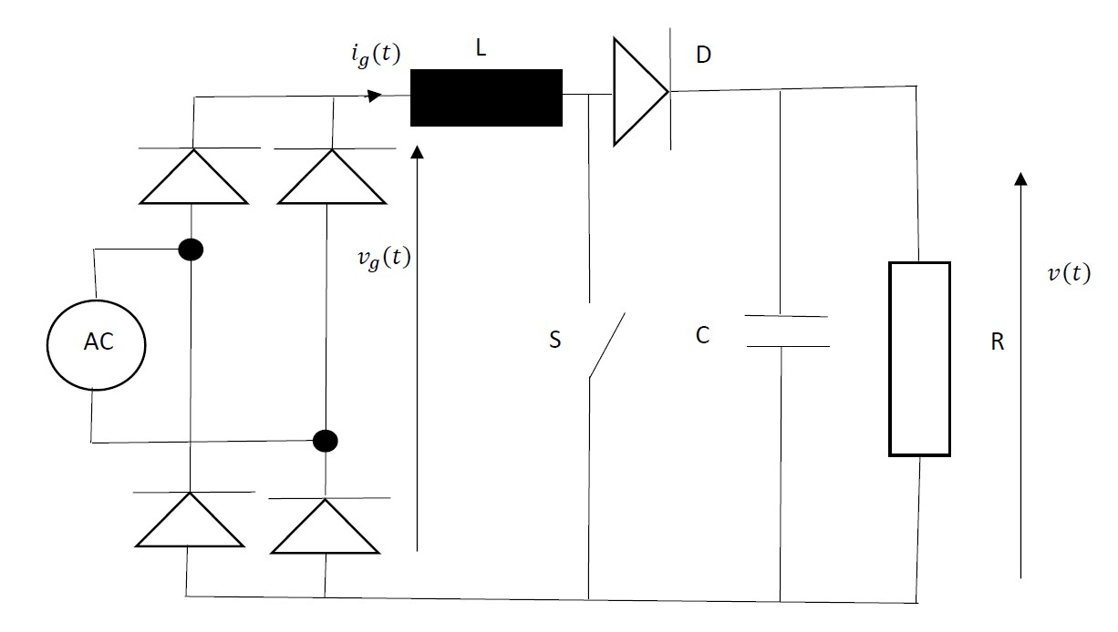
Figure 6: Pulse Width Modulated rectifier
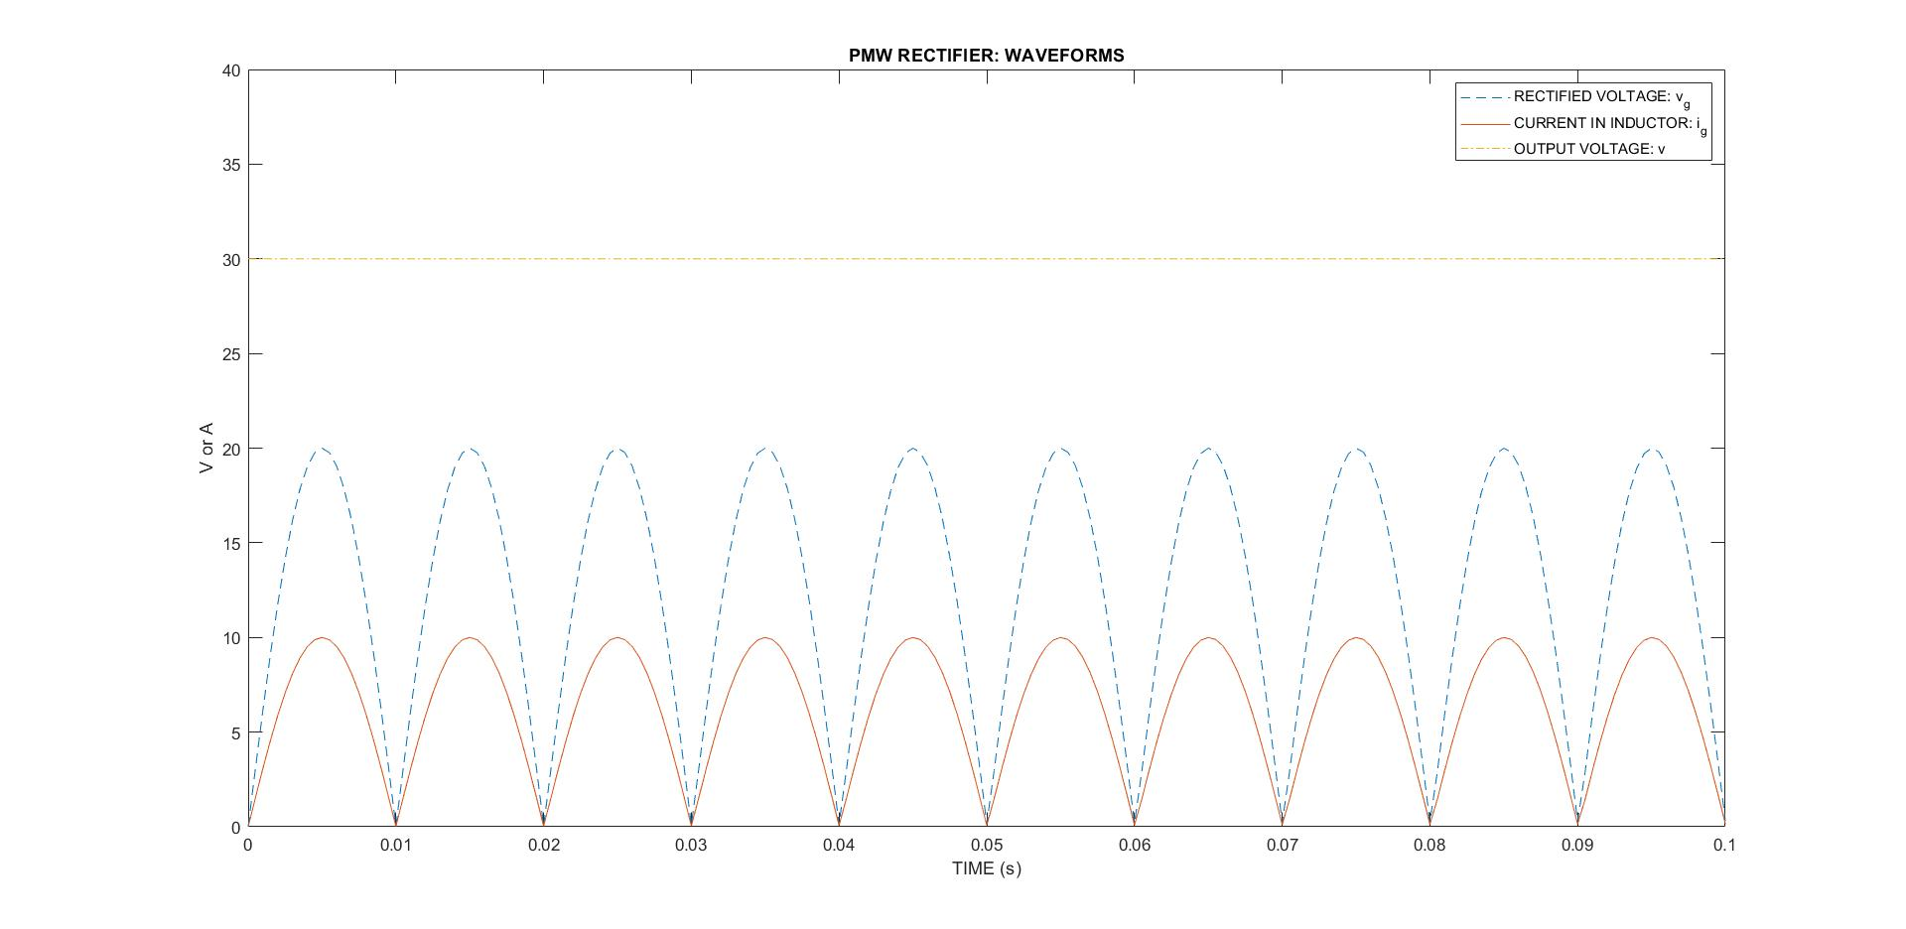
Figure 7: Waveforms of the PWM rectifier
As already mentioned, a controller is needed to vary the duty cycle when opening and closing the semiconductor switch S. The working principle of the Pulse Width Modulated rectifier in Figure 6 is quite straightforward. Suppose the switch S is closed. The voltage $v_{g}\left(t\right)$ stands over the inductor $L$ which implies that
$$L \frac{d i_{g}\left(t\right)}{d t}= v_{g}\left(t\right)>0.$$
When opening the switch S, the inductor current $i_{g}\left(t\right)$ will decrease but it will not drop to zero immediately. Due to the diode D, the current $i_{g}\left(t\right)$ can still flow. When neglecting the voltage drop across the conducting diode,
$$v\left(t\right)= v_{g}\left(t\right)-L \frac{d i_{g}\left(t\right)}{d t}> v_{g}\left(t\right).$$
Suppose the switch S is closed during a time interval $δ T_{S}$ and the same switch is open during a time interval $\left(1-δ\right) T_{S}$. In a steady state situation, the increase of the current $i_{g}\left(t\right)$ equals the decrease i.e.
$$δ T_{S} \frac{v_{g}}{L}= \left(1-δ\right) T_{S} \frac{v-v_{g}}{L} .$$
This implies that
$$v=\frac{v_{g}}{1-δ} .$$
In case the constant output voltage $v$ is larger than the maximum of $v_{g}\left(t\right)$, the duty cycly will depend on the time (actually on the instantaneous value of $v_{g}\left(t\right)$) with
$$δ\left(t\right)=1-\frac{v_{g}\left(t\right)}{v} .$$
3.3: Grid infrastructure
In order to charge the batteries of an electric vehicle, the power electronic converters (including battery chargers) need a decent electrical grid infrastructure. A possible grid configuration of a charging station is visualised in Figure 8. Power is supplied by a medium voltage grid and using a classical 50 Hz transformer a local AC low voltage grid is obtained. Local power generation is possible using photovoltaic panels. Also stationary battery storage can be useful in order to limit and to control the power exchanges between the medium voltage grid and the low voltage grid. Several DC battery chargers (as visualised in Figure 4) are available to charge the batteries of a number of cars simultaneously.
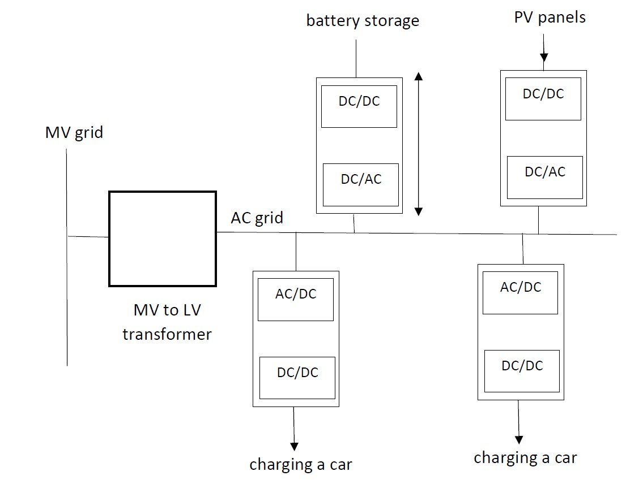
Figure 8: AC grid infrastructure
Using an AC grid has a number of advantages. Using AC grids is mainstream technology i.e. converters, switchgears, protection devices… are available on the market. Well-established standards and practices are available for AC distribution systems.
Instead of using the local AC low voltage grid infrastructure of Figure 8, also the use of a local DC low voltage grid infrastructure (as visualised in Figure 9) can be useful. By using a local DC grid, the number of power electronic converters will be lower. By reducing the number of power electronic converters, losses decrease which provides a higher efficiency. In general, the use of a DC grid makes the use of renewables and battery storage easier.
Notice in Figure 9 the connection with the medium voltage grid using a transfomer and a rectifier. Since the installation contains photovoltaic panels and stationary battery energy storage, it can be a good practice to inject power into the medium voltage grid in case there is an excess of energy generation in comparison with the energy needs of the car batteries.
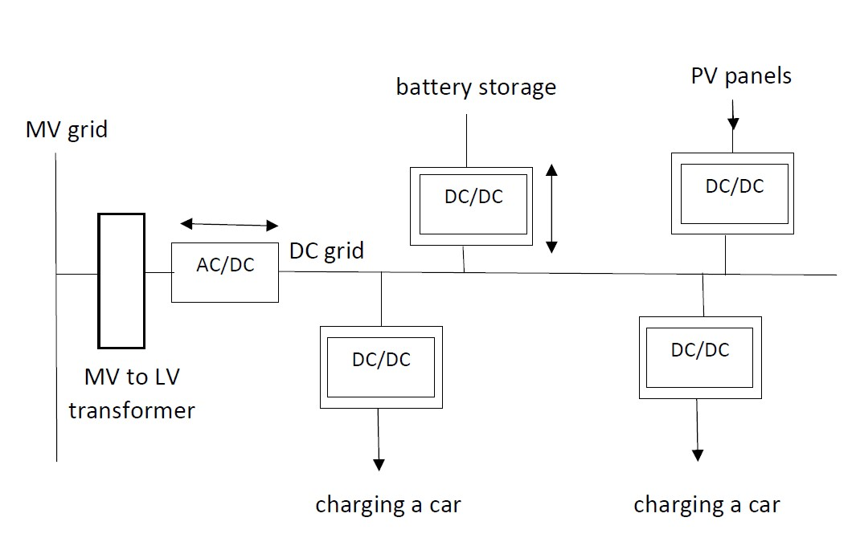
Figure 9: DC grid infrastructure
In Figure 9, a separate MV to LV transformer (step-down transformer) and a separate AC to DC converter have been used. A solid-state transformer SST replaces both devices. Possibly, the solid-state transformer allows a bidirectional power exchange (as also visualised in Figure 9). The internal structure of a solid-state transformer is visualised in Figure 10. Figure 11 shows the grid configuration containing such a solid-state transformer SST.
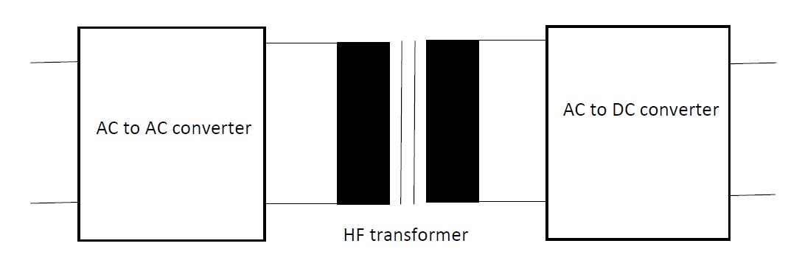
Figure 10: Solid-state transformer
The use of a solid-state transformer allows to reduce the losses (as a rule of thumb, the losses are halved). The solid state transformer of Figure 10 is much smaller than the MV to LV transformer of Figure 9 (the SST contains a HF transformer instead of a 50 Hz transformer) (by using a higher frequency the dimensions of the transformer can be reduced).
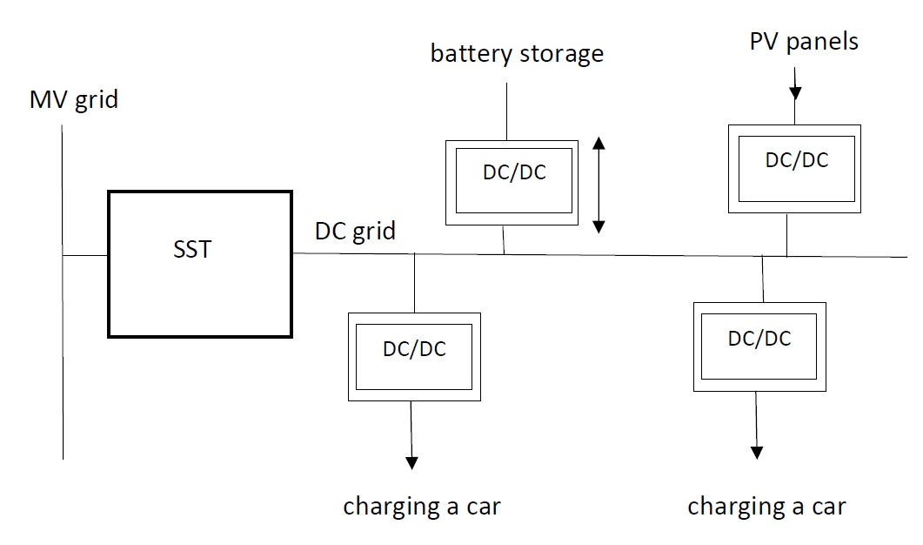
Figure 11: DC grid infrastructure with solid-state transformer
3.4: Integrating car battery chargers in a residential environment
Instead of using separate battery charging stations, it is also possible to integrate the car battery chargers in a domestic environment as visualised in Figure 12. Figure 12 shows a grid configuration where an AC grid and a DC grid are both available.
The photovoltaic panels on the roofs generate DC voltages and using DC to DC concerters, the generated powers are injected into the local DC grid. The local DC grid feeds a number of DC to DC converters which can be used to charge car batteries. The local DC grid also feeds other battery chargers conncted with stationary batteries. These stationary batteries can be charged or discharged according to the power needs of the DC grid.
Not only a local DC grid, but also a local AC grid is available. Indeed, the electrical loads in the households are generally fed by an AC grid, no changes occur here. Notice also the connection with the medium voltage AC grid. Using a solid-state transformer SST, the local AC grid and the local DC grid are connected with the medium voltage AC grid and power can be exchanged in both directions.

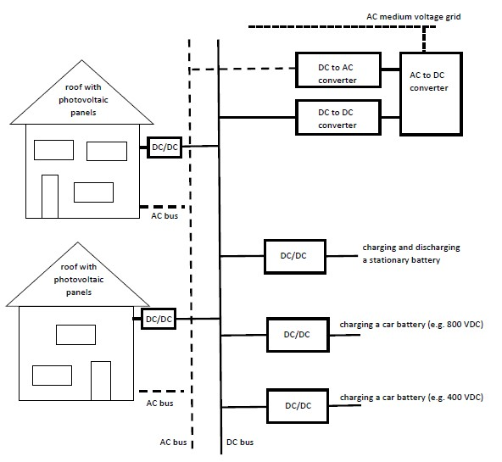
Figure 12: Integrating car battery chargers in a domestic environment
References
M.H. Rashid (ed), Power Electronics Handbook: devices, circuits and applications, Elsevier, London, 2011, ISBN 978-0-12-382036-5.
L. Ribickis, Power Electronics, RTU Press, Riga, 2015, ISBN 978-9934-10-602-6.
S. Srdic, S. Lukic, Toward Extreme Fast Charging, IEEE Electrification Magazine, vol. 7, no. 1: Overcoming Hurdles for Electric Vehicles, March 2019, pp. 22-31.
G. Tamai, What are the Hurdles to Full Vehicle Electrification?, IEEE Electrification Magazine, vol. 7, no. 1: Overcoming Hurdles for Electric Vehicles, March 2019, pp. 5-11.
X.-G. Yang, S. Ge, N. Wu, Y. Mao, F. Sun, C.-Y. Wang, All-Climate Battery Technology for Electric Vehicles, IEEE Electrification Magazine, vol. 7, no. 1: Overcoming Hurdles for Electric Vehicles, March 2019, pp. 12-21.
References: websites
Lithium-ion batteries: https://www.explainthatstuff.com/how-lithium-ion-batteries-work.html
Lithium-ion batteries: https://en.wikipedia.org/wiki/Lithium-ion_battery

