Shift towards an increase of (partially) electrically driven transportation
1: Introduction
When considering transportation, a distinction can be made between the transportation of humans, animals and goods. It is also possible to make a distinction between private means of transportation and public transport systems.
Additionally, a distinction can be made between transportation over land (using roads, railways, canals and rivers), transport over seas and finally air transport. In all these cases humans, animals and goods can be transported.
All these means of transport already exist for centuries and even millenia. Air transport (when excluding space travel) is actually the newest form of transportation. An important milestone was the use of a hot air balloon by the Montgolfier brothers in 1783 in France. Another very important milestone was the construction of the first practical aircraft in 1903 by the Wright brothers. Especially the success of the Wright Flyer was the start of an ever increasing aircraft industry.
Crucial for all means of transport is the fact that energy is needed. In ancient times, a lot of muscle power, by humans or animals, has been used. When considering ships used to transport humans or goods over sea, traditionally a combination of muscle power (by rowing) and wind power (by using sail ships) has been used.
When considering the energy sources, a lot changed during the First Industrial Revolution. The use of steam engines also had an important impact on the transportation sector. Steam ships and steam trains became very popular. Even steam driven cars have been developed. Approximately one century later, the development of internal combustion engines (e.g. using gasoline or diesel) also had a huge impact on the transportation sector.
Since the First Industrial Revolution, the use of fossil fuels is very important. Coal is burned to produce the heat which is needed to produce steam. Gasoline, diesel and other fuels are produced based on crude oil. Also natural gas is a fossil fuel which can be used to drive e.g. a car. Unfortunately, the use of fossil fuels has a number of limitations and disadvantages. Mankind consumes fossil fuels much faster than nature can produce them i.e. depletion of fossil fuels is a threat. By burning fossil fuels, exhaust gases have a negative impact on the environment and the climate (e.g. global warming due to $CO_{2}$).
Several attempts arise to reduce the use of fossil fuels, also when considering the transportation sector. Quite often, these attempts are linked with the introduction of (partially) electrically driven systems. Although it is impossible to give an exhaustive overview of the use of electrical applications in the transportation systems, a number of topics are considered here which also draw the attention of the academic world. More electric aircrafts and more electric ships will be discussed. The use of electric trains is already a number of decades a common practice in a lot of countries and regions worldwide. While the use of electric trains is a mature technology, the use of electric cars and hybrid cars is actually an emerging technology.
2: More electric aircrafts
The propulsion mechanisms of traditional aircrafts are realised by propellers or jet engines using kerosene as energy source. But an aircraft has a large number of other loads and actuators which need to be powered. In general, they are powered by hydraulic, pneumatic and electric sources. In recent times, there is an evolution towards an increased use of electric sources and reducing the hydraulic and pneumatic sources.
By using electrical systems for the aircraft actuation systems, for environmental control systems, for fuel pumping and for wing ice protection, the airplane can become more energy efficient and quieter. By using electrically driven systems, reductions of the weight, volume and even cost of the installations can be obtained. In general, electrical systems are also reliable.
When considering an airplane, a large lifetime is needed for all components (especially in comparison with domestic, industrial and automotive applications). Airplane mechanisms must operate in a harsh environment which also imposes strict requirements on the components.
In the future, perhaps commercial all electric aircrafts will appear. In this situation, also the propulsion will be electrically driven. When considering the Solar Impulse, actually a solar powered aircraft (with batteries) alreadly exist. Notice however that the Solar Implulse is an experimental airplane and still a long way is needed to realise commercial all electric aircrafts.
In case of an all electric aircraft, it is a challenge to store enough energy in a compact way (also the weight must be limited). Significant improvements in rechargeable batteries and fuel-cell technologies are needed. Since full electrically driven airplanes with battery or fuel-cell based energy storage is probably something for the far future, hybrid technologies are expected to be an important intermediate solution.
2.1: Electrical, pneumatic, hydraulic and mechanical systems
Consider an airplane driven by a gas turbine engine. The main goal of the engine is the propulsion of the airplane. By using a gearbox, the engine also drives an electrical generator. By converting mechanical into electrical energy a power source is available to supply a broad range of electrical loads (e.g. lighting, in-flight entertainment,…). By extracting high pressure air from the gas turbine, the pneumatic system is fed. The pneumatic system is used to obtain cabin pressurization, air-conditioning,… Using a gearbox, the engine drives a hydraulic pump allowing to use hydraulic actuators. Finally also mechanical loads like fuel pumps and oil pumps are driven by the gas turbine engine. This approach is visualised in Figure 1.
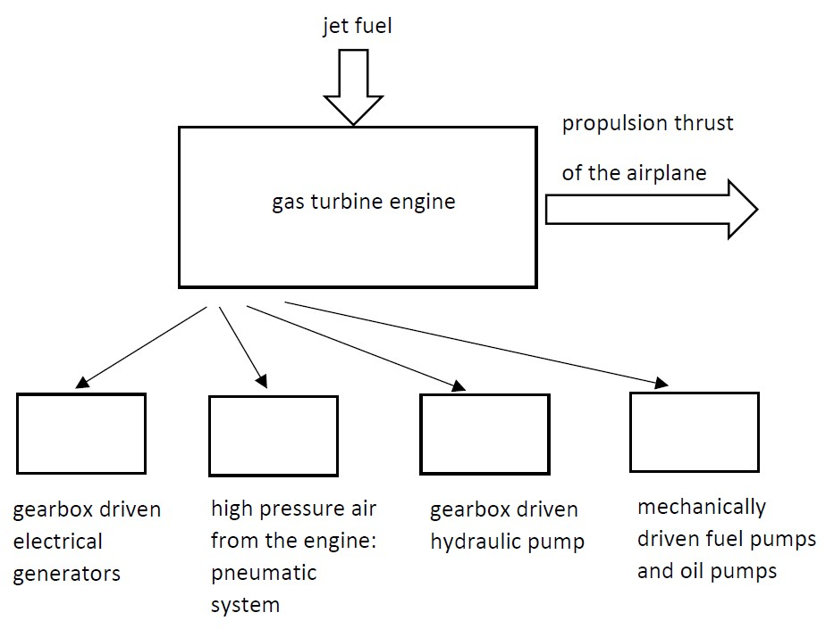
Figure 1: Airplane with electrical, pneumatic, hydraulic and mechanical applications

In the so-called More Electric Aircraft, the gas turbine engine will drive an electrical generator which converts mechanical power into electrical power like all electrical generators. But the electrical generator not only feeds the traditional electrical loads. For instance also the fuel pumps and oil pumps are electrically driven. This approach is visualised in Figure 2.
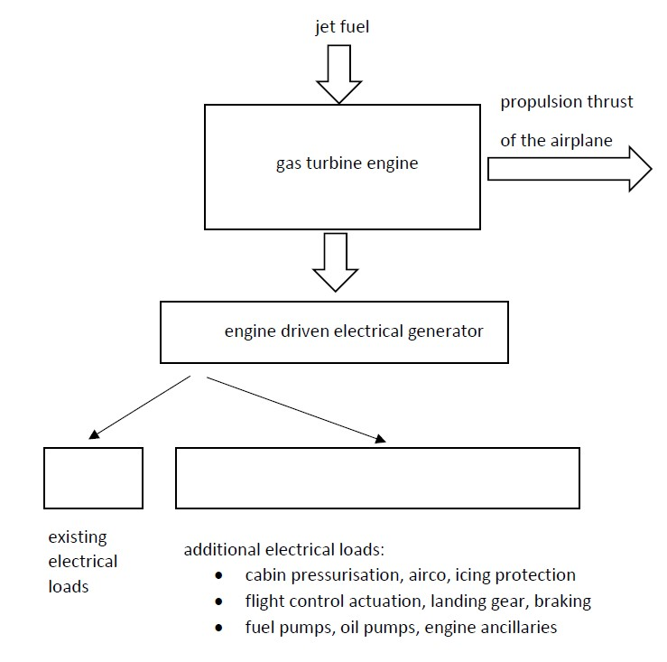
Figure 2: More Electric Aircraft
By using one single power source, i.e. electrical power, an increased efficiency and a reduced fuel consumption can be obtained. By reducing the number of mechanical and hydraulic systems, a reduction of the weight of the airplane can be obtained. In general, electrical systems are not only reliable, they also require less maintenance.
2.2: Electrical power systems
Traditionally, in an airplane a number of different voltage levels exist. For low power loads, a DC-bus of 28V DC is used. On larger airplanes, also voltage levels of 270V DC (+/- 135V DC) are used. In case of AC loads, a 115V AC system with a frequency of 400 Hz is used. By using 400 Hz instead of 50 Hz or 60 Hz, electrical machines are less heavy and smaller.
By using more electrical loads, higher voltage levels are needed to reduce the currents. By reducing the currents, heat losses in the cables are limited without increasing the cable section and the cable weight. Voltage levels of 540V DC (+/- 270V DC) are used. When considering AC based power distribution, a 230V AC system with a frequency of 400 Hz is used. In order to obtain a fixed frequency of 400 Hz, a synchronous generator needs a fixed speed of rotation.
Due to the use of power electronic converters, it is also possible to use a grid with a fixed voltage level of 230V AC in combination with a variable frequency (e.g. a frequency which ranges from 350 Hz to 800 Hz). This approach has the advantage that a fixed speed of rotation of the synchronous generator is not required. The variable frequency is not a problem since a power electronic converter converts the frequency to the frequency needed by the load.
2.3: The use of AC and DC buses
Figure 3 visualises a possible configuration for a More Electric Aircraft power system containing AC buses and DC buses. In Figure 3, two synchronous generators (SG1 and SG2) are used which are driven by the jet engines. The first generator feeds AC bus 1 and the second one feeds AC bus 2. Notice the presence of AC loads where the Wing Ice Protection System (WIPS) is mentioned separately.
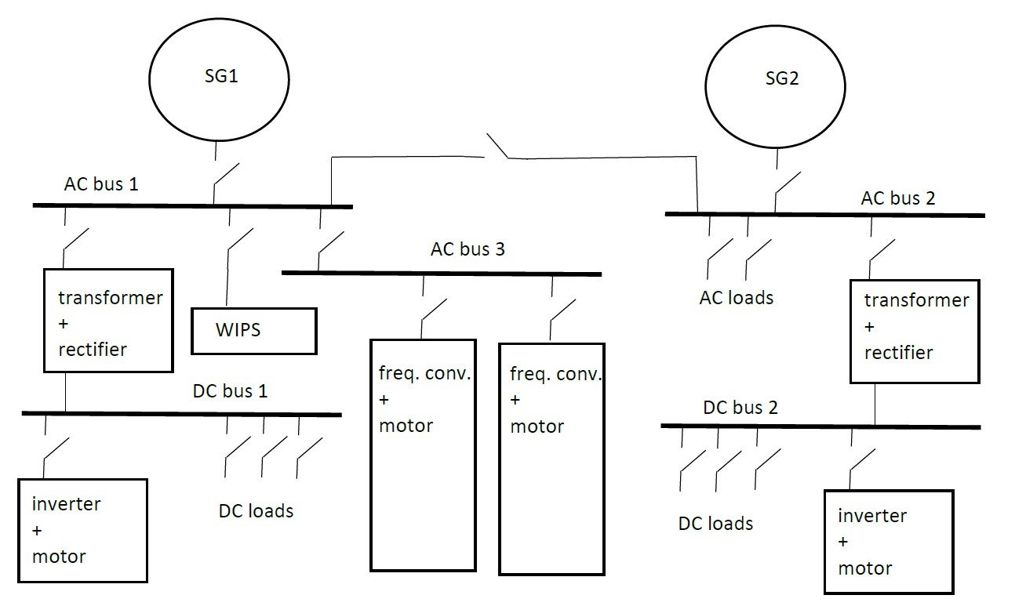
Figure 3: More Electric Aircraft power system
In addition to AC bus 1 and AC bus 2, also AC bus 3 is available. This AC bus 3 is used for flight critical actuation systems: for instance electro-mechanical actuators which are driven by permanent magnet motors. These permanent magnet motors need a controlled frequency (obtained by frequency converters) to control its speed.
By using a transformer and a rectifier, the AC voltages of AC bus 1 or AC bus 2 are converted to a DC voltage. DC bus 1 and DC bus 2 are obtained allowing to feed DC loads. When using an inverter, it is possible to feed e.g. permanent magnet motors to drive actuators.
3: More electric ships
Traditionally, the propulsion of a ship is based on a propeller (or propellers) driven by a diesel combustion engine. Electrification not only appears on board of airplanes, but also when considering ships there is a rise in electrical applications including electrically driven propulsion systems.
A ship propulsion motor is typically a high-torque but low-speed application. When considering electrical ship propulsion motors, AC asynchronous and AC synchronous motors (with an excitation winding) are dominant. Research is going on to develop permanent magnet motors and superconducting motors to drive the ship. It is a challenge to provide the high torque at low speeds using a compact motor having a high efficiency. Not only the development of appropriate electrical motors is important, decent power electronic converters are needed to control the speed of the motors.
Since large electrical powers (several tens of MW) are needed to drive a large ship, the voltage level of the supplying electrical grid must be sufficiently high in order to limit the heat losses in the cables. Medium voltage levels of e.g. 3.3kV, 6.6kV, 11kV, 13.8kV, 15kV and even 20kV are realistic.
3.1: Diesel-electric propulsion
Figure 4 visualizes the basic prinicple of diesel-electric propulsion of a ship (electric propulsion based on energy storage using batteries or fuel cells is not applicable for larger applications and distances since the energy storage needs volumes and weights which are too high). A diesel engine is driving a synchronous generator generating a three phase voltage. Using a transformer, the voltage level can be changed and using a frequency converter a controlled frequency can be obtained which controls the speed of the electrical motor and the propeller.
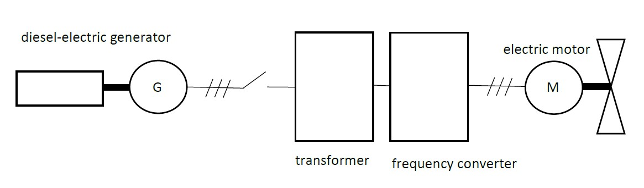
Figure 4: Diesel-electric propulsion of a ship
The use of diesel-electric propulsion, as visualised in Figure 4, has a number of advantages. It is possible to have a lower fossil fuel consumption due to the possibility to optimize the loading of the diesel engines. When reducing the fuel consumption, also the exhaust of ${CO}_{2}$ and other harmful emissions reduces. In general a high reliability can be obtained and maintenance costs are reduced.
It is possible to mount the diesel engine far away from the propellers since power distribution is possible using the electrical grid. In the diesel-mechanical approach, the diesel engine must be mounted very close to the shaft of the propeller implying a limited spacial flexibility. Using an electrical motor, lower propulsion noise and less vibrations are obtained. Electrical motors in combination with decent power electronic converters allow to obtain high torques at a low speed.
Notice the use of a diesel-electric propulsion also has a number of disadvantages. The investment costs are high since a lot of components are needed (electrical generator, electrical equipment, transformers, power electronic converters,…).
A large number of different motor types can be used, but AC asynchronous motors and AC synchronous motors are the most common ones. The development of permanent magnet motors aims to obtain smaller and lighter motors having a high efficiency. The development of High Temperature Superconducting Motors is also going on. Not only the development of appropriate electrical motors is important, decent frequency converters are needed to control the speed of the AC motors.
3.2: Frequency converters
The three most important types of frequency converters are voltage source inverters (VSI), current source inverters (CSI) and cycloconverters. Figure 5 visualises the main structure of a voltage source inverter. The AC grid voltage will be rectified and using a sufficiently large capacitor, a constant DC voltage $U$ is obtained. By using a PWM inverter, a controllable AC voltage is obtained to feed the motor (e.g. an induction motor). The PWM voltage approximates a sine shaped (three phase) voltage. The frequency and the amplitude of the approximated sine shaped voltage can be chosen in order to have the appropriate motor speed.
Two level PWM inverters are frequently used in the industry. When considering larger powers, three level and more general multi level PWM inverters are also used. By using multi level PWM inverters, the switching losses are reduced and still a decent approximation of a sine voltage is obtained. A detailed description of multi level PWM inverters is beyond the scope of the present text.
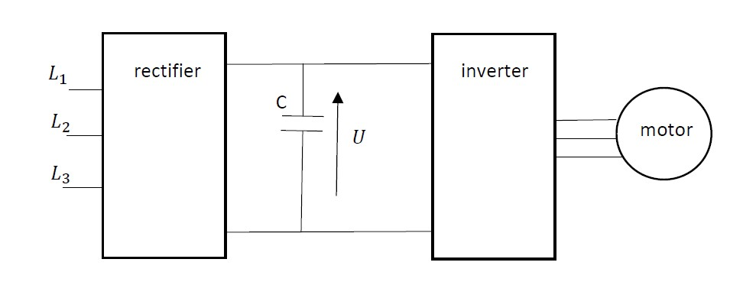
Figure 5: Voltage Source Inverter
Voltage source inverters are the most frequently used type of frequency converters. But especially when considering high powers, and the propulsion of a ship requires high powers, also current source inverters are used. Figure 6 visualises a current source inverter.
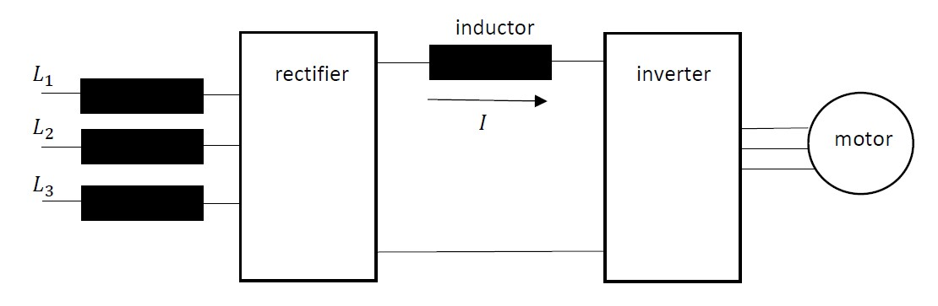
Figure 6: Current Source Inverter
The current source inverter is also fed by a (three phase) AC grid. No constant DC voltage but a constant DC current $I$ is obtained. Using an appropriate inverter, it is possible to feed the AC motor and control its speed and torque. Similar with the VSI, a detailed discussion of the CSI is beyond the scope of the present text. Notice however the CSI is able to recuperate energy (kinetic energy of the rotating machine is converted into electrical energy and sent back to the AC grid) with a minimum of power electronic components (also a VSI is able to recuperate energy but more power electronic components are needed). This energy recuperation property is especially important when dealing with high power applications.
A third type of frequency converter is the cycloconverter which is also mainly used for high power applications. Figure 7 visualises the internal structure of such a three phase cycloconverter. Notice on the left the feeding three phase grid and on the right the electrical motor (e.g. a synchronous motor) which will be fed by a controllable frequency. The converter itself contains for each output phase two thyristor bridges in antiparallel which allows to exchange power in two directions. A discussion of the internal working principles of these thyristor bridges falls outside the scope of the present text.
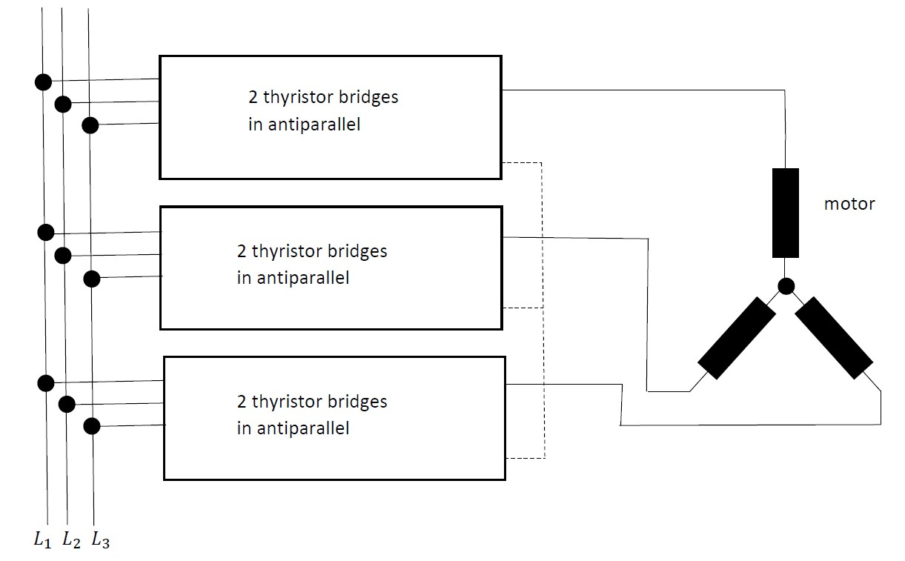
Figure 7: Cycloconverter
Cycloconverters are used to obtain output frequencies which are lower than the original grid frequency (e.g. output frequencies between $0$ and $20 Hz$ in case the original grid frequency equals $50 Hz$). This implies the motor will have a low rotational speed which is indeed needed when considering the propulsion of a ship. With such an approach, a gearbox between the motor and the propeller can be avoided.
Cycloconverters are used for large powers to drive motors with a low rotational speed. This implies the driving torques will be high as required for ship propulsion. In general, cycloconverters have a high efficiency since only one energy conversion is needed (in comparison with VSI and CSI converters where two conversions are needed: AC to DC and DC to AC). Cycloconverters have the disadvantage of being complex systems. Moreover, the current extracted from the feeding grid is far from sinusoidal.
4: Electric trains
In the nineteenth century, trains were driven by steam locomotives. By burning coal (or another fuel) heat is obtained to produce steam. The steam is used to drive reciprocating pistons which drive the wheels of the locomotive. Since steam locomotives need a lot of maintenance and due to their low efficiency, diesel engine driven locomotives appeared in the twentieth century. Also locomotives driven by electrical motors appeared and became very popular.
Similar with the diesel-electric driven ships, also diesel-electric locomotives exist. A diesel engine drives an electrical generator and the generated electrical power is used to feed an electrical traction motor. In the present text, only pure electric driven locomotives will be considered. The electric energy can be stored using batteries and supercapacitors, but especially electric locomotives fed by a third rail or overhead lines are dominant.
4.1: Power supply systems
When considering trains, trams or metros the power supply mainly originates from a third rail or overhead lines. An exhaustive overview of all existing systems worldwide is simply impossible. In the present text, we restrict ourselves to an overview of a number of quite frequently used approaches.
First a distinction can be made between DC and AC sources. Due to modern power electronic converters, it is realistic to feed a DC motor by a DC source, to feed an AC motor by a DC source, to feed a DC motor by an AC cource and to feed an AC motor by an AC source.
DC sources of 600 V to 1000 V are often used for metros, suburban railways and in general light rail traffic. In case larger powers are needed, 1500 VDC or 3000 VDC overhead lines are commonly used. The use of DC power sources is often a heritage from the past when mainly series excited DC traction motors were common. Traditionally DC motors were used since their speed could be controlled using switches and resistances. The series excited DC traction motor had the additional advantage to have a large torque at low speeds which allows to accelerate the locomotive and the wagons.
There is also a variety when considering the commonly used AC sources. A typical heritage of the past is a single phase 15 kV system with a frequency of $162/3 Hz$. This voltage was appropriate to feed a universal motor which is actually a series excited DC motor. Such a universal motor also operates when fed by an AC voltage. Due to problems with the commutator, a frequency of $162/3 Hz$ was needed instead of 50 Hz or 60 Hz.
A world standard is the use of a 25 kV single phase voltage with a frequency of 50 Hz or 60 Hz. In some really heavy duty situations a voltage level of 50 kV is used. By increasing the voltage level, the transmission efficiency increases since lower currents are needed to provide the same power. This allows to reduce the copper losses or to reduce the cross section of the cables. At the other hand side, increasing the voltage level also increases the dangers.
When using DC systems, it is more difficult to break (fault) currents since there are no zero crossings of the current as it is the case for sinusoidal currents. Especially when voltage levels are higher, interrupting DC fault currents is a challenge. This explains the limitation to 3 kV voltage levels (although attempts existed to use higher voltage levels). When using AC systems instead of DC systems, it is not only easier to break currents. It is also possible to adapt the voltage level to the needs by using transformers. Unfortunately, the series impedance of the conductor system is higher when considering AC systems. Indeed, the impedance contains an inductive part which increases the impedance implying larger voltage drops.
The power suppy systems depend on the country (or region) and is also determined by choices made in the past. For instance, a 3 kV DC supply is used in Belgium and Latvia. In Belarus a 25 kV AC system with 50 Hz is used. In Ukraine both 3 kV DC and 25 kV AC systems are used depending on the region.
4.2 DC and AC power supplies
When using a third rail for power supply, normally a DC power supply is used. Overhead lines can be used in case of AC and DC power supplies. The power supply is used to feed the power electronic converter and the motor (the drive system of the train). The overhead line is able to provide power since it is fed by a substation. The current provided by e.g. the overhead line flows through the pantograph of the train, provides the drive system (power electronic converter and motor) with power and flows back to the substation by making electrical contact with the axle (using axle brushes), wheels and finally the running rails. The running rails, which have the earth potential, are actually electrically connected with the substation. In this way, a closed electrical circuit is obtained.
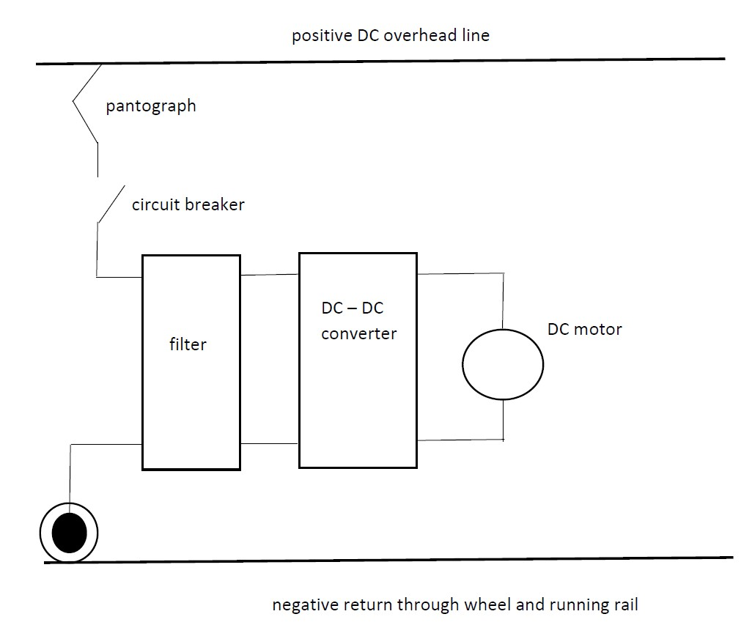
Figure 8: Basic structure of a locomotive fed by a DC overhead line
Figure 8 visualises an overhead line providing a voltage of e.g. 3000 VDC. Notice the pantograph and using a circuit breaker the locomotive can be connected and disconnected from the overhead line. After a filter, a DC – DC converter is used to obtain a controllable DC voltage which allows to control the speed of the DC motor. The DC motor can be a DC series motor but also a separately excited DC motor can be used (in that situation an additional power electronic converter is needed to feed the excitation winding with a controllable voltage). Finally notice that axle brushes are used to make an electrical connection with the axle, wheels and finally the running rail. Figure 8 is very basic and more details are needed in real life. Notice also that an AC motor can be used by replacing the DC – DC converter by a DC – AC converter.
Figure 9 visualises an overhead line providing a single phase AC voltage of e.g. 25 kV. Notice again the pantograph and using a circuit breaker the locomotive can be connected and disconnected from the overhead line. Notice that axle brushes are used to make an electrical connection with the axle, wheels and finally the running rail. A transformer is used to reduce the AC voltage level and in general the winding ratio of the transformer can be adapted to the needs. An AC – DC converter is used to allow a controllable DC voltage feeding the DC traction motor.
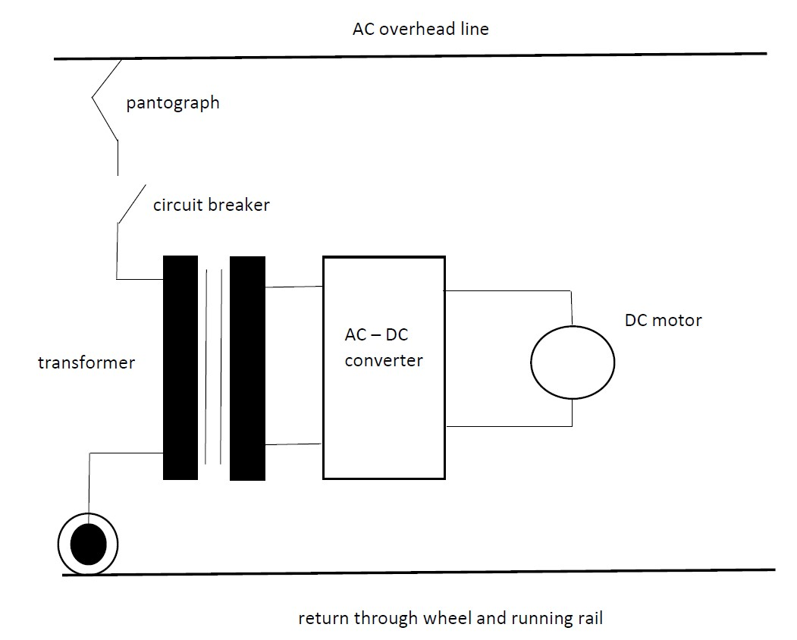
Figure 9: Basic structure of a locomotive fed by an AC overhead line with a DC motor
Figure 10 is very similar with Figure 9. By using a frequency converter (e.g. a voltage source inverter can be used), a three phase voltage having an adjustable frequency and an adjustable RMS value can be obtained to control the speed of the AC traction motor.
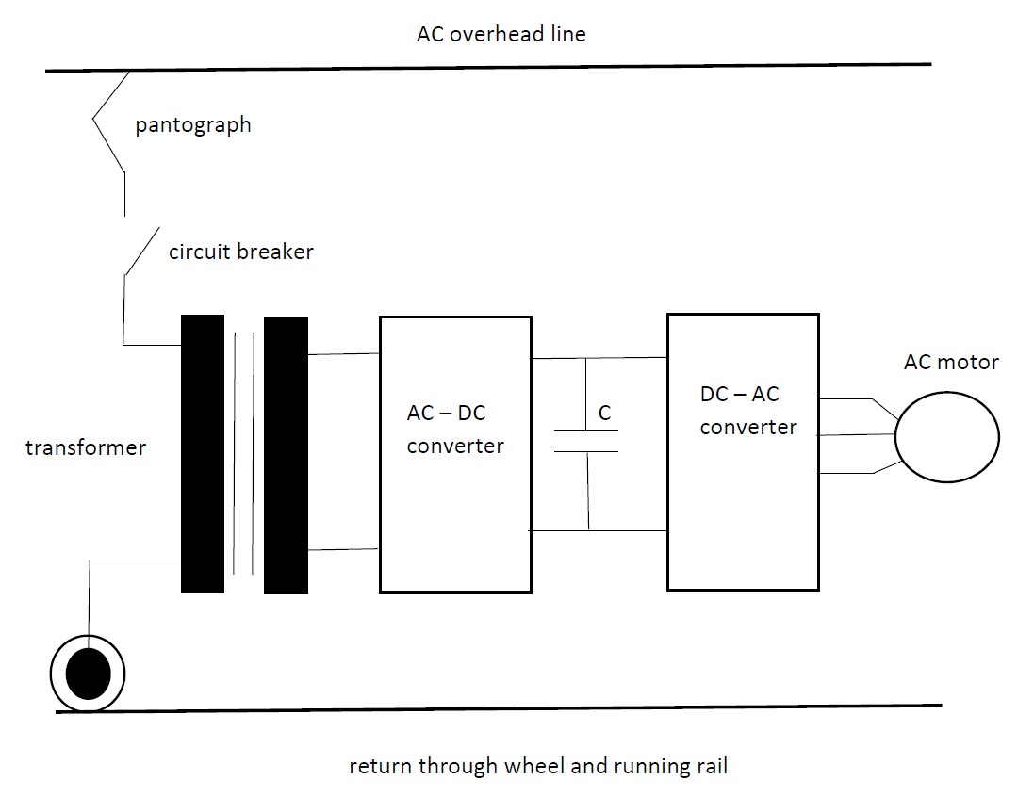
Figure 10: Basic structure of a locomotive fed by an AC overhead line with an AC motor
4.3: Physical characteristics of the use of railway systems
The use of railway systems is common practice in a vast number of countries. Railway systems provide a number of important advantages. Due to the low coefficient of friction between the wheels and the running rails, a low rolling resistance is obtained. This property allows an efficient propulsion and a high energy efficiency. By using railway systems, high speeds of operation are possible.
The low coefficient of friction between the wheels and the rails also implies some disadvantages. There is a risk of slip, the acceleration rate is limited and also the braking rate is limited. The weather has a large impact on the contact surface which influences the coefficient of friction.
When electrical locomotives are used, regenerative braking is possible. While braking the train, the traction motor operates as a generator and kinetic energy is converted into electrical energy. The generated power is injected into the overhead line and other trains can consume that power. By using overhead lines or a third rail system, no large electrical storage using e.g. batteries is needed.
A railway system uses rails which implies no steering is needed and the train has a predictable motion. Moreover, high standards of safety are possible. At the other hand side, the rails are fixed and the train can only be used where rails are available. Trains actually have a limited network flexibility. Especially buses and cars using the road provide the advantage to have a large network flexibility. Car drivers can take the route they like and need.
5: Electric cars
Mainly due to the large flexibility, the use of cars is very popular. The vast majority of the households in an industrialized country have one or more cars. Today, the vast majority of the cars use a fossil fuel like gasoline or diesel as an energy source. But around 1900, the situation was very different. For instance in the USA in 1900, 4192 cars were registrated: 1681 steam driven cars, 936 gasoline cars and 1575 electric cars. These numbers show that electric cars were much more popular than gasoline cars. The first car to exceed a speed of 100 km/h was the electric car of Camille Janetzy (1899 in France) (https://en.wikipedia.org/wiki/La_Jamais_Contente).
After 1900, the situation changed. The discovery of new oil wells, dropping prices of gasoline (and fossil fuels in general) and the compact energy storage obtained by these fossil fuels implied a vast dominance of fossil fueled cars. Also today, cars using fossil fuels are still dominant.
In order to reduce the dependence on fossil fuels, since a number of decades there is again a growing interest in the use of electric cars. Electric cars are also an opportunity to reduce the emission of harmful exhaust gases (like ${CO}_{2}$). Although Tesla (https://www.tesla.com/) is probably the best known company to develop and manufacture electric cars, a large number of (traditional) car manufacturers are also developing and selling electric cars.
Since energy storage using batteries is less compact than energy storage using fossil fuels like gasoline, also hybrid cars are available on the market. By combining a combustion engine and an electric motor (which is also able to function as a generator) the advantages of electric cars and fossil fuel powered cars can be combined. It is important to realise a sufficiently large range, to increase the energy efficiency, to reduce the exhaust of harmful exhaust gases and keep the car affordable.
6: Conclusions
When considering the transportation of humans, animals and goods, a large variety of means of transportation exist. All means of transportation have their advantages and disadvantages and in all cases technical challenges remain.
References
A. Boglietti, A. Cavagnino, A. Tenconi, S. Vaschetto, The Safety Critical Electric Machines and Drives in the More Electric Aircraft: a Survey, 35th Annual Conference of IEEE Industrial Electronics, 3-5 November 2009, Porto, Portugal, pp. 2587-2594.
M. Chymera, C. J. Goodman, Overview of Electric Railway Systems and the Calculation of Train Performance, IET Professional Development Course on Electric Traction Systems, 5-8 November 2012, London, UK.
L. Dimitrov, S. Kanturska, Features in the selection and operation of AC Motors for electric propulsion system in ship, 15th International Conference on Electrical Machines, Drives and Power Systems (ELMA), 1-3 June 2017, Sofia, Bulgaria, pp. 228-232.
B. Gemmell, J. Dorn, D. Retzmann, D. Soerangr, Prospects of Multilevel VSC Technologies for Power Transmission, IEEE/PES Transmission and Distribution Conference and Exposition, 21-24 April 2008, Chicago, IL, USA.
T. J. McCoy, J. V. Amy jr., The State-of-the-Art of Integrated Electric Power and Propulsion Systems and Technologies on Ships, IEEE Electric Ship Technologies Symposium, 20-22 April 2009, Baltimore, MD, USA, pp. 340-344.
J. Pollefliet, Elektronische vermogencontrole, deel 1: vermogenelektronica, Academia Press, Gent, Belgium, ISBN 90 382 0657 7, 2004 (in Dutch).
J. Pollefliet, Elektronische vermogencontrole, deel 2: elektronische motorcontrole, Academia Press, Gent, Belgium, ISBN 90 382 0661 5, 2004 (in Dutch).
B. Sarlioglu, C. T. Morris, More Electric Aircraft: Review, Challenges, and Opportunities for Commercial Transport Aircraft, IEEE Transactions on Transportation Electrification, vol. 1, no. 1, june 2015, pp. 54-64.
F. Schmid, C. J. Goodman, Overview of Electric Railway Systems, 13th IET Professional Development Course on Electric Traction Systems, 3-6 November 2014, Londen, UK.
S. Soylu (Ed.), Electric Vehicles – The Benefits and Barriers, IntechOpen, Rijeka, Croatia, 2011, ISBN 978-953-307-287-6.
P. Wheeler, Technology for the More and All Electric Aircraft of the Future, IEEE International Conference on Automatica (ICA-ACCA), 19-21 October 2016, Curico, Chile.
References: websites
The Solar Impulse: https://en.wikipedia.org/wiki/Solar_Impulse
Electric locomotives for trains: https://en.wikipedia.org/wiki/Electric_locomotive
The railway Technical Website: http://www.railway-technical.com/infrastructure/electric-traction-power.html
Electric Traction Systems and their advantages: https://www.electronicshub.org/electric-traction-system/

