MINISTRY OF EDUCATION AND SCIENCE OF UKRAINE

KHARKIV NATIONAL AUTOMOBILE AND HIGHWAY UNIVERSITY

KAZAKH NATIONAL UNIVERSITY AL-FARABI (KAZAKHSTAN)

TEXAS A&M UNIVERSITY-COMMERCE (USA)

SUN YAT-SEN UNIVERSITY (CHINA)

BELSE STATE UNIVERSITY NAMED AFTER ALEKO RUSSO (MOLDOVA)

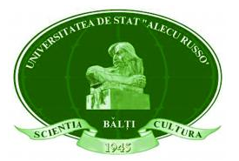
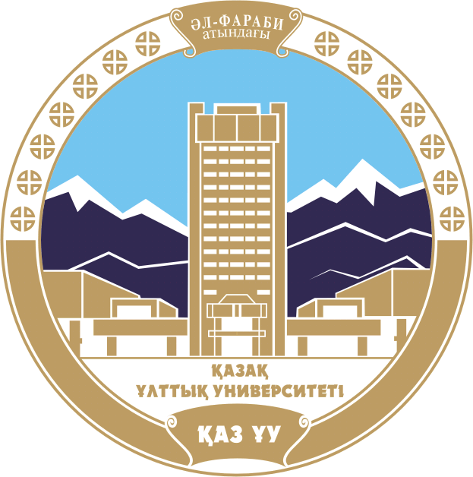




CALL FOR PAPERS
Dear colleagues!
We invite you to participate in the

International Conference of Applied Sciences
"Problems and perspectives in language training of international students"
The conference will be held on the 19 of October 2023
(UkrISTEI-certified, with the certificate № 571 issued on the 19, December, 2022)

The purpose of the conference is sharing the latest developments
in the area of linguodidactics

The main issues of the conference:
- Theoretical and applied aspects of linguistics and methodology of language training for international students;
- Modern educational process: traditional and innovative technologies, algorithms and techniques in teaching foreign students;
- Psychological and pedagogical bases of the organizing the educational process: issues of adaptation and integration of foreign students in the educational environment of the university;
- Intercultural Communication in the practice of teaching a second language;
- Second language for special purposes.

The Participation Mode:
Due to the military situation in the country, the conference will be held ONLINE. It is planned to upload the conference proceedings in the digital version in free access on the website of KhNADU two weeks after the conference (11/02/2023), emailing to all participants both it and the certificates of participation. Please note that even the digital collection of proceedings will have an ISBN while the participation in the conference is free.
Official languages of the conference: Ukrainian, English (the use of Russian is possible for non-Ukrainian citizens).

Note that to take part in the conference participants are to apply before October 14, 2023 via the email and send all their materials to kafmp@ukr.net Specifically you should send us your work (for example, ‘johnson_abstract’).
You also are to submit the following Application form:
https://docs.google.com/forms/d/e/1FAIpQLSe2n-dSnYxl77kGdSKWGZ0EjdxgrjnyMCSCg2_91V5j9pDFKw/viewform?usp=sharing

Address of a conference committee:
Kharkiv National Automobile and Highway University, Faculty of training foreign citizens, Yaroslava Mudrogo st., 25, Kharkiv, 61002, Ukraine.
Language Training Department: Head. PhD, Assoc. Morgunova Nadiia,
tel. +38 093 487 33 84; morgan.ns777@gmail.com
Philology Department: Head (executor). PhD, Assoc. Opryshko Natalia,
tel. +380990972750
Executive Secretary of the Conference - PhD, Assoc. Semenenko Inga
Requirements for abstracts:
General size - 3-5 pages; A-4 (a file with the extension * .doc and NOT docx); font - Times New Roman, 14 pt .; spacing - 1,5; indention - 1.25 cm; all margins - 2 cm.
The text shall be presented as follows: Title of the paper (font – bold, centered); surname and first name of the author(s) (font - bold, italic); his/her post, university, city, country, e-mail) – font - italics, single spacing; one line pass; the main body.
List of sources used for writing abstracts shall be located at the end of the text in alphabetical order, without indentation, single spaced, font 12 pt. under the heading References. References in the text of the article should be submitted only in square brackets, for example [1], [1; 6], where numbers 1 and 6 correspond to the serial number of the work or source in the List of used sources. If references to sources are consecutive from 1 to 6, then [1-4]. References to specific pages should be given after the source number with a comma followed by the lowercase letter “c.”), for example: [1, p. 5]. If there are references to several works, they are separated by semicolons: [1, p. 5; 6, p. 25-33].
Materials which do not meet these requirements shall not be accepted.
Example:
Peculiarities of foreign students in higher education
Ivanova I.I.
Associate Professor, Department of Philology
Kharkov National Automobile and Highway University
Kharkiv, Ukraine
e-mail: ivanova@gmail.com
(text)
References:
- Krashen S. Second Language Acquisition and Second Language Learning. Oxford; New York: Pergamon Press. 2015. 161 р.
- Robin B. What is Digital Storytelling? Educational Use of Digital Storytelling. URL: http://digitalstorytelling.coe.uh.edu/page.cfm?id=27

